|  |  |  |
| --- | --- | --- |
|  | **prostep ivip Recommendation** | **PSI**  **PSI Reference Number** |

**Title of Recommendation**

**Title of Part**

Version 1.1, 29.10.2008

Status:



© prostep ivip Association

Contents

1. Data Types iv

1.1. anyURI iv

1.2. dateTime iv

1.3. description iv

1.4. double iv

1.5. identifier iv

1.6. integer iv

1.7. string iv

1.8. title v

2. Dimensions v

2.1. Angle v

2.2. Density v

2.3. Length v

2.4. Linear Thermal Expansion Coefficient v

2.5. Mass vi

2.6. Strain vi

2.7. Stress vi

3. Data Entities vi

3.1. Specific Elements vii

3.1.1. Organization vii

3.1.2. Product Architecture xv

3.1.3. Product Design xxvi

3.1.4. Product Verification lxxviii

3.1.5. Product Validation lxxxiv

3.1.6. Manufacturing & Supply Chain lxxxix

3.1.7. Operation xcix

3.1.8. Context Elements ci

4. Use-Cases cviii

4.1. Collaboration Use-Cases cviii

4.1.1. Product Development cix

4.1.2. Production Development cxl

4.1.3. Manufacturing & Supply Chain cliv

4.1.4. Product Operation clxiv

4.1.5. Procurement clxxii

4.1.6. Product Line Engineering clxxv

4.1.7. Long-Term Archiving clxxviii

4.2. CASCaDE clxxx

4.2.1. Collaborative Product Requirements Management clxxxi

4.2.2. Collaborative Architecture Design Co-Development clxxxii

4.2.3. Co-Simulation & early Requirements V&V clxxxii

4.2.4. Collaborative 3D MBD, Electrical and Software Design Co-Development clxxxii

4.2.5. Collaborative Manufacturing Engineering clxxxvi

4.2.6. Collaborative Digital Product Quality Management (APQP) clxxxvi

4.2.7. LOTAR Long-term Archiving and Retrieval clxxxvi

4.2.8. Model-based Acquisition clxxxvi

# Data Types

Lists all datatypes used in the ontology.

## anyURI

|  |  |
| --- | --- |
| **URI** | xs:anyURI |
|  |  |

## dateTime

|  |  |
| --- | --- |
| **URI** | xs:dateTime |
|  |  |

## description

An account of the resource.

Description may include but is not limited to: an abstract, a table of contents, a graphical representation, or a free-text account of the resource.

|  |  |
| --- | --- |
| **URI** | dc:description |
|  |  |

## double

|  |  |
| --- | --- |
| **URI** | xs:double |
|  |  |

## identifier

An unambiguous reference to the resource within a given context.

Recommended practice is to identify the resource by means of a string conforming to an identification system. Examples include International Standard Book Number (ISBN), Digital Object Identifier (DOI), and Uniform Resource Name (URN). Persistent identifiers should be provided as HTTP URIs.

|  |  |
| --- | --- |
| **URI** | dc:identifier |
|  |  |

## integer

|  |  |
| --- | --- |
| **URI** | xs:integer |
|  |  |

## string

|  |  |
| --- | --- |
| **URI** | xs:string |
|  |  |

## title

|  |  |
| --- | --- |
| **URI** | dc:title |
|  |  |

# Dimensions

Lists all dimensions used in the ontology.

## Angle

The abstract notion of angle. Narrow concepts include plane angle and solid angle. While both plane angle and solid angle are dimensionless, they are actually length/length and area/area respectively.

Applicable units are those of quantitykind:Angle

|  |  |
| --- | --- |
| **URI** | <http://qudt.org/vocab/quantitykind/Angle> |
| **Units** | <http://qudt.org/vocab/unit/DEG> |

## Density

The mass density or density of a material is defined as its mass per unit volume. The symbol most often used for density is

. Mathematically, density is defined as mass divided by volume:

, where

is the density,

is the mass, and

is the volume. In some cases, density is also defined as its weight per unit volume, although this quantity is more properly called specific weight.

Applicable units are those of quantitykind:Density

|  |  |
| --- | --- |
| **URI** | <http://qudt.org/vocab/quantitykind/Density> |
| **Units** | <http://qudt.org/vocab/unit/KiloGM-PER-M3> |

## Length

In geometric measurements, length most commonly refers to the longest dimension of an object. In some contexts, the term "length" is reserved for a certain dimension of an object along which the length is measured.

Applicable units are those of quantitykind:Length

|  |  |
| --- | --- |
| **URI** | <http://qudt.org/vocab/quantitykind/Length> |
| **Units** | <http://qudt.org/vocab/unit/MilliM>  <http://qudt.org/vocab/unit/M> |

## Linear Thermal Expansion Coefficient

When the temperature of a substance changes, the energy that is stored in the intermolecular bonds between atoms changes. When the stored energy increases, so does the length of the molecular bonds. As a result, solids typically expand in response to heating and contract on cooling; this dimensional response to temperature change is expressed by its coefficient of thermal expansion. Different coefficients of thermal expansion can be defined for a substance depending on whether the expansion is measured by: linear thermal expansion, area thermal expansion, or volumetric thermal expansion.

|  |  |
| --- | --- |
| **URI** | <http://qudt.org/vocab/quantitykind/LinearThermalExpansion> |
| **Units** | <http://qudt.org/vocab/unit/PER-K>  <http://qudt.org/vocab/unit/MilliM-PER-K> |

## Mass

In physics, mass, more specifically inertial mass, can be defined as a quantitative measure of an object's resistance to acceleration. The SI unit of mass is the kilogram (

)Applicable units are those of quantitykind:Mass

|  |  |
| --- | --- |
| **URI** | <http://qudt.org/vocab/quantitykind/Mass> |
| **Units** | <http://qudt.org/vocab/unit/KiloGM> |

## Strain

In any branch of science dealing with materials and their behaviour, strain is the geometrical expression of deformation caused by the action of stress on a physical body. Strain is calculated by first assuming a change between two body states: the beginning state and the final state. Then the difference in placement of two points in this body in those two states expresses the numerical value of strain. Strain therefore expresses itself as a change in size and/or shape.

|  |  |
| --- | --- |
| **URI** | <http://qudt.org/vocab/quantitykind/Strain> |
| **Units** | <http://qudt.org/vocab/unit/PERCENT>  <http://qudt.org/vocab/unit/N-PER-MilliM2> |

## Stress

Stress is a measure of the average amount of force exerted per unit area of a surface within a deformable body on which internal forces act. In other words, it is a measure of the intensity or internal distribution of the total internal forces acting within a deformable body across imaginary surfaces. These internal forces are produced between the particles in the body as a reaction to external forces applied on the body. Stress is defined as

.Applicable units are those of quantitykind:ForcePerArea

|  |  |
| --- | --- |
| **URI** | <http://qudt.org/vocab/quantitykind/Stress> |
| **Units** | <http://qudt.org/vocab/unit/N-PER-MilliM2> |

# Data Entities

Lists all classes, attributes and relations in the ontology.

## Specific Elements



Figure Specific Elements

### Organization

Includes all entities representing a corporate or project organization



Figure Icon

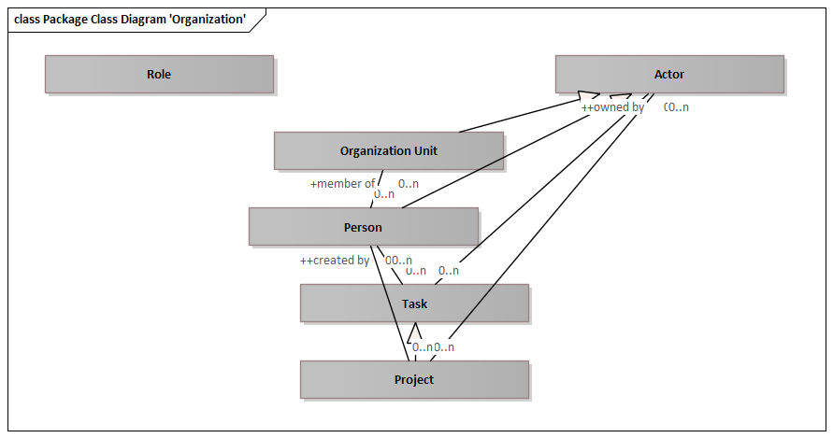

Figure Package Class Diagram 'Organization'

#### Role

A defined function to be performed by a project team member, such as testing, filing, inspecting, coding.

https://intranet.prostep.org/display/PROJ/Glossary

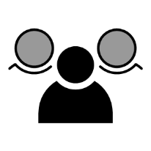

Figure Icon

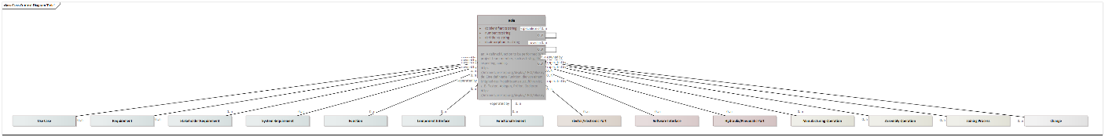

Figure Class Context Diagram 'Role'

|  |  |
| --- | --- |
| **Delivered by** | Business or Mission Analysis |
| **Delivered to** | Requirements Engineering  Systems Architecture  Functional Safety  Collaborative Product Requirements Management |

Attributes

|  |  |  |
| --- | --- | --- |
| Identifier | xs:string | Unambiguous identifier of the element |
| Number | xs:string | Legible number or name of the element, i. e. part number |
| Title | xs:string | Title of the element |
| Description | xs:string | Description of the element |

Outbound Relations

|  |  |  |
| --- | --- | --- |
| part of | Role | Parent element |
| used in | Role | Context element of the usage |
| specialism of | Role | More generic item |

Inbound Relations

|  |  |  |
| --- | --- | --- |
|  |  | Parent element |
|  |  | Context element of the usage |
|  |  | More generic item |
| Use Case | owned by | Role owning this element |
| Requirement | owned by | Role owning this element |
| Stakeholder Requirement | owned by | Role owning this element |
| System Requirement | owned by | Role owning this element |
| Function | owned by | Role owning this element |
| Component Interface | operated by | Interacting role |
| Electric/Electronic Port | operated by | Interacting role |
| Software Interface | operated by | Interacting role |
| Hydraulic/Pneumatic Port | operated by | Interacting role |
| Manufacturing Operation | owned by | Role owning this element |
| Assembly Operation | owned by | Role owning this element |
| Heat Treatment | owned by | Role owning this element |
| Joining Process | owned by | Role owning this element |
| Change | owned by | Role owning this element |

#### Actor

Abstract class for an actor. Derived, specific classes are person and organization unit.



Figure Icon

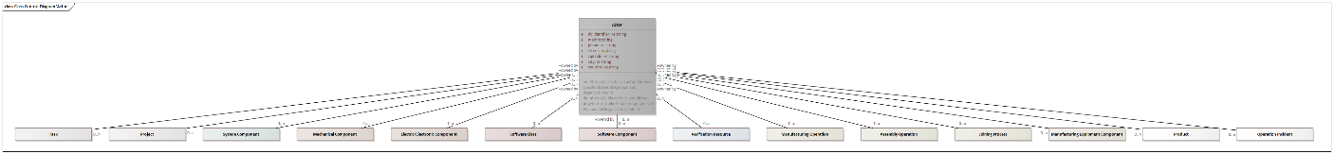

Figure Class Context Diagram 'Actor'

|  |  |
| --- | --- |
| **Specializations** | Person  Organization Unit |

Attributes

|  |  |  |
| --- | --- | --- |
| Identifier | xs:string | Unambiguous identifier of the element |
| Mail | xs:string | E-mail address of the actor |
| Phone | xs:string | Phone number of the actor |
| Street | xs:string | Street of the actor |
| ZIP Code | xs:string | ZIP code number of the actor |
| City | xs:string | City of the actor |
| Country | xs:string | Country of the actor |

Inbound Relations

|  |  |  |
| --- | --- | --- |
| Task | owned by | Actor owning this element |
| Project | owned by | Actor owning this element |
| System Component | owned by | Actor owning this element |
| Mechanical Component | owned by | Actor owning this element |
| Electric/Electronic Component | owned by | Actor owning this element |
| Software Class | owned by | Actor owning this element |
| Software Component | owned by | Actor owning this element |
| Verification Resource | owned by | Actor owning this element |
| Manufacturing Operation | owned by | Actor owning this element |
| Assembly Operation | owned by | Actor owning this element |
| Heat Treatment | owned by | Actor owning this element |
| Joining Process | owned by | Actor owning this element |
| Manufacturing Equipment Component | owned by | Actor owning this element |
| Product | owned by | Actor owning this element |
| Operation Incident | owned by | Actor owning this element |

#### Person

Represents a real person, but may also be a system user that appears in source data. The FOAF (Friend of a Friend) Ontology has been considered, but is not used as it does not provide a structured representation for firstname, lastname and title of a person.



Figure Icon

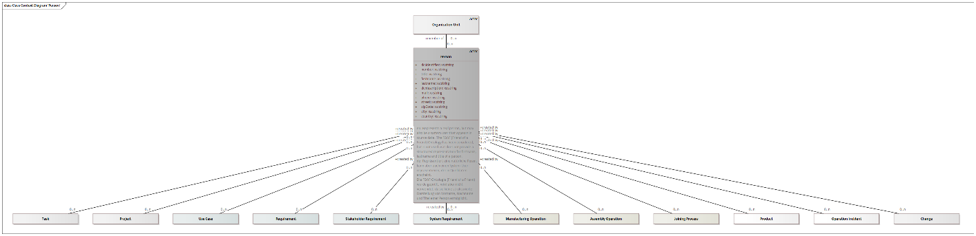

Figure Class Context Diagram 'Person'

|  |  |
| --- | --- |
| **Generalizations** | Actor |

Attributes

|  |  |  |
| --- | --- | --- |
| Identifier | xs:string | Unambiguous identifier of the element |
| Number | xs:string | Legible number or name of the element, i. e. part number |
| Title | xs:string | Title or degree of the person |
| Firstname | xs:string | First name of the person |
| Lastname | xs:string | Last name of the person |
| Description | xs:string | Description of the element |
| Mail | xs:string | E-mail address of the actor |
| Phone | xs:string | Phone number of the actor |
| Street | xs:string | Street of the actor |
| ZIP Code | xs:string | ZIP code number of the actor |
| City | xs:string | City of the actor |
| Country | xs:string | Country of the actor |

Outbound Relations

|  |  |  |
| --- | --- | --- |
| member of | Organization Unit | Parent organization unit |

Inbound Relations

|  |  |  |
| --- | --- | --- |
| Task | created by | The person who created this element |
| Project | created by | The person who created this element |
| Use Case | created by | The person who created this element |
| Requirement | created by | The person who created this element |
| Stakeholder Requirement | created by | The person who created this element |
| System Requirement | created by | The person who created this element |
| Manufacturing Operation | created by | The person who created this element |
| Assembly Operation | created by | The person who created this element |
| Heat Treatment | created by | The person who created this element |
| Joining Process | created by | The person who created this element |
| Product | created by | The person who created this element |
| Operation Incident | created by | The person who created this element |
| Change | created by | The person who created this element |

#### Organization Unit

An organization unit is part of a corporate structure. It comprises persons as well as sub-organization units.



Figure Icon

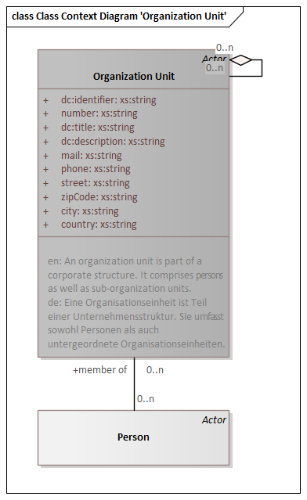

Figure Class Context Diagram 'Organization Unit'

|  |  |
| --- | --- |
| **Generalizations** | Actor |

Attributes

|  |  |  |
| --- | --- | --- |
| Identifier | xs:string | Unambiguous identifier of the element |
| Number | xs:string | Legible number or name of the element, i. e. part number |
| Title | xs:string | Title of the element |
| Description | xs:string | Description of the element |
| Mail | xs:string | E-mail address of the actor |
| Phone | xs:string | Phone number of the actor |
| Street | xs:string | Street of the actor |
| ZIP Code | xs:string | ZIP code number of the actor |
| City | xs:string | City of the actor |
| Country | xs:string | Country of the actor |

Outbound Relations

|  |  |  |
| --- | --- | --- |
| part of | Organization Unit | Parent element |

Inbound Relations

|  |  |  |
| --- | --- | --- |
| Person | member of | Parent organization unit |
|  |  | Parent element |

#### Task

A task is a definite piece of work assigned to a person or organisation



Figure Icon

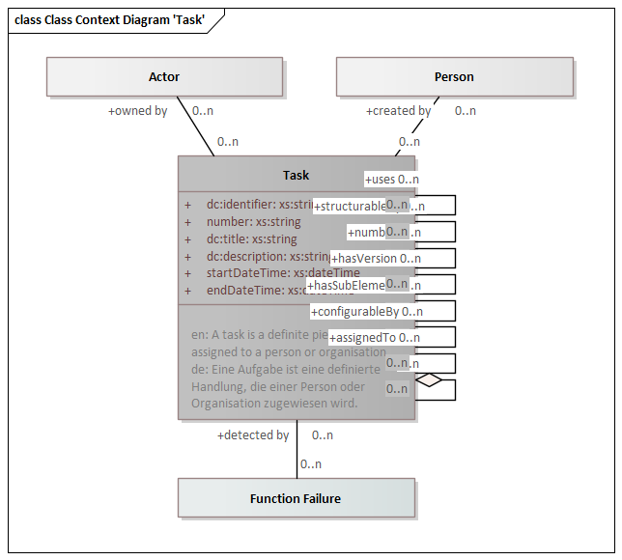

Figure Class Context Diagram 'Task'

|  |  |
| --- | --- |
| **Specializations** | Project |

Attributes

|  |  |  |
| --- | --- | --- |
| Identifier | xs:string | Unambiguous identifier of the element |
| Number | xs:string | Legible number or name of the element, i. e. part number |
| Title | xs:string | Title of the element |
| Description | xs:string | Description of the element |
| StartDateTime | xs:dateTime | Start date and time of the element |
| EndDateTime | xs:dateTime | End date and time of the element |

Outbound Relations

|  |  |  |
| --- | --- | --- |
| part of | Task | Parent element |
| created by | Person | The person who created this element |
| owned by | Actor | Actor owning this element |

Inbound Relations

|  |  |  |
| --- | --- | --- |
|  |  | Parent element |
| Function Failure | detected by | Detection task for the function failure |

#### Project

Represents a project or sub-project



Figure Icon

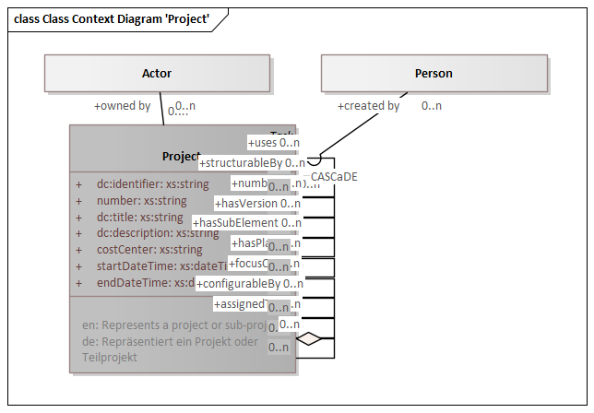

Figure Class Context Diagram 'Project'

|  |  |
| --- | --- |
| **Generalizations** | Task |

Attributes

|  |  |  |
| --- | --- | --- |
| Identifier | xs:string | Unambiguous identifier of the element |
| Number | xs:string | Legible number or name of the element, i. e. part number |
| Title | xs:string | Title of the element |
| Description | xs:string | Description of the element |
| Cost center | xs:string | Cost center of the project |
| StartDateTime | xs:dateTime | Start date and time of the element |
| EndDateTime | xs:dateTime | End date and time of the element |

Outbound Relations

|  |  |  |
| --- | --- | --- |
| part of | Project | Parent element |
| created by | Person | The person who created this element |
| owned by | Actor | Actor owning this element |

Inbound Relations

|  |  |  |
| --- | --- | --- |
|  |  | Parent element |

### Product Architecture

Includes all entities contributing to the product architecture



Figure Icon

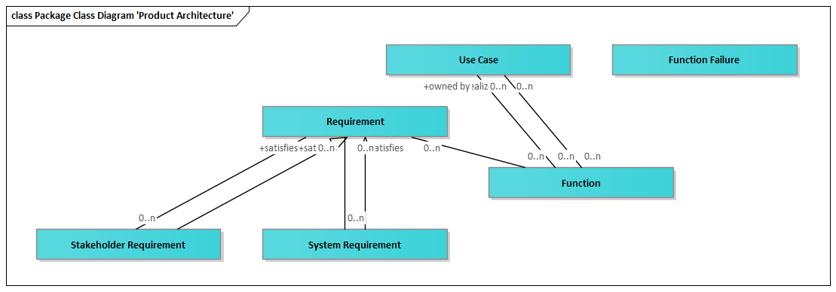

Figure Package Class Diagram 'Product Architecture'

#### Use Case

Specifies what the user of a product will do in order to achieve a goal

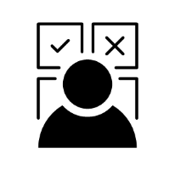

Figure Icon

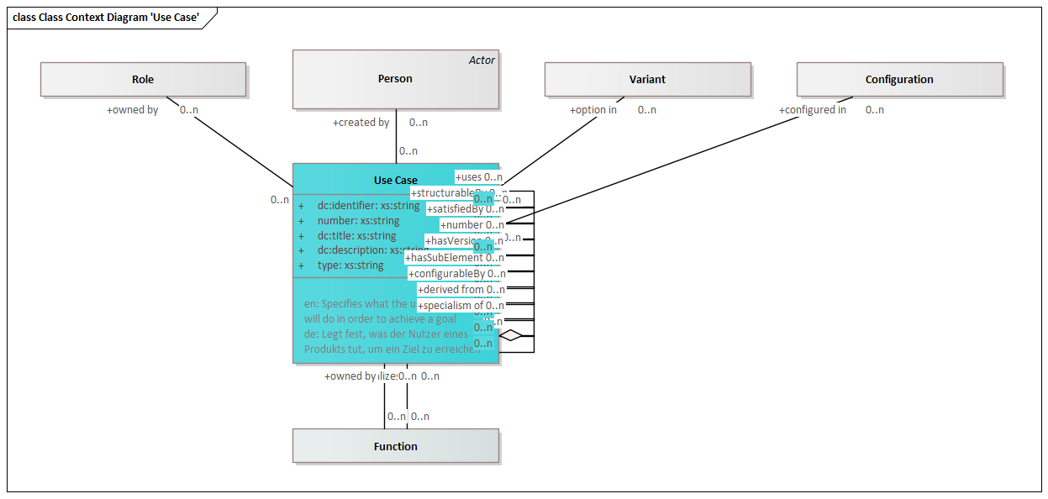

Figure Class Context Diagram 'Use Case'

|  |  |
| --- | --- |
| **Delivered by** | Business or Mission Analysis |
| **Delivered to** | Requirements Engineering  Systems Architecture  Functional Safety  Product Usage  Maintenance & Service  Collaborative Product Requirements Management |

Attributes

|  |  |  |
| --- | --- | --- |
| Identifier | xs:string | Unambiguous identifier of the element |
| Number | xs:string | Legible number or name of the element, i. e. part number |
| Title | xs:string | Title of the element |
| Description | xs:string | Description of the element |
| Type | xs:string | Type of an element |

Outbound Relations

|  |  |  |
| --- | --- | --- |
| part of | Use Case | Parent element |
| specialism of | Use Case | More generic item |
| configured in | Configuration | Relation to a configuration |
| option in | Variant | Relation to a variant |
| derived from | Use Case |  |
| created by | Person | The person who created this element |
| owned by | Role | Role owning this element |

Inbound Relations

|  |  |  |
| --- | --- | --- |
|  |  | Parent element |
|  |  | More generic item |
|  |  |  |
| Function | owned by |  |
| Function | realizes | Use cases realized with this function |

#### Requirement

Characteristics that identify the accomplishment levels needed to achieve specific objectives for a given set of conditions.

Requirements can be 'must have', 'can have' and 'nice to have'.

A. A condition or capability needed by a user to solve a problem or achieve an objective.

B. A condition or capability that must be met or possessed by a system or system component to satisfy a contract, standard, specification, or other formally imposed document.

C. A documented representation of a condition or capability as in definition (A:) or (B).

https://intranet.prostep.org/display/PROJ/Glossary

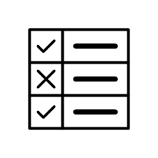

Figure Icon

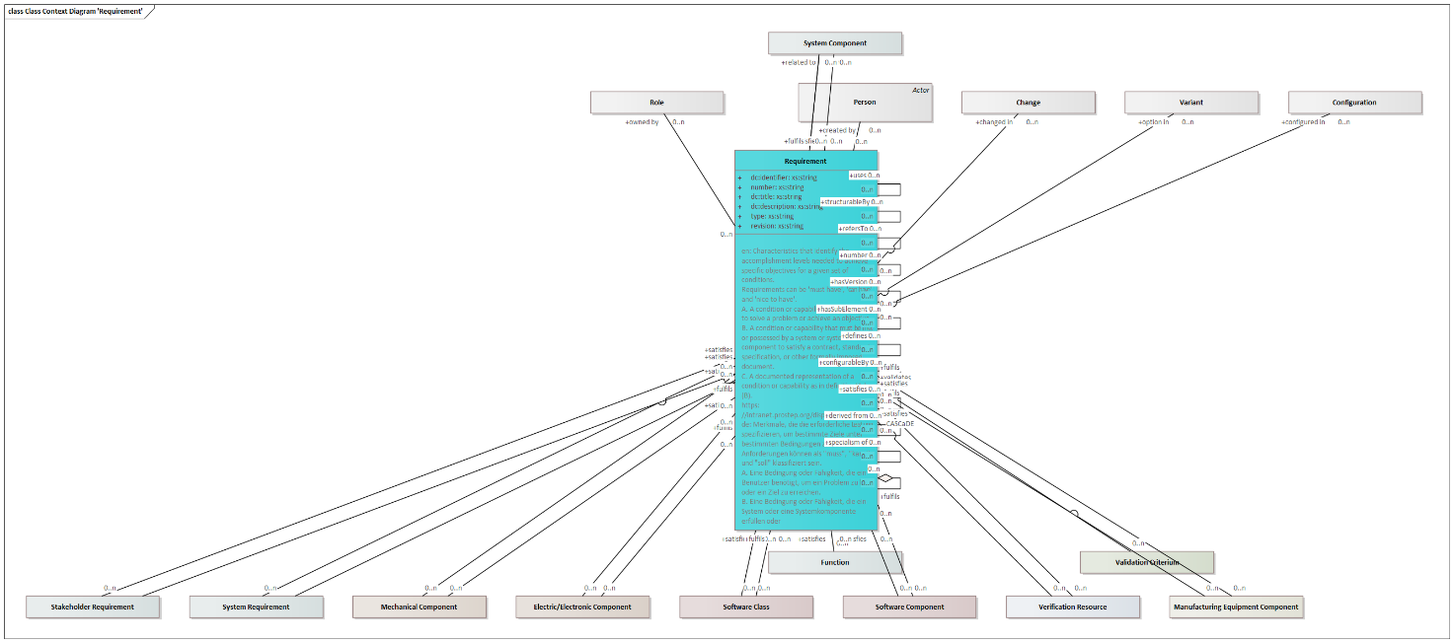

Figure Class Context Diagram 'Requirement'

|  |  |
| --- | --- |
| **Specializations** | Stakeholder Requirement  System Requirement |
| **Delivered by** | Requirements Engineering  Collaborative Product Requirements Management |

Attributes

|  |  |  |
| --- | --- | --- |
| Identifier | xs:string | Unambiguous identifier of the element |
| Number | xs:string | Legible number or name of the element, i. e. part number |
| Title | xs:string | Title of the element |
| Description | xs:string | Description of the element |
| Type | xs:string | Type of an element |
| Revision | xs:string | Revisionskennung des Elements |

Outbound Relations

|  |  |  |
| --- | --- | --- |
| part of | Requirement | Parent element |
| specialism of | Requirement | More generic item |
| configured in | Configuration | Relation to a configuration |
| option in | Variant | Relation to a variant |
| changed in | Change | Relation to a change |
| derived from | Requirement |  |
| created by | Person | The person who created this element |
| owned by | Role | Role owning this element |
| satisfies | Requirement | Requirement satisfied by this requirement. This is typically used for a stakeholder requirement satisfied by a system requirement |
| related to | System Component | System Component this requirement relates to. |

Inbound Relations

|  |  |  |
| --- | --- | --- |
|  |  | Parent element |
|  |  | More generic item |
|  |  |  |
|  |  | Requirement satisfied by this requirement. This is typically used for a stakeholder requirement satisfied by a system requirement |
| Stakeholder Requirement | satisfies | Requirement satisfied by this requirement. This is typically used for a stakeholder requirement satisfied by a system requirement |
| System Requirement | satisfies | Requirement satisfied by this requirement. This is typically used for a stakeholder requirement satisfied by a system requirement |
| Function | satisfies | Requirement satisfied by this function |
| System Component | satisfies | Requirement satisfied by this system component |
| System Component | fulfils | Requirement implemented by the component. According to systems engineering best-practice, a requirement should first be answered by a function, and the function will be implemented by a component. This direct relation should therefore only be used if no functions have been defined. |
| Mechanical Component | satisfies | Requirement satisfied by this system component |
| Mechanical Component | fulfils | Requirement implemented by the component. According to systems engineering best-practice, a requirement should first be answered by a function, and the function will be implemented by a component. This direct relation should therefore only be used if no functions have been defined. |
| Electric/Electronic Component | satisfies | Requirement satisfied by this system component |
| Electric/Electronic Component | fulfils | Requirement implemented by the component. According to systems engineering best-practice, a requirement should first be answered by a function, and the function will be implemented by a component. This direct relation should therefore only be used if no functions have been defined. |
| Software Class | satisfies | Requirement satisfied by this system component |
| Software Class | fulfils | Requirement implemented by the component. According to systems engineering best-practice, a requirement should first be answered by a function, and the function will be implemented by a component. This direct relation should therefore only be used if no functions have been defined. |
| Software Component | satisfies | Requirement satisfied by this system component |
| Software Component | fulfils | Requirement implemented by the component. According to systems engineering best-practice, a requirement should first be answered by a function, and the function will be implemented by a component. This direct relation should therefore only be used if no functions have been defined. |
| Verification Resource | satisfies | Requirement satisfied by this system component |
| Verification Resource | fulfils | Requirement implemented by the component. According to systems engineering best-practice, a requirement should first be answered by a function, and the function will be implemented by a component. This direct relation should therefore only be used if no functions have been defined. |
| Validation Criterium | validates | Requirement validated by this validation criterium |
| Manufacturing Equipment Component | satisfies | Requirement satisfied by this system component |
| Manufacturing Equipment Component | fulfils | Requirement implemented by the component. According to systems engineering best-practice, a requirement should first be answered by a function, and the function will be implemented by a component. This direct relation should therefore only be used if no functions have been defined. |

#### Stakeholder Requirement

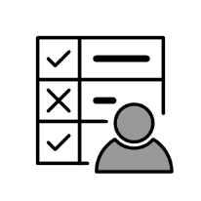

Figure Icon

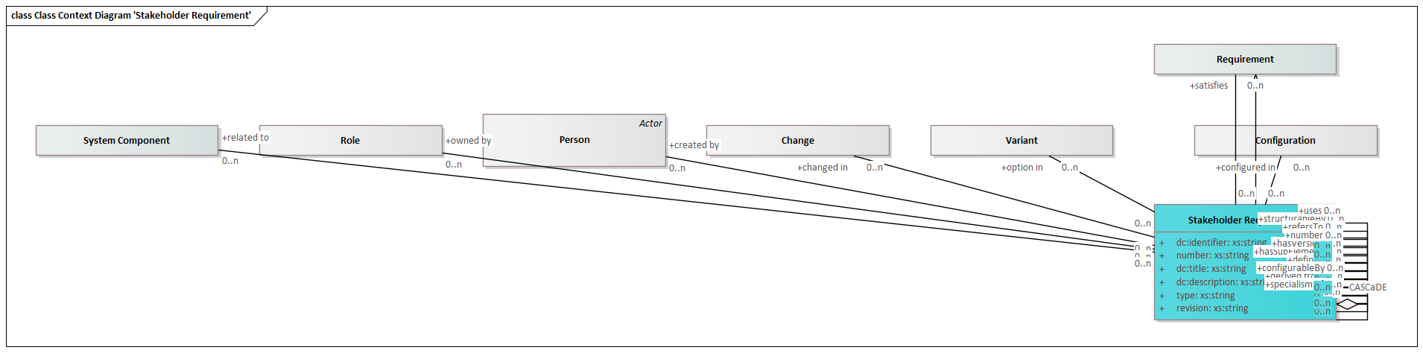

Figure Class Context Diagram 'Stakeholder Requirement'

|  |  |
| --- | --- |
| **Generalizations** | Requirement |
| **Delivered by** | Collaborative Product Requirements Management |
| **Delivered to** | Systems Architecture  Long-Term Archiving |

Attributes

|  |  |  |
| --- | --- | --- |
| Identifier | xs:string | Unambiguous identifier of the element |
| Number | xs:string | Legible number or name of the element, i. e. part number |
| Title | xs:string | Title of the element |
| Description | xs:string | Description of the element |
| Type | xs:string | Type of an element |
| Revision | xs:string | Revisionskennung des Elements |

Outbound Relations

|  |  |  |
| --- | --- | --- |
| part of | Stakeholder Requirement | Parent element |
| specialism of | Stakeholder Requirement | More generic item |
| configured in | Configuration | Relation to a configuration |
| option in | Variant | Relation to a variant |
| changed in | Change | Relation to a change |
| derived from | Stakeholder Requirement |  |
| created by | Person | The person who created this element |
| owned by | Role | Role owning this element |
| satisfies | Requirement | Requirement satisfied by this requirement. This is typically used for a stakeholder requirement satisfied by a system requirement |
| related to | System Component | System Component this requirement relates to. |

Inbound Relations

|  |  |  |
| --- | --- | --- |
|  |  | Parent element |
|  |  | More generic item |
|  |  |  |

#### System Requirement

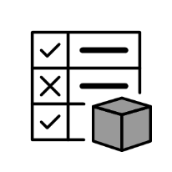

Figure Icon

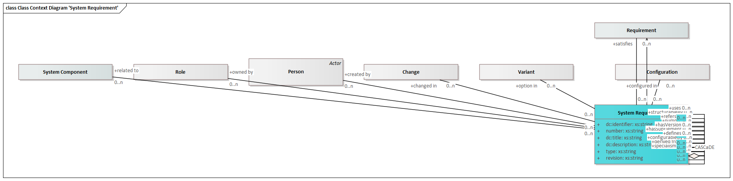

Figure Class Context Diagram 'System Requirement'

|  |  |
| --- | --- |
| **Generalizations** | Requirement |
| **Delivered by** | Collaborative Architecture Design Co-Development |
| **Delivered to** | Functional Safety  Mechanical Design  Define Joining Elements  Electrical/Electronical Design  Software Engineering  Plan and prepare Simulation  Prepare Testing  Design product line  Long-Term Archiving |

Attributes

|  |  |  |
| --- | --- | --- |
| Identifier | xs:string | Unambiguous identifier of the element |
| Number | xs:string | Legible number or name of the element, i. e. part number |
| Title | xs:string | Title of the element |
| Description | xs:string | Description of the element |
| Type | xs:string | Type of an element |
| Revision | xs:string | Revisionskennung des Elements |

Outbound Relations

|  |  |  |
| --- | --- | --- |
| part of | System Requirement | Parent element |
| specialism of | System Requirement | More generic item |
| configured in | Configuration | Relation to a configuration |
| option in | Variant | Relation to a variant |
| changed in | Change | Relation to a change |
| derived from | System Requirement |  |
| created by | Person | The person who created this element |
| owned by | Role | Role owning this element |
| satisfies | Requirement | Requirement satisfied by this requirement. This is typically used for a stakeholder requirement satisfied by a system requirement |
| related to | System Component | System Component this requirement relates to. |

Inbound Relations

|  |  |  |
| --- | --- | --- |
|  |  | Parent element |
|  |  | More generic item |
|  |  |  |

#### Function

A system, product or component function describes the way a system works or performs a specific task.



Figure Icon

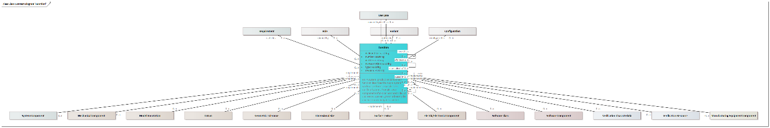

Figure Class Context Diagram 'Function'

|  |  |
| --- | --- |
| **Delivered by** | Systems Architecture  Functional Safety  Collaborative Architecture Design Co-Development |
| **Delivered to** | Functional Safety  Mechanical Design  Electrical/Electronical Design  Software Engineering  Plan and prepare Simulation  Prepare Testing  Product Usage  Maintenance & Service  Disassembly & Recycling  Design product line  Long-Term Archiving |

Attributes

|  |  |  |
| --- | --- | --- |
| Identifier | xs:string | Unambiguous identifier of the element |
| Number | xs:string | Legible number or name of the element, i. e. part number |
| Title | xs:string | Title of the element |
| Description | xs:string | Description of the element |
| Type | xs:string | Type of an element |
| Revision | xs:string | Revisionskennung des Elements |

Outbound Relations

|  |  |  |
| --- | --- | --- |
| part of | Function | Parent element |
| used in | Function | Context element of the usage |
| specialism of | Function | More generic item |
| configured in | Configuration | Relation to a configuration |
| option in | Variant | Relation to a variant |
| owned by | Role | Role owning this element |
| owned by | Use Case |  |
| satisfies | Requirement | Requirement satisfied by this function |
| follows | Function | In a sequence of product functions, specifies the previous product function. |
| uses | Function | Function used by this Function |
| realizes | Use Case | Use cases realized with this function |

Inbound Relations

|  |  |  |
| --- | --- | --- |
|  |  | Parent element |
|  |  | Context element of the usage |
|  |  | More generic item |
|  |  | In a sequence of product functions, specifies the previous product function. |
|  |  | Function used by this Function |
| Function Failure | affects | Product function affected by this product function failure |
| System Component | implements | Product function implemented by the component |
| Mechanical Component | implements | Product function implemented by the component |
| Model Annotation | implements | Product function implemented by the model annotation |
| Datum | implements | Product function implemented by the model annotation |
| Geometric Tolerance | implements | Product function implemented by the model annotation |
| Dimensional Size | implements | Product function implemented by the model annotation |
| Surface Texture | implements | Product function implemented by the model annotation |
| Electric/Electronic Component | implements | Product function implemented by the component |
| Software Class | implements | Product function implemented by the component |
| Software Component | implements | Product function implemented by the component |
| Verification Characteristic | verifies | Function verified by this verification characteristic |
| Verification Resource | implements | Product function implemented by the component |
| Manufacturing Equipment Component | implements | Product function implemented by the component |

#### Function Failure

Represents a system, product or component failure. A failure negates a corresponding function. Malfunctions are typically managed in an FMEA.



Figure Icon

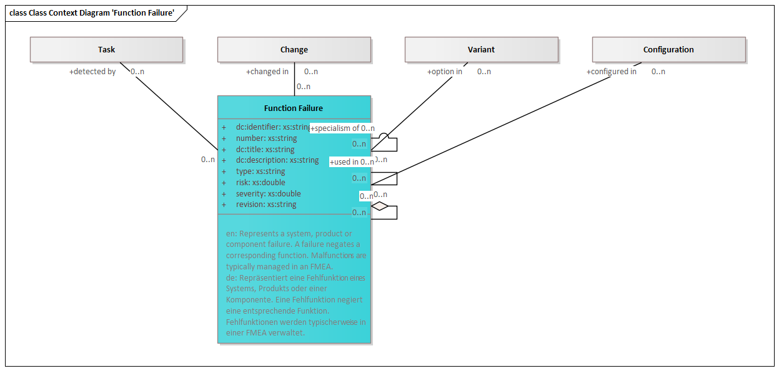

Figure Class Context Diagram 'Function Failure'

|  |  |
| --- | --- |
| **Delivered by** | Systems Architecture  Functional Safety  Collaborative Architecture Design Co-Development |
| **Delivered to** | Inspection Planning  Long-Term Archiving |

Attributes

|  |  |  |
| --- | --- | --- |
| Identifier | xs:string | Unambiguous identifier of the element |
| Number | xs:string | Legible number or name of the element, i. e. part number |
| Title | xs:string | Title of the element |
| Description | xs:string | Description of the element |
| Type | xs:string | Type of an element |
| Risk | xs:double | Risk of a function failure to occur. |
| Severity | xs:double | Severity of a function failure when it occurs. |
| Revision | xs:string | Revisionskennung des Elements |

Outbound Relations

|  |  |  |
| --- | --- | --- |
| part of | Function Failure | Parent element |
| used in | Function Failure | Context element of the usage |
| specialism of | Function Failure | More generic item |
| configured in | Configuration | Relation to a configuration |
| option in | Variant | Relation to a variant |
| changed in | Change | Relation to a change |
| affects | Function | Product function affected by this product function failure |
| causes | Function Failure | Product function failure caused by this product function failure |
| detected by | Task | Detection task for the function failure |

Inbound Relations

|  |  |  |
| --- | --- | --- |
|  |  | Parent element |
|  |  | Context element of the usage |
|  |  | More generic item |
|  |  | Product function failure caused by this product function failure |

### Product Design

Comprises all entities for domain-specific product design, including mechanical, electric/electronic and software design.



Figure Icon

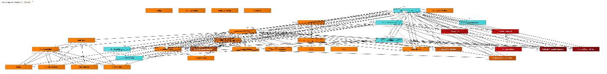

Figure Package Class Diagram 'Product Design'

#### Systems Design

Includes all entities relevant to the design of a system. The system level is intended to be generic and will find its specific implementation in mechanical design, electric/electronic design or software design.



Figure Icon

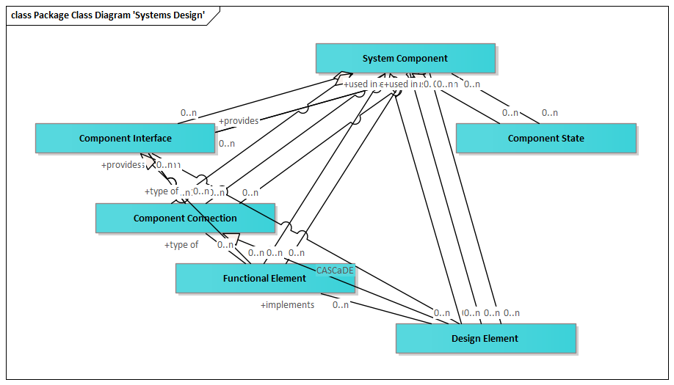

Figure Package Class Diagram 'Systems Design'

##### System Component

Represents a generic component of a system

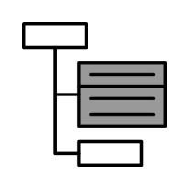

Figure Icon

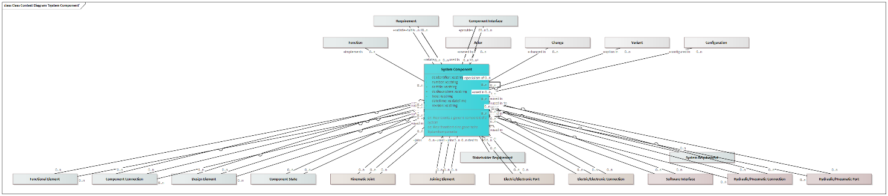

Figure Class Context Diagram 'System Component'

|  |  |
| --- | --- |
| **Specializations** | Mechanical Component  Electric/Electronic Component  Software Class  Software Component  Verification Resource  Manufacturing Equipment Component |
| **Delivered by** | Systems Architecture  Functional Safety  Collaborative Architecture Design Co-Development |
| **Delivered to** | Functional Safety  Mechanical Design  Electrical/Electronical Design  Software Engineering  Design product line  Design product asset instance  Definition product asset instance configurability space  Long-Term Archiving |

Attributes

|  |  |  |
| --- | --- | --- |
| Identifier | xs:string | Unambiguous identifier of the element |
| Number | xs:string | Legible number or name of the element, i. e. part number |
| Title | xs:string | Title of the element |
| Description | xs:string | Description of the element |
| Type | xs:string | Type of an element |
| DateTime | xs:dateTime | Date and time of the element |
| Revision | xs:string | Revisionskennung des Elements |

Outbound Relations

|  |  |  |
| --- | --- | --- |
| part of | System Component | Parent element |
| used in | System Component | Context element of the usage |
| specialism of | System Component | More generic item |
| configured in | Configuration | Relation to a configuration |
| option in | Variant | Relation to a variant |
| changed in | Change | Relation to a change |
| owned by | Actor | Actor owning this element |
| implements | Function | Product function implemented by the component |
| satisfies | Requirement | Requirement satisfied by this system component |
| fulfils | Requirement | Requirement implemented by the component. According to systems engineering best-practice, a requirement should first be answered by a function, and the function will be implemented by a component. This direct relation should therefore only be used if no functions have been defined. |
| provides | Component Interface |  |

Inbound Relations

|  |  |  |
| --- | --- | --- |
| Requirement | related to | System Component this requirement relates to. |
| Stakeholder Requirement | related to | System Component this requirement relates to. |
| System Requirement | related to | System Component this requirement relates to. |
|  |  | Parent element |
|  |  | Context element of the usage |
|  |  | More generic item |
| Component Interface | part of | Parent system component |
| Component Interface | used in | Context system component of the usage |
| Component Connection | part of | Parent system component |
| Component Connection | used in | Context system component of the usage |
| Component Connection | joins | Represents the system components joined by this component connection. |
| Component State | part of | Parent system component |
| Component State | used in | Context system component of the usage |
| Kinematic Joint | part of | Parent system component |
| Kinematic Joint | used in | Context system component of the usage |
| Kinematic Joint | joins | Represents the system components joined by this component connection. |
| Joining Element | part of | Parent system component |
| Joining Element | used in | Context system component of the usage |
| Joining Element | joins | Represents the system components joined by this component connection. |
| Electric/Electronic Port | part of | Parent system component |
| Electric/Electronic Port | used in | Context system component of the usage |
| Electric/Electronic Connection | part of | Parent system component |
| Electric/Electronic Connection | used in | Context system component of the usage |
| Electric/Electronic Connection | joins | Represents the system components joined by this component connection. |
| Software Interface | part of | Parent system component |
| Software Interface | used in | Context system component of the usage |
| Hydraulic/Pneumatic Connection | part of | Parent system component |
| Hydraulic/Pneumatic Connection | used in | Context system component of the usage |
| Hydraulic/Pneumatic Connection | joins | Represents the system components joined by this component connection. |
| Hydraulic/Pneumatic Port | part of | Parent system component |
| Hydraulic/Pneumatic Port | used in | Context system component of the usage |

##### Component Interface

Represents a generic interface of a system component

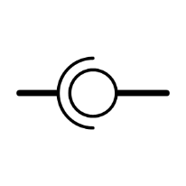

Figure Icon

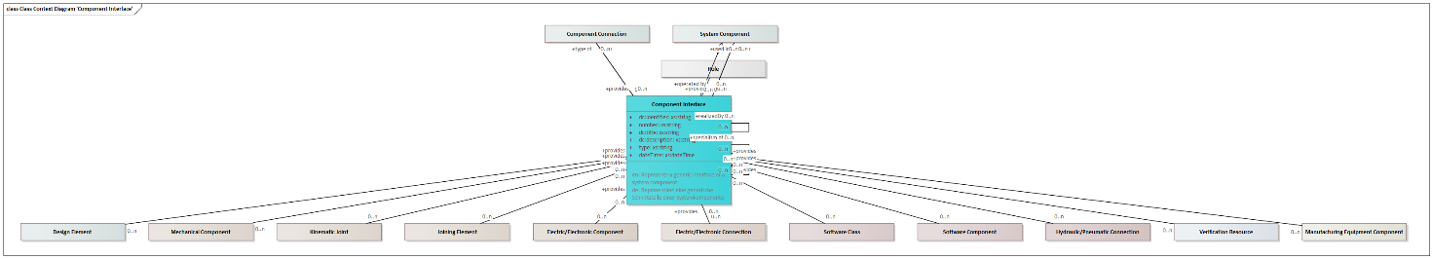

Figure Class Context Diagram 'Component Interface'

|  |  |
| --- | --- |
| **Specializations** | Electric/Electronic Port  Software Interface  Hydraulic/Pneumatic Port |
| **Delivered by** | Systems Architecture  Functional Safety  Collaborative Architecture Design Co-Development |
| **Delivered to** | Functional Safety  Mechanical Design  Electrical/Electronical Design  Software Engineering  Design product line  Design product asset instance  Definition product asset instance configurability space  Long-Term Archiving |

Attributes

|  |  |  |
| --- | --- | --- |
| Identifier | xs:string | Unambiguous identifier of the element |
| Number | xs:string | Legible number or name of the element, i. e. part number |
| Title | xs:string | Title of the element |
| Description | xs:string | Description of the element |
| Type | xs:string | Type of an element |
| DateTime | xs:dateTime | Date and time of the element |

Outbound Relations

|  |  |  |
| --- | --- | --- |
| part of | Component Interface | Parent element |
| part of | System Component | Parent system component |
| used in | System Component | Context system component of the usage |
| specialism of | Component Interface | More generic item |
| operated by | Role | Interacting role |
| type of | Component Connection |  |

Inbound Relations

|  |  |  |
| --- | --- | --- |
| System Component | provides |  |
|  |  | Parent element |
|  |  | More generic item |
| Component Connection | provides |  |
| Mechanical Component | provides |  |
| Kinematic Joint | provides |  |
| Joining Element | provides |  |
| Electric/Electronic Component | provides |  |
| Electric/Electronic Connection | provides |  |
| Software Class | provides |  |
| Software Component | provides |  |
| Hydraulic/Pneumatic Connection | provides |  |
| Verification Resource | provides |  |
| Manufacturing Equipment Component | provides |  |

##### Component Connection

Represents a connection between two components through interfaces

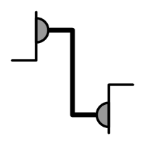

Figure Icon

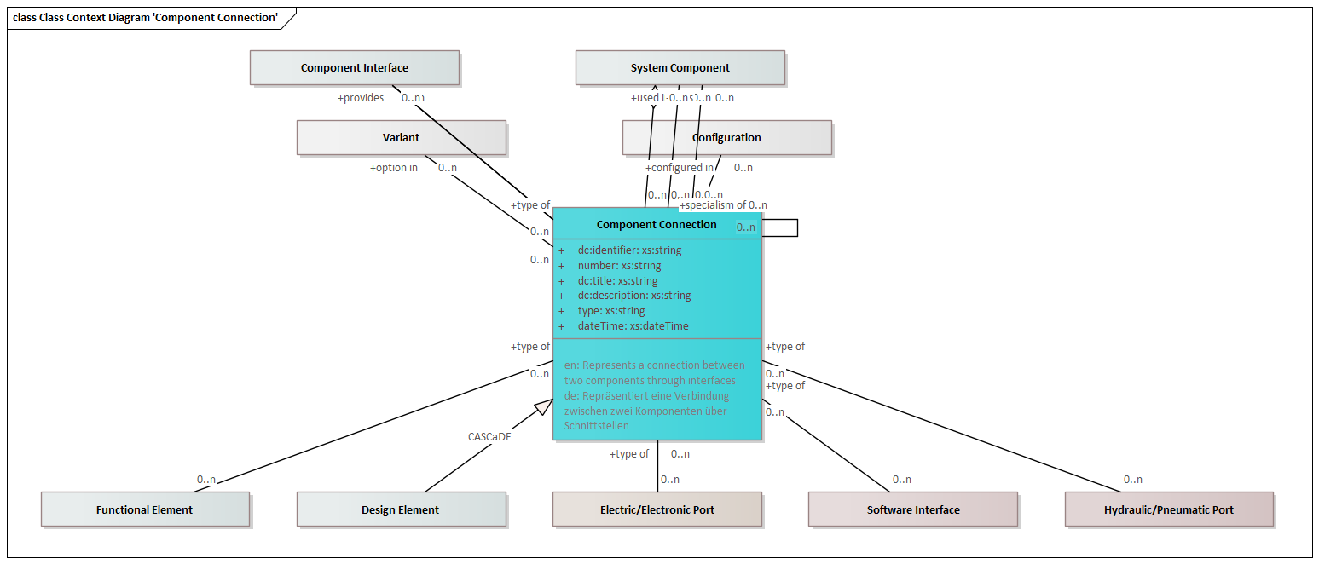

Figure Class Context Diagram 'Component Connection'

|  |  |
| --- | --- |
| **Specializations** | Kinematic Joint  Joining Element  Electric/Electronic Connection  Hydraulic/Pneumatic Connection |
| **Delivered by** | Systems Architecture  Functional Safety  Collaborative Architecture Design Co-Development |
| **Delivered to** | Functional Safety  Mechanical Design  Electrical/Electronical Design  Software Engineering  Design product line  Design product asset instance  Definition product asset instance configurability space  Long-Term Archiving |

Attributes

|  |  |  |
| --- | --- | --- |
| Identifier | xs:string | Unambiguous identifier of the element |
| Number | xs:string | Legible number or name of the element, i. e. part number |
| Title | xs:string | Title of the element |
| Description | xs:string | Description of the element |
| Type | xs:string | Type of an element |
| DateTime | xs:dateTime | Date and time of the element |

Outbound Relations

|  |  |  |
| --- | --- | --- |
| part of | System Component | Parent system component |
| used in | System Component | Context system component of the usage |
| specialism of | Component Connection | More generic item |
| configured in | Configuration | Relation to a configuration |
| option in | Variant | Relation to a variant |
| joins | System Component | Represents the system components joined by this component connection. |
| provides | Component Interface |  |

Inbound Relations

|  |  |  |
| --- | --- | --- |
| Component Interface | type of |  |
|  |  | More generic item |
| Electric/Electronic Port | type of |  |
| Software Interface | type of |  |
| Hydraulic/Pneumatic Port | type of |  |

##### Component State

Represents the condition of a system component. Can be it a value, a condition, an information storage or a physical shape.

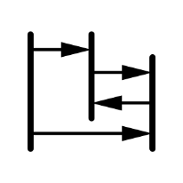

Figure Icon

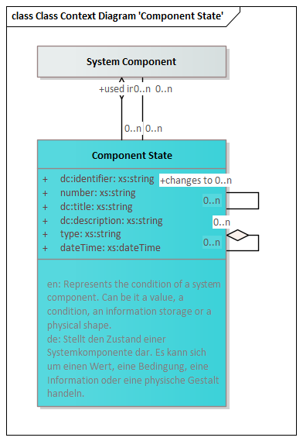

Figure Class Context Diagram 'Component State'

|  |  |
| --- | --- |
| **Delivered by** | Systems Architecture  Functional Safety  Collaborative Architecture Design Co-Development |
| **Delivered to** | Functional Safety  Mechanical Design  Electrical/Electronical Design  Software Engineering  Design product line  Design product asset instance  Definition product asset instance configurability space  Long-Term Archiving |

Attributes

|  |  |  |
| --- | --- | --- |
| Identifier | xs:string | Unambiguous identifier of the element |
| Number | xs:string | Legible number or name of the element, i. e. part number |
| Title | xs:string | Title of the element |
| Description | xs:string | Description of the element |
| Type | xs:string | Type of an element |
| DateTime | xs:dateTime | Date and time of the element |

Outbound Relations

|  |  |  |
| --- | --- | --- |
| part of | Component State | Parent element |
| part of | System Component | Parent system component |
| used in | System Component | Context system component of the usage |
| changes to | Component State | Target state that is reached starting from an initial state |

Inbound Relations

|  |  |  |
| --- | --- | --- |
|  |  | Parent element |
|  |  | Target state that is reached starting from an initial state |

#### Mechanical Design

Includes all entities relevant to mechanical design



Figure Icon

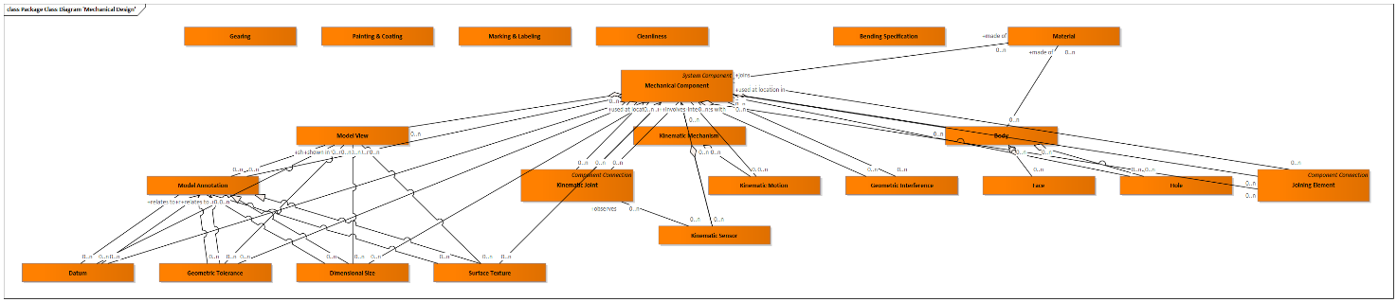

Figure Package Class Diagram 'Mechanical Design'

##### Mechanical Component

Represents a single mechanical part, an assembly or the entire product

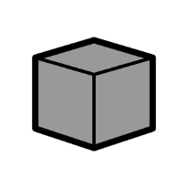

Figure Icon

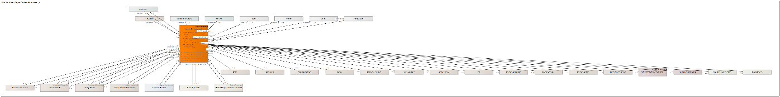

Figure Class Context Diagram 'Mechanical Component'

|  |  |
| --- | --- |
| **Generalizations** | System Component |
| **Specializations** | Verification Resource  Manufacturing Equipment Component |
| **Delivered by** | Mechanical Design |
| **Delivered to** | Define Joining Elements  Electrical/Electronical Design  Software Engineering  Electrical/Mechanical Design Collaboration  Plan and prepare Simulation  Perform and document Simulation  Prepare Testing  Perform and document Testing  Process Planning  Inspection Planning  Cost Calculation  Plant Layout  Tools & Equipment Design  Parts Manufacturing  Product Assembly  Quality Inspection  Packaging & Logistics  Product Usage  Maintenance & Service  Disassembly & Recycling  Procurement  Long-Term Archiving |

Attributes

|  |  |  |
| --- | --- | --- |
| Identifier | xs:string | Unambiguous identifier of the element |
| Number | xs:string | Legible number or name of the element, i. e. part number |
| Title | xs:string | Title of the element |
| Description | xs:string | Description of the element |
| Type | xs:string | Type of an element |
| DateTime | xs:dateTime | Date and time of the element |
| Mass | dim:Mass | Mass of the mechanical component |
| Revision | xs:string | Revisionskennung des Elements |

Outbound Relations

|  |  |  |
| --- | --- | --- |
| part of | Mechanical Component | Parent element |
| used in | Mechanical Component | Context element of the usage |
| used at location in | Mechanical Component | Context element of a located usage |
| specialism of | Mechanical Component | More generic item |
| configured in | Configuration | Relation to a configuration |
| option in | Variant | Relation to a variant |
| changed in | Change | Relation to a change |
| owned by | Actor | Actor owning this element |
| implements | Function | Product function implemented by the component |
| satisfies | Requirement | Requirement satisfied by this system component |
| fulfils | Requirement | Requirement implemented by the component. According to systems engineering best-practice, a requirement should first be answered by a function, and the function will be implemented by a component. This direct relation should therefore only be used if no functions have been defined. |
| provides | Component Interface |  |
| made of | Material | Material assigned to the mechanical component |

Inbound Relations

|  |  |  |
| --- | --- | --- |
|  |  | Parent element |
|  |  | Context element of the usage |
|  |  | Context element of a located usage |
|  |  | More generic item |
| Body | part of | Parent mechanical component |
| Geometric Interference | part of | Parent mechanical component |
| Geometric Interference | interferes with | Mechanical component instance this interference relates to |
| Model View | part of | Parent mechanical component |
| Model Annotation | part of | Parent mechanical component |
| Datum | part of | Parent mechanical component |
| Geometric Tolerance | part of | Parent mechanical component |
| Dimensional Size | part of | Parent mechanical component |
| Surface Texture | part of | Parent mechanical component |
| Hole | used at location in | Context element of a located usage |
| Kinematic Mechanism | part of | Parent mechanical component |
| Kinematic Joint | part of | Parent mechanical component |
| Kinematic Joint | used at location in | Context element of a located usage |
| Kinematic Joint | joins | Represents the system components joined by this component connection. |
| Kinematic Sensor | used at location in | Context element of a located usage |
| Kinematic Motion | involves | Components involved by the kinematic motion |
| Joining Element | part of | Parent mechanical component |
| Joining Element | used at location in | Context element of a located usage |
| Joining Element | joins | Represents the system components joined by this component connection. |
| Electric/Electronic Component | relates to | Mechanical component this electric/electronic component relates to |
| Electric/Electronic Component | used at location in | Context element of a located usage |
| Electric/Electronic Port | used at location in | Context element of a located usage |
| Hydraulic/Pneumatic Connection | joins | Represents the system components joined by this component connection. |
| Hydraulic/Pneumatic Port | used at location in | Context element of a located usage |
| Verification Resource | used at location in | Context element of a located usage |
| Manufacturing Operation | applies to | Mechanical or electrical component this manufacturing operation applies to |
| Assembly Operation | applies to | Mechanical or electrical component this manufacturing operation applies to |
| Assembly Operation | adds | Mechanical or electrical components added by this manufacturing operation |
| Heat Treatment | applies to | Mechanical or electrical component this manufacturing operation applies to |
| Joining Process | applies to | Mechanical or electrical component this manufacturing operation applies to |
| Manufacturing Equipment Component | used at location in | Context element of a located usage |

##### Body

Geometric representation of the component



Figure Icon

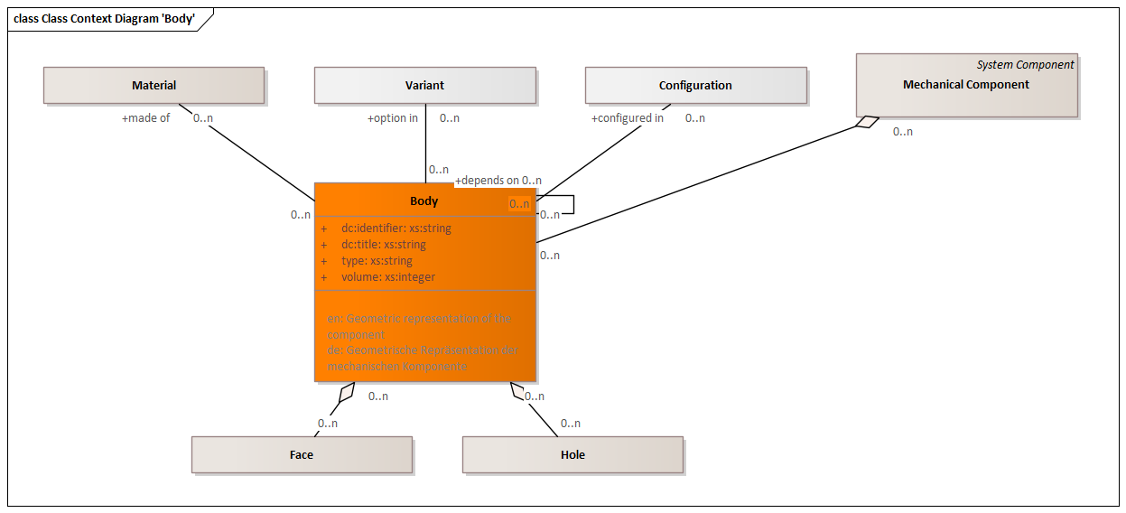

Figure Class Context Diagram 'Body'

|  |  |
| --- | --- |
| **Delivered by** | Mechanical Design |
| **Delivered to** | Electrical/Electronical Design  Software Engineering  Electrical/Mechanical Design Collaboration  Plan and prepare Simulation  Perform and document Simulation  Prepare Testing  Process Planning  Inspection Planning  Cost Calculation  Plant Layout  Tools & Equipment Design  Parts Manufacturing  Product Assembly  Quality Inspection  Packaging & Logistics  Maintenance & Service  Disassembly & Recycling  Procurement  Long-Term Archiving |

Attributes

|  |  |  |
| --- | --- | --- |
| Identifier | xs:string | Unambiguous identifier of the element |
| Title | xs:string | Title of the element |
| Type | xs:string | Type of an element |
| Volume | xs:integer | Geometric volumen of the element |

Outbound Relations

|  |  |  |
| --- | --- | --- |
| part of | Mechanical Component | Parent mechanical component |
| depends on | Body | Body this body depends on |
| configured in | Configuration | Relation to a configuration |
| option in | Variant | Relation to a variant |
| made of | Material | Material assigned to the mechanical component |

Inbound Relations

|  |  |  |
| --- | --- | --- |
|  |  | Body this body depends on |
| Face | part of | Parent body |
| Hole | part of | Parent body |

##### Face

Face on the geometric representation of the component



Figure Icon

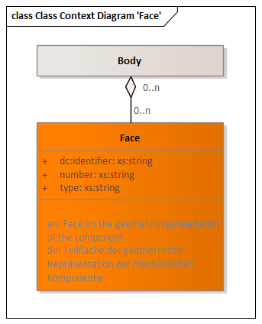

Figure Class Context Diagram 'Face'

|  |  |
| --- | --- |
| **Delivered to** | Define Joining Elements |

Attributes

|  |  |  |
| --- | --- | --- |
| Identifier | xs:string | Unambiguous identifier of the element |
| Number | xs:string | Legible number or name of the element, i. e. part number |
| Type | xs:string | Type of an element |

Outbound Relations

|  |  |  |
| --- | --- | --- |
| part of | Body | Parent body |

##### Geometric Interference

Interference (proximity, contact or clash) between two component instances

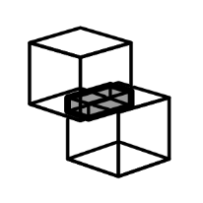

Figure Icon

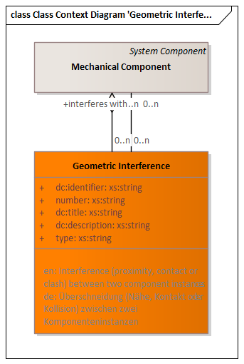

Figure Class Context Diagram 'Geometric Interference'

|  |  |
| --- | --- |
| **Delivered by** | Mechanical Design |
| **Delivered to** | Plan and prepare Simulation |

Attributes

|  |  |  |
| --- | --- | --- |
| Identifier | xs:string | Unambiguous identifier of the element |
| Number | xs:string | Legible number or name of the element, i. e. part number |
| Title | xs:string | Title of the element |
| Description | xs:string | Description of the element |
| Type | xs:string | Type of an element |

Outbound Relations

|  |  |  |
| --- | --- | --- |
| part of | Mechanical Component | Parent mechanical component |
| interferes with | Mechanical Component | Mechanical component instance this interference relates to |

##### Material

Material assigned to the mechanical component

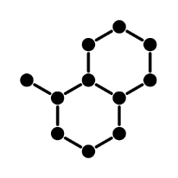

Figure Icon

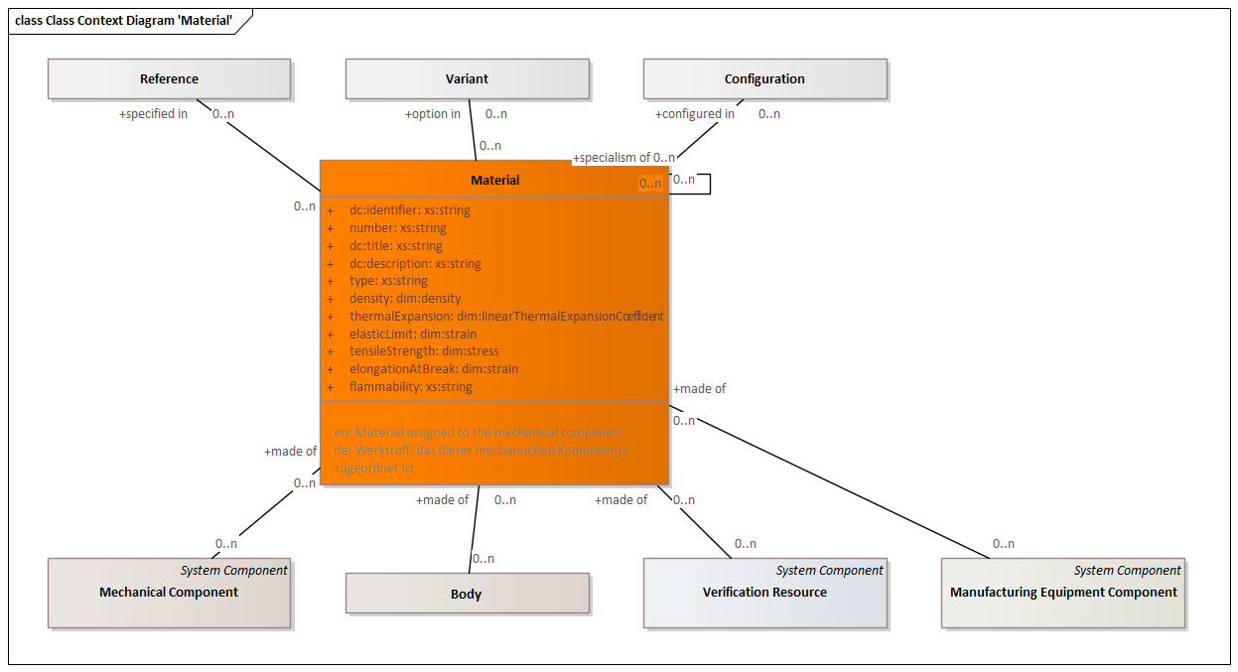

Figure Class Context Diagram 'Material'

|  |  |
| --- | --- |
| **Delivered by** | Mechanical Design |
| **Delivered to** | Define Joining Elements  Plan and prepare Simulation  Perform and document Simulation  Prepare Testing  Perform and document Testing  Process Planning  Inspection Planning  Cost Calculation  Tools & Equipment Design  Parts Manufacturing  Product Assembly  Packaging & Logistics  Product Usage  Maintenance & Service  Disassembly & Recycling  Procurement  Long-Term Archiving |

Attributes

|  |  |  |
| --- | --- | --- |
| Identifier | xs:string | Unambiguous identifier of the element |
| Number | xs:string | Legible number or name of the element, i. e. part number |
| Title | xs:string | Title of the element |
| Description | xs:string | Description of the element |
| Type | xs:string | Type of an element |
| Density | dim:Density | Specific density of the material |
| Thermal Expansion | dim:Linear Thermal Expansion Coefficient | Thermal expansion of the material |
| Elastic Limit | dim:Strain | Elastic limit of the material |
| Tensile Strength | dim:Stress | Tensile strength of the material |
| Elongation at Break | dim:Strain | Elongation of the material at break |
| Flammability | xs:string | Flammability of the material |

Outbound Relations

|  |  |  |
| --- | --- | --- |
| specialism of | Material | More generic item |
| configured in | Configuration | Relation to a configuration |
| option in | Variant | Relation to a variant |
| specified in | Reference | Relation to a variant |

Inbound Relations

|  |  |  |
| --- | --- | --- |
| Mechanical Component | made of | Material assigned to the mechanical component |
| Body | made of | Material assigned to the mechanical component |
|  |  | More generic item |
| Verification Resource | made of | Material assigned to the mechanical component |
| Manufacturing Equipment Component | made of | Material assigned to the mechanical component |

##### Model View

Represents a view of product geometry, including the definition of the viewpoint, and the visibility of components and annotations

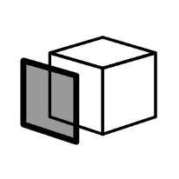

Figure Icon

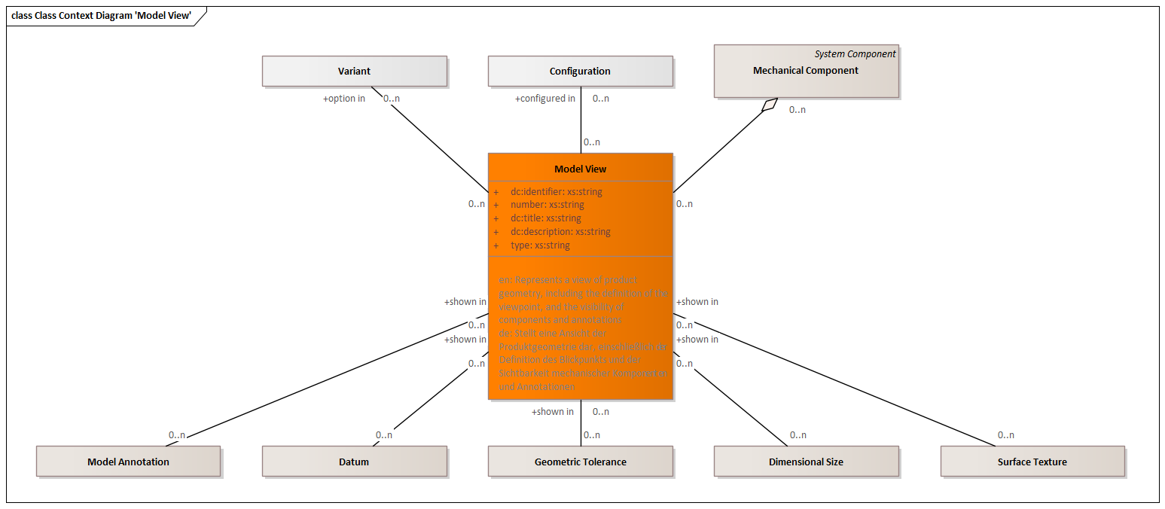

Figure Class Context Diagram 'Model View'

|  |  |
| --- | --- |
| **Delivered by** | Mechanical Design |
| **Delivered to** | Process Planning  Inspection Planning  Cost Calculation  Plant Layout  Tools & Equipment Design  Parts Manufacturing  Product Assembly |

Attributes

|  |  |  |
| --- | --- | --- |
| Identifier | xs:string | Unambiguous identifier of the element |
| Number | xs:string | Legible number or name of the element, i. e. part number |
| Title | xs:string | Title of the element |
| Description | xs:string | Description of the element |
| Type | xs:string | Type of an element |

Outbound Relations

|  |  |  |
| --- | --- | --- |
| part of | Mechanical Component | Parent mechanical component |
| configured in | Configuration | Relation to a configuration |
| option in | Variant | Relation to a variant |

Inbound Relations

|  |  |  |
| --- | --- | --- |
| Model Annotation | shown in | Parent model view |
| Datum | shown in | Parent model view |
| Geometric Tolerance | shown in | Parent model view |
| Dimensional Size | shown in | Parent model view |
| Surface Texture | shown in | Parent model view |

##### Model Annotation

A text annotation, dimension, tolerance, surface specification, etc. with relation to product geometry

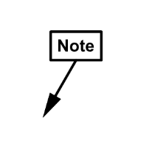

Figure Icon

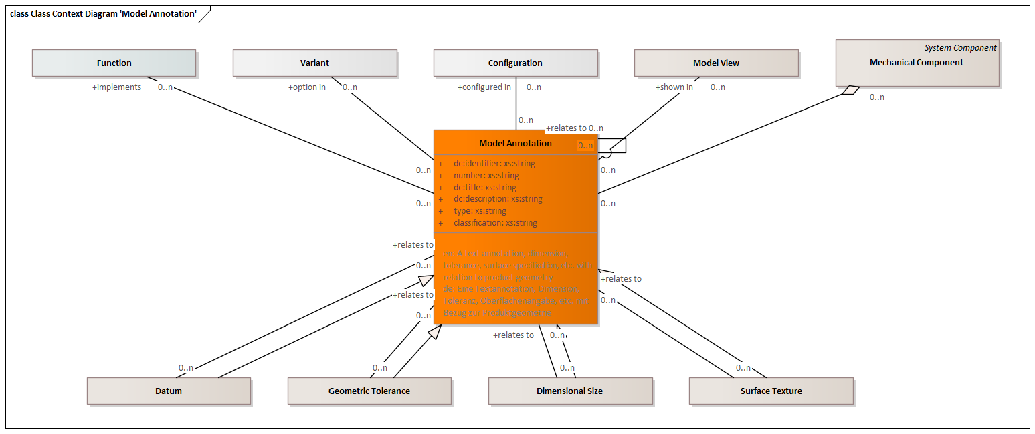

Figure Class Context Diagram 'Model Annotation'

|  |  |
| --- | --- |
| **Specializations** | Datum  Geometric Tolerance  Dimensional Size  Surface Texture |
| **Delivered by** | Mechanical Design |
| **Delivered to** | Long-Term Archiving |

Attributes

|  |  |  |
| --- | --- | --- |
| Identifier | xs:string | Unambiguous identifier of the element |
| Number | xs:string | Legible number or name of the element, i. e. part number |
| Title | xs:string | Title of the element |
| Description | xs:string | Description of the element |
| Type | xs:string | Type of an element |
| Classification | xs:string | Classification of the annotation |

Outbound Relations

|  |  |  |
| --- | --- | --- |
| part of | Mechanical Component | Parent mechanical component |
| shown in | Model View | Parent model view |
| configured in | Configuration | Relation to a configuration |
| option in | Variant | Relation to a variant |
| implements | Function | Product function implemented by the model annotation |
| relates to | Model Annotation | Related annotations, i. e. datums |

Inbound Relations

|  |  |  |
| --- | --- | --- |
|  |  | Related annotations, i. e. datums |
| Datum | relates to | Related annotations, i. e. datums |
| Geometric Tolerance | relates to | Related annotations, i. e. datums |
| Dimensional Size | relates to | Related annotations, i. e. datums |
| Surface Texture | relates to | Related annotations, i. e. datums |

##### Datum

Represents a tolerancing datum or datum target

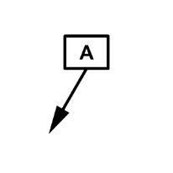

Figure Icon

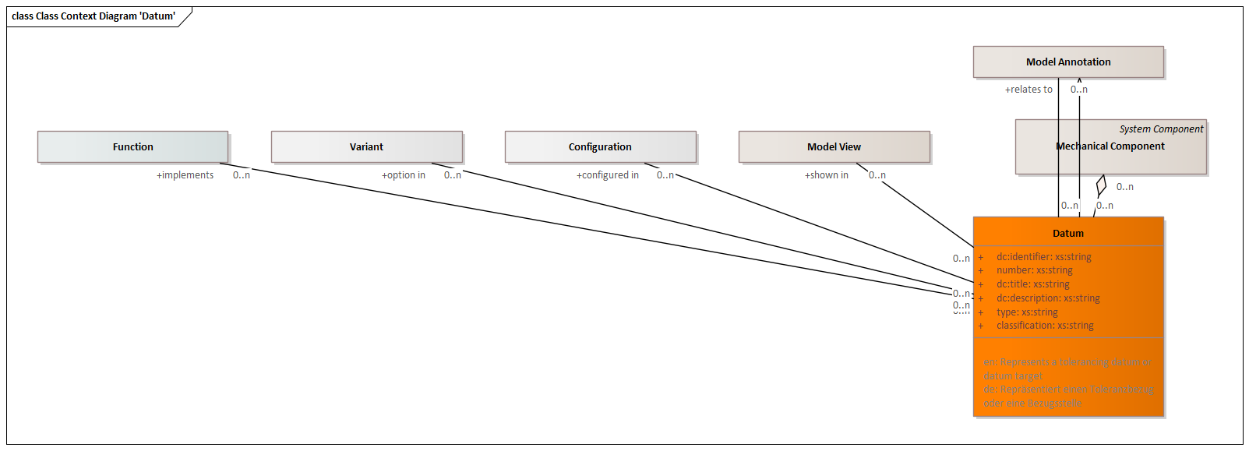

Figure Class Context Diagram 'Datum'

|  |  |
| --- | --- |
| **Generalizations** | Model Annotation |
| **Delivered to** | Plan and prepare Simulation  Prepare Testing  Process Planning  Inspection Planning  Cost Calculation  Plant Layout  Tools & Equipment Design  Parts Manufacturing  Product Assembly  Procurement |

Attributes

|  |  |  |
| --- | --- | --- |
| Identifier | xs:string | Unambiguous identifier of the element |
| Number | xs:string | Legible number or name of the element, i. e. part number |
| Title | xs:string | Title of the element |
| Description | xs:string | Description of the element |
| Type | xs:string | Type of an element |
| Classification | xs:string | Classification of the annotation |

Outbound Relations

|  |  |  |
| --- | --- | --- |
| part of | Mechanical Component | Parent mechanical component |
| shown in | Model View | Parent model view |
| configured in | Configuration | Relation to a configuration |
| option in | Variant | Relation to a variant |
| implements | Function | Product function implemented by the model annotation |
| relates to | Model Annotation | Related annotations, i. e. datums |

##### Geometric Tolerance

Represents a geometric tolerance, such as form, position, orientation, or runout

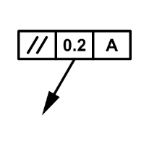

Figure Icon

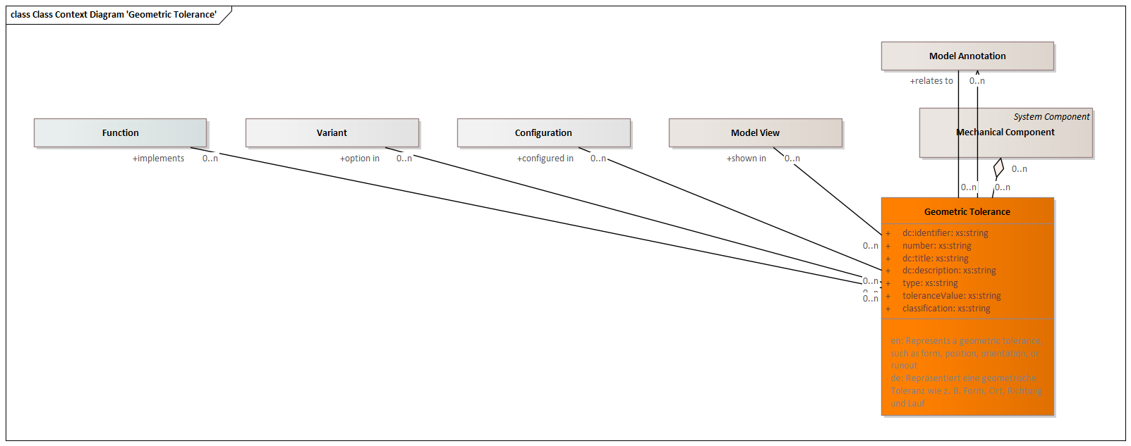

Figure Class Context Diagram 'Geometric Tolerance'

|  |  |
| --- | --- |
| **Generalizations** | Model Annotation |
| **Delivered to** | Plan and prepare Simulation  Prepare Testing  Process Planning  Inspection Planning  Cost Calculation  Plant Layout  Tools & Equipment Design  Parts Manufacturing  Product Assembly  Procurement |

Attributes

|  |  |  |
| --- | --- | --- |
| Identifier | xs:string | Unambiguous identifier of the element |
| Number | xs:string | Legible number or name of the element, i. e. part number |
| Title | xs:string | Title of the element |
| Description | xs:string | Description of the element |
| Type | xs:string | Type of an element |
| Tolerance Value | xs:string | Tolerance value of a geometric tolerance |
| Classification | xs:string | Classification of the annotation |

Outbound Relations

|  |  |  |
| --- | --- | --- |
| part of | Mechanical Component | Parent mechanical component |
| shown in | Model View | Parent model view |
| configured in | Configuration | Relation to a configuration |
| option in | Variant | Relation to a variant |
| implements | Function | Product function implemented by the model annotation |
| relates to | Model Annotation | Related annotations, i. e. datums |

##### Dimensional Size

Represents a size

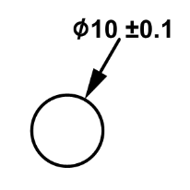

Figure Icon

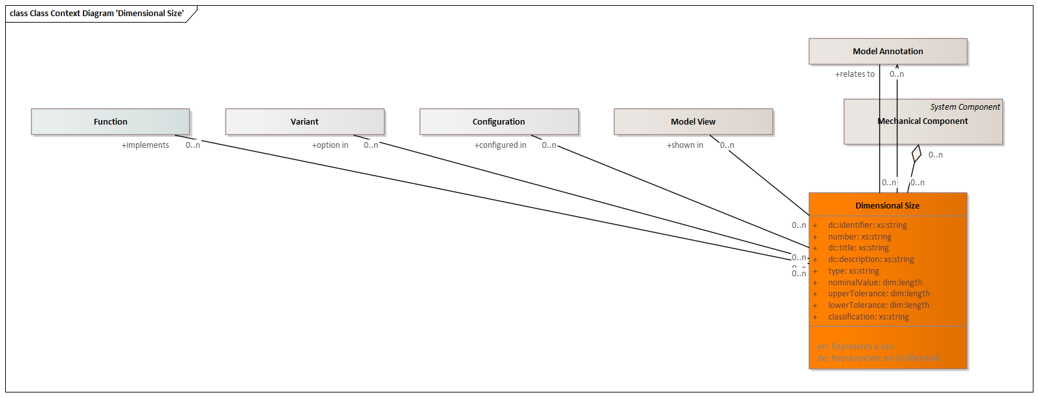

Figure Class Context Diagram 'Dimensional Size'

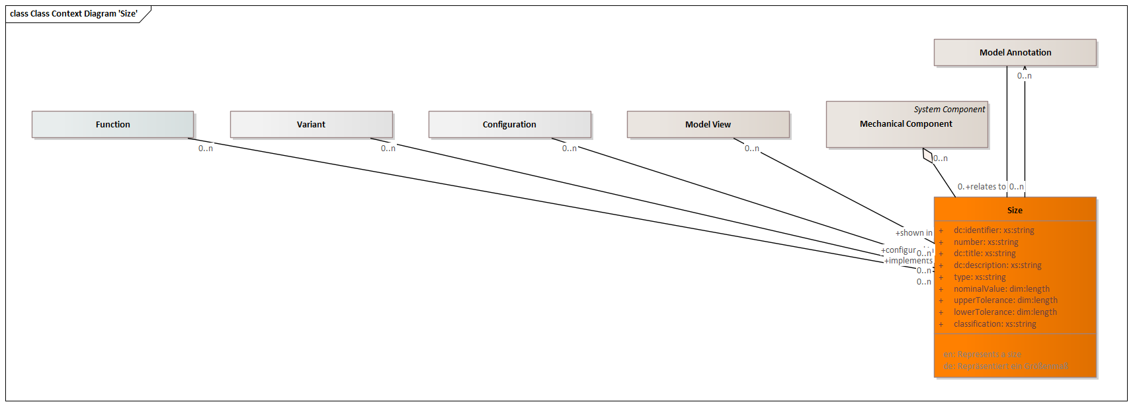

Figure Class Context Diagram 'Size'

|  |  |
| --- | --- |
| **Generalizations** | Model Annotation |
| **Delivered to** | Plan and prepare Simulation  Prepare Testing  Process Planning  Inspection Planning  Cost Calculation  Plant Layout  Tools & Equipment Design  Parts Manufacturing  Product Assembly  Procurement |

Attributes

|  |  |  |
| --- | --- | --- |
| Identifier | xs:string | Unambiguous identifier of the element |
| Number | xs:string | Legible number or name of the element, i. e. part number |
| Title | xs:string | Title of the element |
| Description | xs:string | Description of the element |
| Type | xs:string | Type of an element |
| Nominal Value | dim:Length | Nominal value of the annotation |
| Upper Tolerance | dim:Length | Upper tolerance of the annotation |
| Lower Tolerance | dim:Length | Lower tolerance of the annotation |
| Classification | xs:string | Classification of the annotation |

Outbound Relations

|  |  |  |
| --- | --- | --- |
| part of | Mechanical Component | Parent mechanical component |
| shown in | Model View | Parent model view |
| configured in | Configuration | Relation to a configuration |
| option in | Variant | Relation to a variant |
| implements | Function | Product function implemented by the model annotation |
| relates to | Model Annotation | Related annotations, i. e. datums |

##### Surface Texture

Represents surface texture such as roughness and waviness

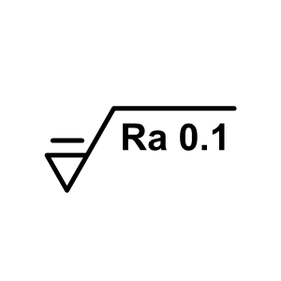

Figure Icon

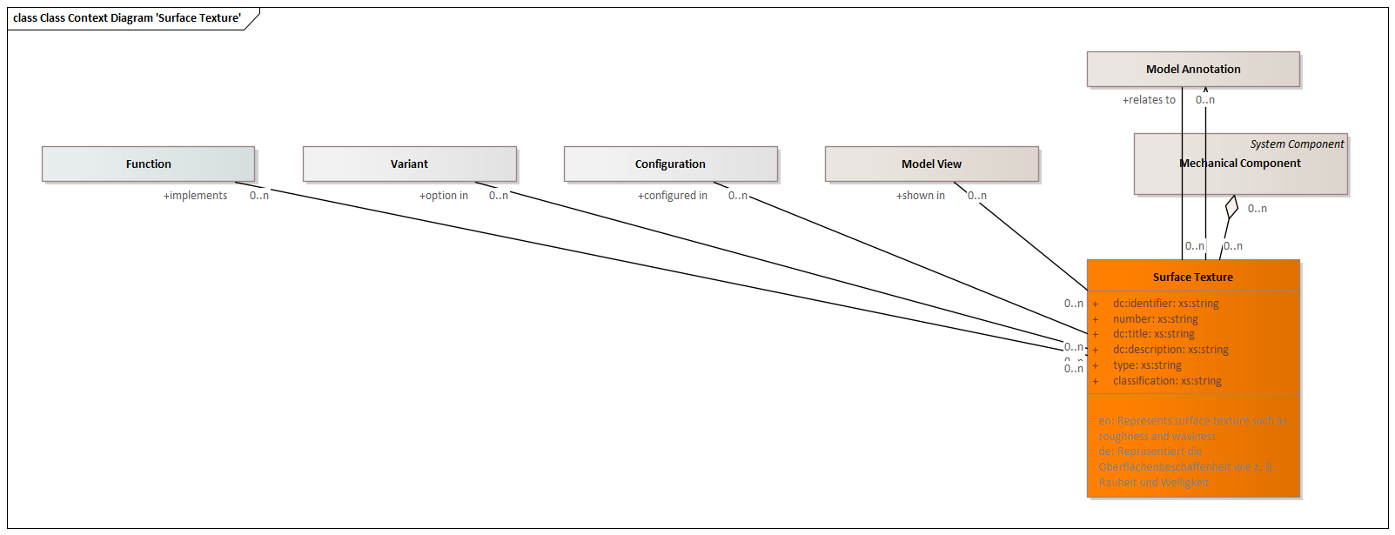

Figure Class Context Diagram 'Surface Texture'

|  |  |
| --- | --- |
| **Generalizations** | Model Annotation |
| **Delivered to** | Plan and prepare Simulation  Prepare Testing  Process Planning  Inspection Planning  Cost Calculation  Plant Layout  Tools & Equipment Design  Parts Manufacturing  Product Assembly  Procurement |

Attributes

|  |  |  |
| --- | --- | --- |
| Identifier | xs:string | Unambiguous identifier of the element |
| Number | xs:string | Legible number or name of the element, i. e. part number |
| Title | xs:string | Title of the element |
| Description | xs:string | Description of the element |
| Type | xs:string | Type of an element |
| Classification | xs:string | Classification of the annotation |

Outbound Relations

|  |  |  |
| --- | --- | --- |
| part of | Mechanical Component | Parent mechanical component |
| shown in | Model View | Parent model view |
| configured in | Configuration | Relation to a configuration |
| option in | Variant | Relation to a variant |
| implements | Function | Product function implemented by the model annotation |
| relates to | Model Annotation | Related annotations, i. e. datums |

##### Hole

A cylindrical or conical hole in a part, typically used as a mechanical interface to other mechanical components.

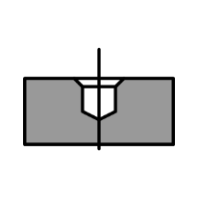

Figure Icon

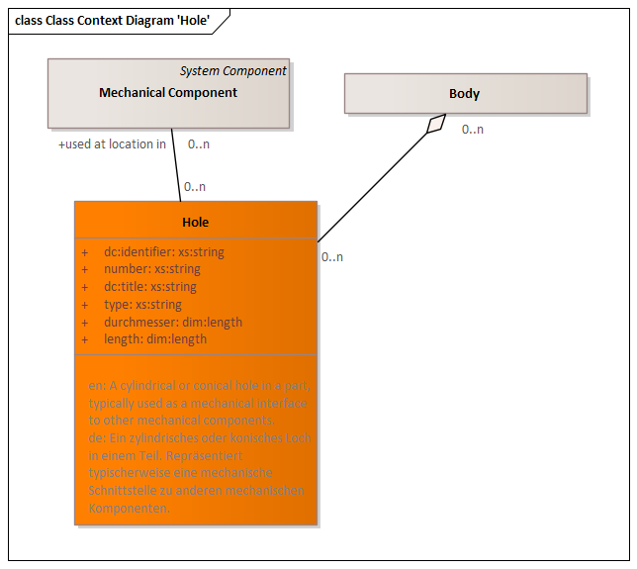

Figure Class Context Diagram 'Hole'

|  |  |
| --- | --- |
| **Delivered to** | Plan and prepare Simulation  Prepare Testing  Process Planning  Inspection Planning  Cost Calculation  Parts Manufacturing  Disassembly & Recycling  Procurement |

Attributes

|  |  |  |
| --- | --- | --- |
| Identifier | xs:string | Unambiguous identifier of the element |
| Number | xs:string | Legible number or name of the element, i. e. part number |
| Title | xs:string | Title of the element |
| Type | xs:string | Type of an element |
| Durchmesser | dim:Length |  |
| Length | dim:Length |  |

Outbound Relations

|  |  |  |
| --- | --- | --- |
| part of | Body | Parent body |
| used at location in | Mechanical Component | Context element of a located usage |

##### Gearing

Gearing specification

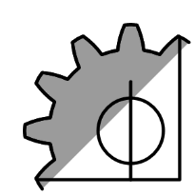

Figure Icon

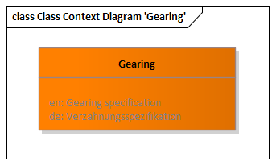

Figure Class Context Diagram 'Gearing'

|  |  |
| --- | --- |
| **Delivered to** | Plan and prepare Simulation  Prepare Testing  Process Planning  Inspection Planning  Cost Calculation  Parts Manufacturing  Procurement |

##### Kinematic Mechanism

Represents a kinematic mechanism

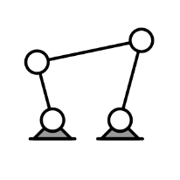

Figure Icon

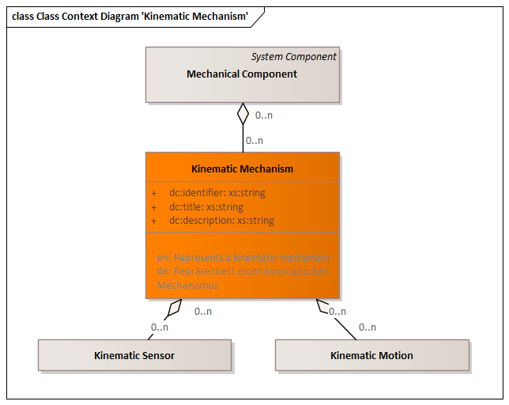

Figure Class Context Diagram 'Kinematic Mechanism'

|  |  |
| --- | --- |
| **Delivered by** | Mechanical Design |
| **Delivered to** | Plan and prepare Simulation  Prepare Testing  Process Planning  Inspection Planning  Cost Calculation  Product Assembly  Long-Term Archiving |

Attributes

|  |  |  |
| --- | --- | --- |
| Identifier | xs:string | Unambiguous identifier of the element |
| Title | xs:string | Title of the element |
| Description | xs:string | Description of the element |

Outbound Relations

|  |  |  |
| --- | --- | --- |
| part of | Mechanical Component | Parent mechanical component |

Inbound Relations

|  |  |  |
| --- | --- | --- |
| Kinematic Sensor | part of | Parent kinematic mechanism |
| Kinematic Motion | part of | Parent kinematic mechanism |

##### Kinematic Joint

Represents a kinematic joint between a pair of component instances

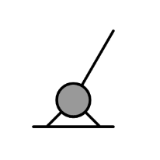

Figure Icon

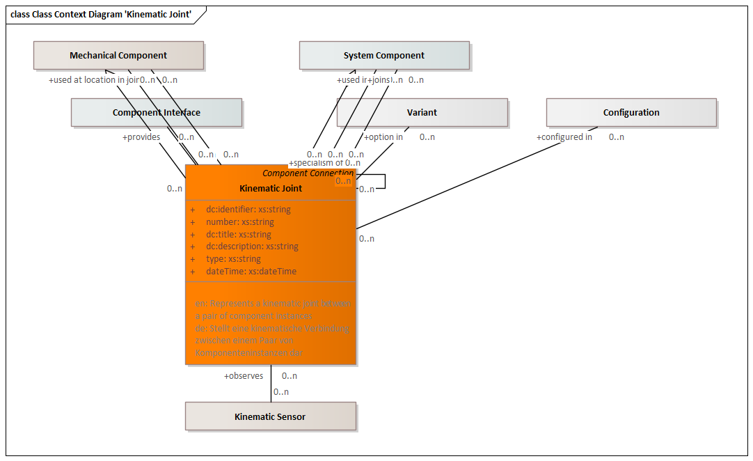

Figure Class Context Diagram 'Kinematic Joint'

|  |  |
| --- | --- |
| **Generalizations** | Component Connection |
| **Delivered by** | Mechanical Design |
| **Delivered to** | Plan and prepare Simulation  Prepare Testing  Process Planning  Inspection Planning  Cost Calculation  Product Assembly  Long-Term Archiving |

Attributes

|  |  |  |
| --- | --- | --- |
| Identifier | xs:string | Unambiguous identifier of the element |
| Number | xs:string | Legible number or name of the element, i. e. part number |
| Title | xs:string | Title of the element |
| Description | xs:string | Description of the element |
| Type | xs:string | Type of an element |
| DateTime | xs:dateTime | Date and time of the element |

Outbound Relations

|  |  |  |
| --- | --- | --- |
| part of | System Component | Parent system component |
| part of | Mechanical Component | Parent mechanical component |
| used in | System Component | Context system component of the usage |
| used at location in | Mechanical Component | Context element of a located usage |
| specialism of | Kinematic Joint | More generic item |
| configured in | Configuration | Relation to a configuration |
| option in | Variant | Relation to a variant |
| joins | System Component | Represents the system components joined by this component connection. |
| joins | Mechanical Component | Represents the system components joined by this component connection. |
| provides | Component Interface |  |

Inbound Relations

|  |  |  |
| --- | --- | --- |
|  |  | More generic item |
| Kinematic Sensor | observes | Kinematic joint observed by this kinematic sensor |

##### Kinematic Sensor

Represents a kinematic sensor

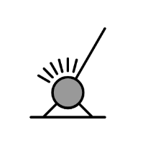

Figure Icon

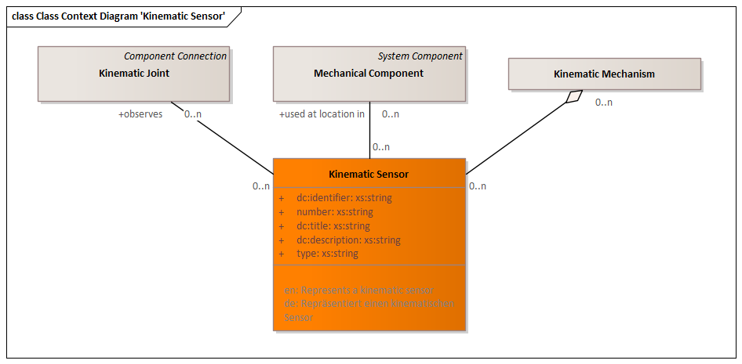

Figure Class Context Diagram 'Kinematic Sensor'

|  |  |
| --- | --- |
| **Delivered by** | Mechanical Design |
| **Delivered to** | Plan and prepare Simulation  Prepare Testing |

Attributes

|  |  |  |
| --- | --- | --- |
| Identifier | xs:string | Unambiguous identifier of the element |
| Number | xs:string | Legible number or name of the element, i. e. part number |
| Title | xs:string | Title of the element |
| Description | xs:string | Description of the element |
| Type | xs:string | Type of an element |

Outbound Relations

|  |  |  |
| --- | --- | --- |
| part of | Kinematic Mechanism | Parent kinematic mechanism |
| used at location in | Mechanical Component | Context element of a located usage |
| observes | Kinematic Joint | Kinematic joint observed by this kinematic sensor |

##### Kinematic Motion

Represents a kinematic motion

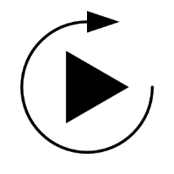

Figure Icon

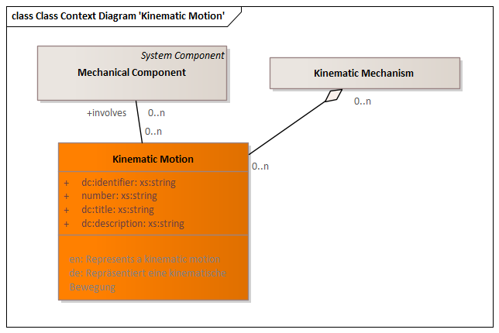

Figure Class Context Diagram 'Kinematic Motion'

|  |  |
| --- | --- |
| **Delivered by** | Mechanical Design |
| **Delivered to** | Plan and prepare Simulation  Prepare Testing |

Attributes

|  |  |  |
| --- | --- | --- |
| Identifier | xs:string | Unambiguous identifier of the element |
| Number | xs:string | Legible number or name of the element, i. e. part number |
| Title | xs:string | Title of the element |
| Description | xs:string | Description of the element |

Outbound Relations

|  |  |  |
| --- | --- | --- |
| part of | Kinematic Mechanism | Parent kinematic mechanism |
| involves | Mechanical Component | Components involved by the kinematic motion |

##### Joining Element

Represents a joining element such as a welding spot, a rivet, etc.

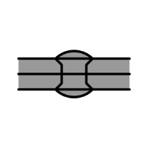

Figure Icon

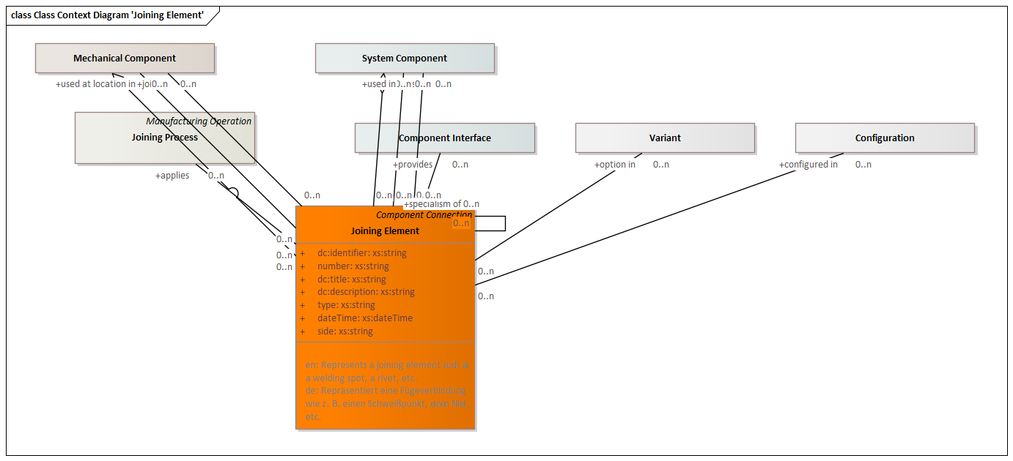

Figure Class Context Diagram 'Joining Element'

|  |  |
| --- | --- |
| **Generalizations** | Component Connection |
| **Delivered by** | Mechanical Design  Define Joining Elements |
| **Delivered to** | Plan and prepare Simulation  Prepare Testing  Process Planning  Inspection Planning  Cost Calculation  Tools & Equipment Design  Product Assembly  Quality Inspection  Packaging & Logistics  Maintenance & Service  Disassembly & Recycling  Procurement  Long-Term Archiving |

Attributes

|  |  |  |
| --- | --- | --- |
| Identifier | xs:string | Unambiguous identifier of the element |
| Number | xs:string | Legible number or name of the element, i. e. part number |
| Title | xs:string | Title of the element |
| Description | xs:string | Description of the element |
| Type | xs:string | Type of an element |
| DateTime | xs:dateTime | Date and time of the element |
| Side | xs:string | Side of the joining element |

Outbound Relations

|  |  |  |
| --- | --- | --- |
| part of | System Component | Parent system component |
| part of | Mechanical Component | Parent mechanical component |
| used in | System Component | Context system component of the usage |
| used at location in | Mechanical Component | Context element of a located usage |
| specialism of | Joining Element | More generic item |
| configured in | Configuration | Relation to a configuration |
| option in | Variant | Relation to a variant |
| joins | System Component | Represents the system components joined by this component connection. |
| joins | Mechanical Component | Represents the system components joined by this component connection. |
| provides | Component Interface |  |
| applies | Joining Process | Joining process used for this joining element |

Inbound Relations

|  |  |  |
| --- | --- | --- |
|  |  | More generic item |

##### Painting & Coating

Description of a painting or coating for this mechanical component

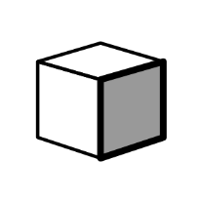

Figure Icon

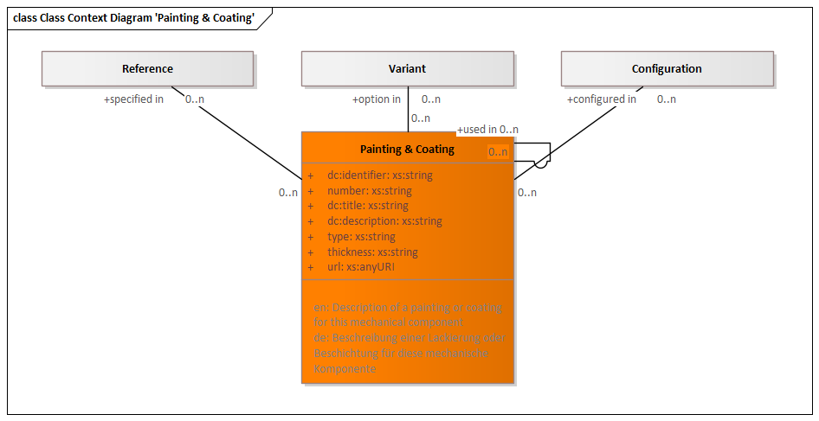

Figure Class Context Diagram 'Painting & Coating'

|  |  |
| --- | --- |
| **Delivered to** | Plan and prepare Simulation  Prepare Testing  Process Planning  Inspection Planning  Cost Calculation  Tools & Equipment Design  Parts Manufacturing  Disassembly & Recycling  Procurement |

Attributes

|  |  |  |
| --- | --- | --- |
| Identifier | xs:string | Unambiguous identifier of the element |
| Number | xs:string | Legible number or name of the element, i. e. part number |
| Title | xs:string | Title of the element |
| Description | xs:string | Description of the element |
| Type | xs:string | Type of an element |
| Thickness | xs:string | Thickness of the painting or coating |
| URL | xs:anyURI | Unique resource locator of an element |

Outbound Relations

|  |  |  |
| --- | --- | --- |
| used in | Painting & Coating | Context element of the usage |
| configured in | Configuration | Relation to a configuration |
| option in | Variant | Relation to a variant |
| specified in | Reference | Relation to a variant |

Inbound Relations

|  |  |  |
| --- | --- | --- |
|  |  | Context element of the usage |

##### Marking & Labeling

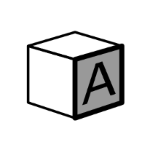

Figure Icon

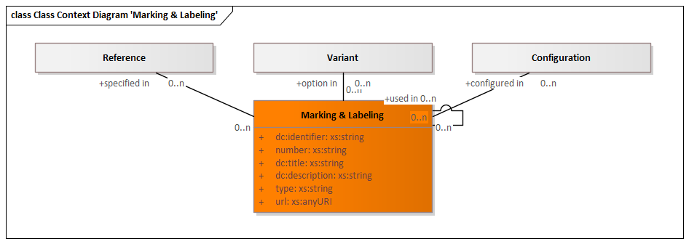

Figure Class Context Diagram 'Marking & Labeling'

|  |  |
| --- | --- |
| **Delivered to** | Plan and prepare Simulation  Prepare Testing  Process Planning  Inspection Planning  Cost Calculation  Tools & Equipment Design  Parts Manufacturing  Procurement |

Attributes

|  |  |  |
| --- | --- | --- |
| Identifier | xs:string | Unambiguous identifier of the element |
| Number | xs:string | Legible number or name of the element, i. e. part number |
| Title | xs:string | Title of the element |
| Description | xs:string | Description of the element |
| Type | xs:string | Type of an element |
| URL | xs:anyURI | Unique resource locator of an element |

Outbound Relations

|  |  |  |
| --- | --- | --- |
| used in | Marking & Labeling | Context element of the usage |
| configured in | Configuration | Relation to a configuration |
| option in | Variant | Relation to a variant |
| specified in | Reference | Relation to a variant |

Inbound Relations

|  |  |  |
| --- | --- | --- |
|  |  | Context element of the usage |

##### Heat Treatment Area

Heat treatment of a mechanical component

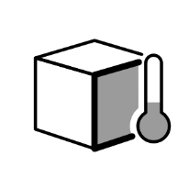

Figure Icon

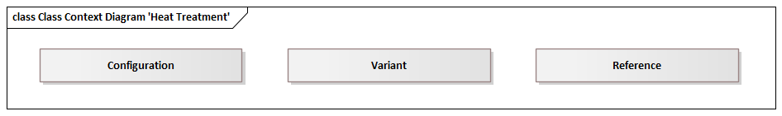

Figure Class Context Diagram 'Heat Treatment'

|  |  |
| --- | --- |
| **Delivered to** | Plan and prepare Simulation  Prepare Testing  Process Planning  Inspection Planning  Cost Calculation  Tools & Equipment Design  Parts Manufacturing  Procurement |

Attributes

|  |  |  |
| --- | --- | --- |
| Identifier | xs:string | Unambiguous identifier of the element |
| Number | xs:string | Legible number or name of the element, i. e. part number |
| Title | xs:string | Title of the element |
| Description | xs:string | Description of the element |
| Type | xs:string | Type of an element |
| URL | xs:anyURI | Unique resource locator of an element |
| Hardness | xs:string |  |

Outbound Relations

|  |  |  |
| --- | --- | --- |
| used in | Heat Treatment Area | Context element of the usage |
| configured in | Configuration | Relation to a configuration |
| option in | Variant | Relation to a variant |
| specified in | Reference | Relation to a variant |
| applies | Heat Treatment | Heat treatment operation used for this heat treatment specification |

Inbound Relations

|  |  |  |
| --- | --- | --- |
|  |  | Context element of the usage |

##### Cleanliness

Technical cleanliness of a mechanical component



Figure Icon

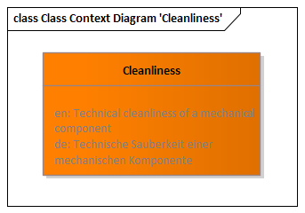

Figure Class Context Diagram 'Cleanliness'

|  |  |
| --- | --- |
| **Delivered to** | Plan and prepare Simulation  Prepare Testing  Process Planning  Inspection Planning  Cost Calculation  Tools & Equipment Design  Parts Manufacturing  Procurement |

##### Bending Specification

Represents a spatial bending specification that applies a bending angle around an axis.

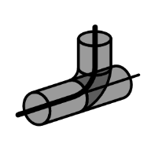

Figure Icon

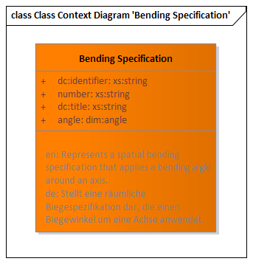

Figure Class Context Diagram 'Bending Specification'

|  |  |
| --- | --- |
| **Delivered to** | Plan and prepare Simulation  Prepare Testing  Process Planning  Inspection Planning  Cost Calculation  Tools & Equipment Design  Parts Manufacturing  Procurement |

Attributes

|  |  |  |
| --- | --- | --- |
| Identifier | xs:string | Unambiguous identifier of the element |
| Number | xs:string | Legible number or name of the element, i. e. part number |
| Title | xs:string | Title of the element |
| Angle | dim:Angle |  |

#### Electric/Electronic Design

Includes all entities relevant to electric/electronic design



Figure Icon

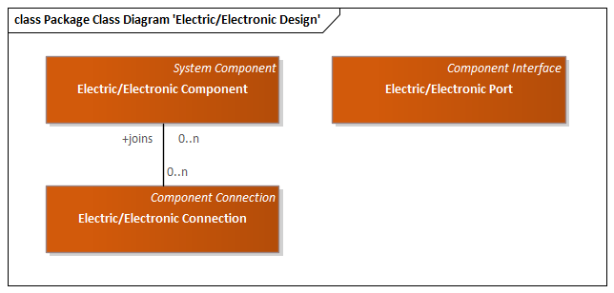

Figure Package Class Diagram 'Electric Electronic Design'

##### Electric/Electronic Component

Represents an electric/electronic component



Figure Icon

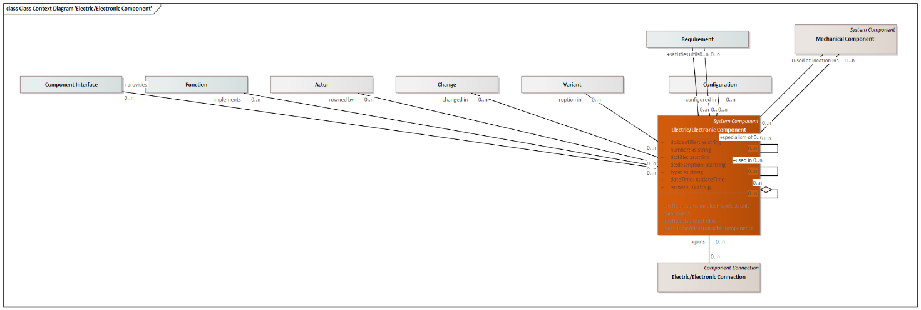

Figure Class Context Diagram 'Electric Electronic Component'

|  |  |
| --- | --- |
| **Generalizations** | System Component |
| **Delivered by** | Electrical/Electronical Design |
| **Delivered to** | Software Engineering  Electrical/Mechanical Design Collaboration  Plan and prepare Simulation  Prepare Testing  Process Planning  Inspection Planning  Cost Calculation  Plant Layout  Tools & Equipment Design  Product Usage  Maintenance & Service  Disassembly & Recycling  Procurement |

Attributes

|  |  |  |
| --- | --- | --- |
| Identifier | xs:string | Unambiguous identifier of the element |
| Number | xs:string | Legible number or name of the element, i. e. part number |
| Title | xs:string | Title of the element |
| Description | xs:string | Description of the element |
| Type | xs:string | Type of an element |
| DateTime | xs:dateTime | Date and time of the element |
| Revision | xs:string | Revisionskennung des Elements |

Outbound Relations

|  |  |  |
| --- | --- | --- |
| relates to | Mechanical Component | Mechanical component this electric/electronic component relates to |
| part of | Electric/Electronic Component | Parent element |
| used in | Electric/Electronic Component | Context element of the usage |
| used at location in | Mechanical Component | Context element of a located usage |
| specialism of | Electric/Electronic Component | More generic item |
| configured in | Configuration | Relation to a configuration |
| option in | Variant | Relation to a variant |
| changed in | Change | Relation to a change |
| owned by | Actor | Actor owning this element |
| implements | Function | Product function implemented by the component |
| satisfies | Requirement | Requirement satisfied by this system component |
| fulfils | Requirement | Requirement implemented by the component. According to systems engineering best-practice, a requirement should first be answered by a function, and the function will be implemented by a component. This direct relation should therefore only be used if no functions have been defined. |
| provides | Component Interface |  |

Inbound Relations

|  |  |  |
| --- | --- | --- |
|  |  | Parent element |
|  |  | Context element of the usage |
|  |  | More generic item |
| Electric/Electronic Connection | joins | Represents the system components joined by this component connection. |

##### Electric/Electronic Port

Represents an electric/electronic port on an electric/electronic component

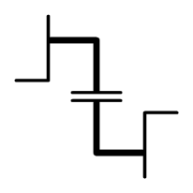

Figure Icon

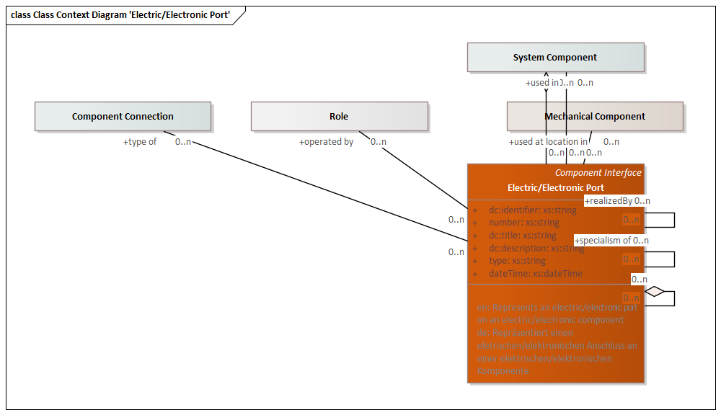

Figure Class Context Diagram 'Electric Electronic Port'

|  |  |
| --- | --- |
| **Generalizations** | Component Interface |
| **Delivered by** | Electrical/Electronical Design |
| **Delivered to** | Software Engineering  Electrical/Mechanical Design Collaboration  Plan and prepare Simulation  Prepare Testing  Process Planning  Inspection Planning  Cost Calculation  Plant Layout  Tools & Equipment Design  Product Usage  Maintenance & Service  Disassembly & Recycling  Procurement |

Attributes

|  |  |  |
| --- | --- | --- |
| Identifier | xs:string | Unambiguous identifier of the element |
| Number | xs:string | Legible number or name of the element, i. e. part number |
| Title | xs:string | Title of the element |
| Description | xs:string | Description of the element |
| Type | xs:string | Type of an element |
| DateTime | xs:dateTime | Date and time of the element |

Outbound Relations

|  |  |  |
| --- | --- | --- |
| part of | Electric/Electronic Port | Parent element |
| part of | System Component | Parent system component |
| used in | System Component | Context system component of the usage |
| used at location in | Mechanical Component | Context element of a located usage |
| specialism of | Electric/Electronic Port | More generic item |
| operated by | Role | Interacting role |
| type of | Component Connection |  |

Inbound Relations

|  |  |  |
| --- | --- | --- |
|  |  | Parent element |
|  |  | More generic item |

##### Electric/Electronic Connection

Represents an electric/electronic connection



Figure Icon

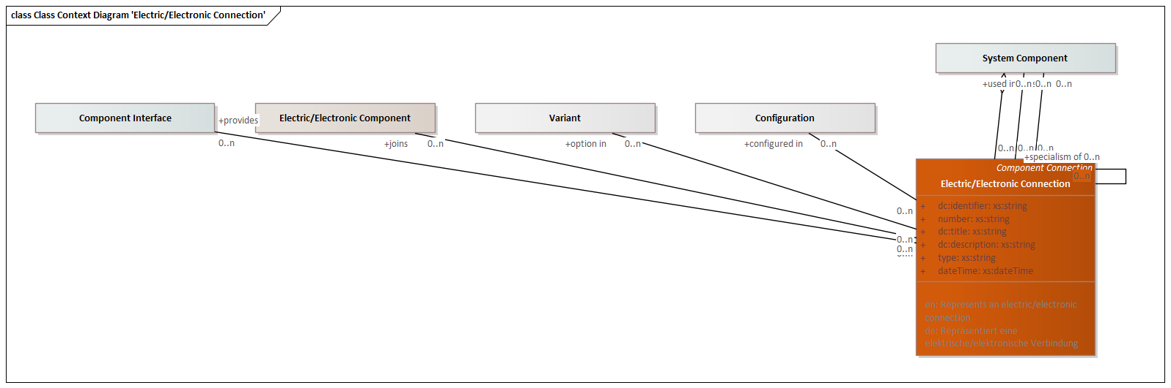

Figure Class Context Diagram 'Electric Electronic Connection'

|  |  |
| --- | --- |
| **Generalizations** | Component Connection |
| **Delivered by** | Electrical/Electronical Design |
| **Delivered to** | Software Engineering  Electrical/Mechanical Design Collaboration  Plan and prepare Simulation  Prepare Testing  Process Planning  Inspection Planning  Cost Calculation  Plant Layout  Tools & Equipment Design  Product Usage  Maintenance & Service  Disassembly & Recycling  Procurement |

Attributes

|  |  |  |
| --- | --- | --- |
| Identifier | xs:string | Unambiguous identifier of the element |
| Number | xs:string | Legible number or name of the element, i. e. part number |
| Title | xs:string | Title of the element |
| Description | xs:string | Description of the element |
| Type | xs:string | Type of an element |
| DateTime | xs:dateTime | Date and time of the element |

Outbound Relations

|  |  |  |
| --- | --- | --- |
| part of | System Component | Parent system component |
| used in | System Component | Context system component of the usage |
| specialism of | Electric/Electronic Connection | More generic item |
| configured in | Configuration | Relation to a configuration |
| option in | Variant | Relation to a variant |
| joins | System Component | Represents the system components joined by this component connection. |
| joins | Electric/Electronic Component | Represents the system components joined by this component connection. |
| provides | Component Interface |  |

Inbound Relations

|  |  |  |
| --- | --- | --- |
|  |  | More generic item |

#### Software Design

Includes all entities relevant to software design



Figure Icon

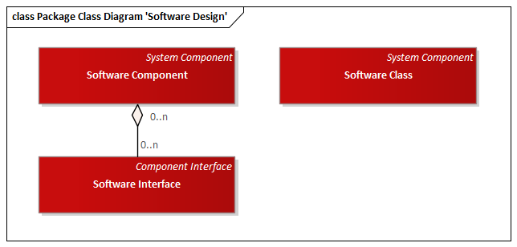

Figure Package Class Diagram 'Software Design'

##### Software Class

A class in source code that represents a logical collection data and functions



Figure Icon

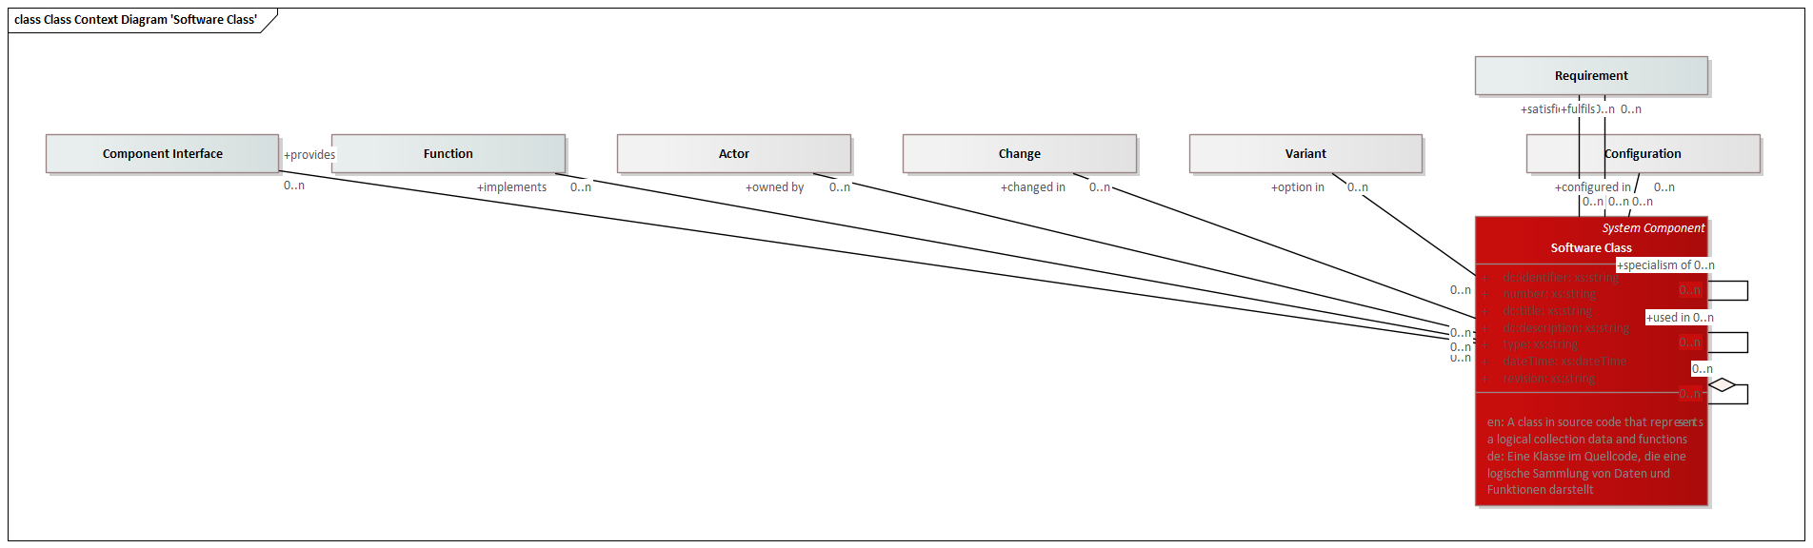

Figure Class Context Diagram 'Software Class'

|  |  |
| --- | --- |
| **Generalizations** | System Component |
| **Delivered by** | Software Engineering |
| **Delivered to** | Plan and prepare Simulation  Prepare Testing  Maintenance & Service |

Attributes

|  |  |  |
| --- | --- | --- |
| Identifier | xs:string | Unambiguous identifier of the element |
| Number | xs:string | Legible number or name of the element, i. e. part number |
| Title | xs:string | Title of the element |
| Description | xs:string | Description of the element |
| Type | xs:string | Type of an element |
| DateTime | xs:dateTime | Date and time of the element |
| Revision | xs:string | Revisionskennung des Elements |

Outbound Relations

|  |  |  |
| --- | --- | --- |
| part of | Software Class | Parent element |
| used in | Software Class | Context element of the usage |
| specialism of | Software Class | More generic item |
| configured in | Configuration | Relation to a configuration |
| option in | Variant | Relation to a variant |
| changed in | Change | Relation to a change |
| owned by | Actor | Actor owning this element |
| implements | Function | Product function implemented by the component |
| satisfies | Requirement | Requirement satisfied by this system component |
| fulfils | Requirement | Requirement implemented by the component. According to systems engineering best-practice, a requirement should first be answered by a function, and the function will be implemented by a component. This direct relation should therefore only be used if no functions have been defined. |
| provides | Component Interface |  |

Inbound Relations

|  |  |  |
| --- | --- | --- |
|  |  | Parent element |
|  |  | Context element of the usage |
|  |  | More generic item |

##### Software Interface

An interface in source code that allows a class to interact with other components of a software



Figure Icon

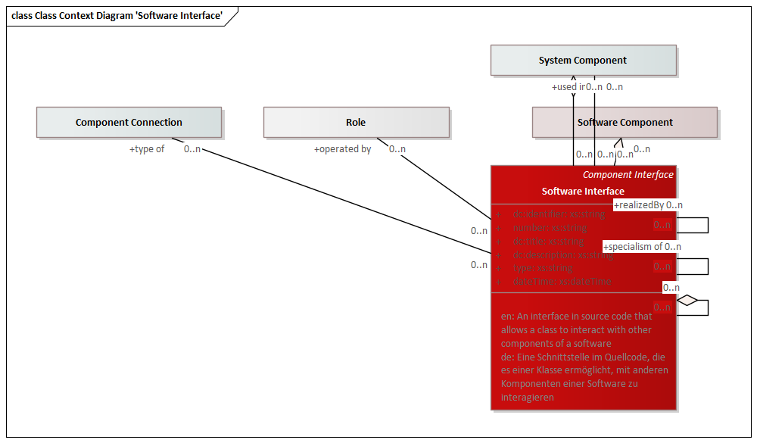

Figure Class Context Diagram 'Software Interface'

|  |  |
| --- | --- |
| **Generalizations** | Component Interface |
| **Delivered by** | Software Engineering |
| **Delivered to** | Plan and prepare Simulation  Prepare Testing  Product Usage  Maintenance & Service |

Attributes

|  |  |  |
| --- | --- | --- |
| Identifier | xs:string | Unambiguous identifier of the element |
| Number | xs:string | Legible number or name of the element, i. e. part number |
| Title | xs:string | Title of the element |
| Description | xs:string | Description of the element |
| Type | xs:string | Type of an element |
| DateTime | xs:dateTime | Date and time of the element |

Outbound Relations

|  |  |  |
| --- | --- | --- |
| part of | Software Interface | Parent element |
| part of | System Component | Parent system component |
| part of | Software Component | Parent software component |
| used in | System Component | Context system component of the usage |
| specialism of | Software Interface | More generic item |
| operated by | Role | Interacting role |
| type of | Component Connection |  |

Inbound Relations

|  |  |  |
| --- | --- | --- |
|  |  | Parent element |
|  |  | More generic item |

##### Software Component

A compiled component of software to be used in a product, i. e. executable or library



Figure Icon

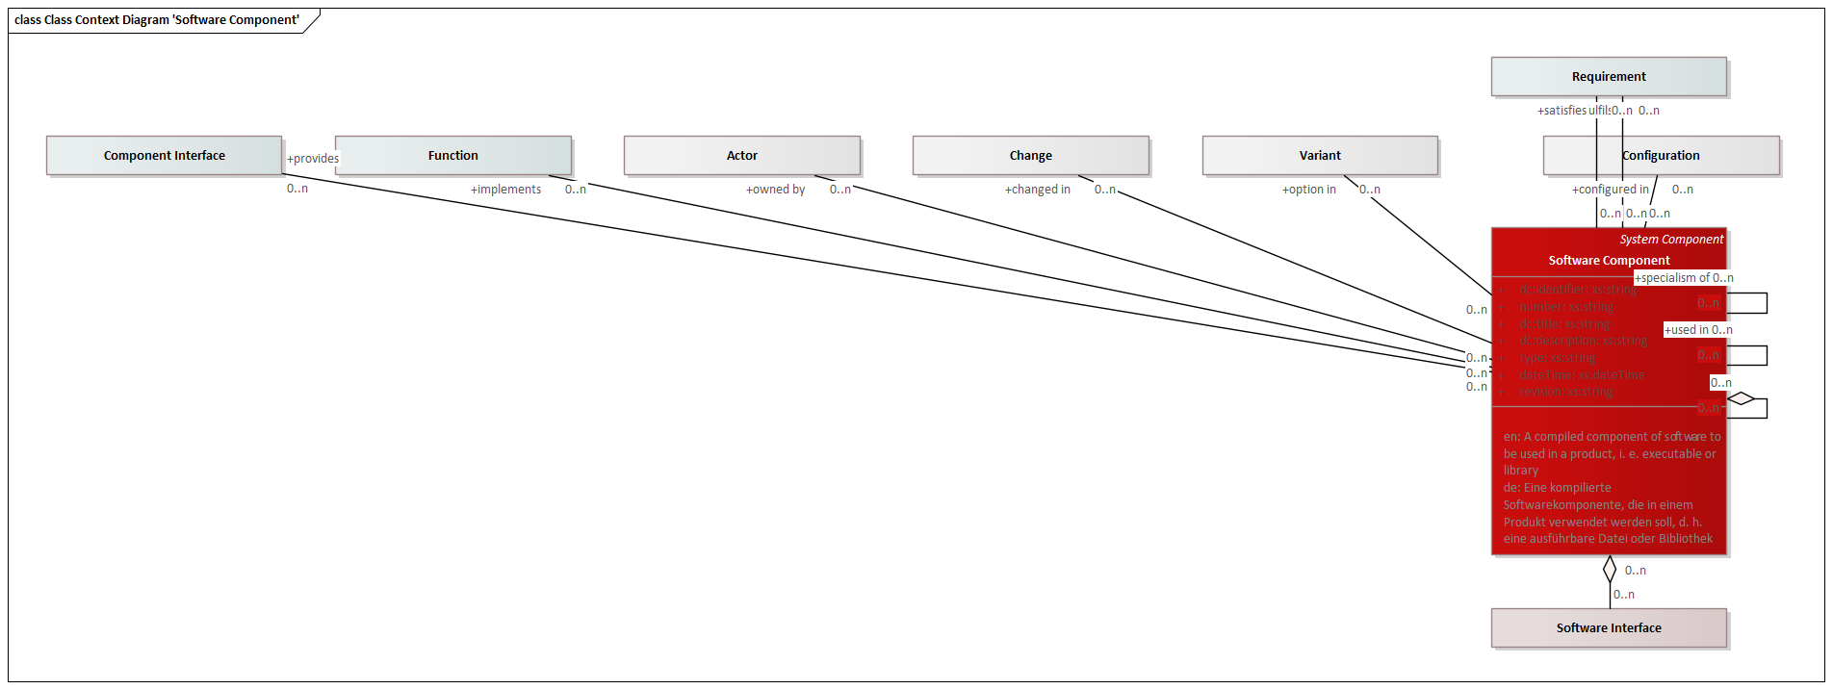

Figure Class Context Diagram 'Software Component'

|  |  |
| --- | --- |
| **Generalizations** | System Component |
| **Delivered by** | Software Engineering |
| **Delivered to** | Plan and prepare Simulation  Prepare Testing  Product Usage  Maintenance & Service |

Attributes

|  |  |  |
| --- | --- | --- |
| Identifier | xs:string | Unambiguous identifier of the element |
| Number | xs:string | Legible number or name of the element, i. e. part number |
| Title | xs:string | Title of the element |
| Description | xs:string | Description of the element |
| Type | xs:string | Type of an element |
| DateTime | xs:dateTime | Date and time of the element |
| Revision | xs:string | Revisionskennung des Elements |

Outbound Relations

|  |  |  |
| --- | --- | --- |
| part of | Software Component | Parent element |
| used in | Software Component | Context element of the usage |
| specialism of | Software Component | More generic item |
| configured in | Configuration | Relation to a configuration |
| option in | Variant | Relation to a variant |
| changed in | Change | Relation to a change |
| owned by | Actor | Actor owning this element |
| implements | Function | Product function implemented by the component |
| satisfies | Requirement | Requirement satisfied by this system component |
| fulfils | Requirement | Requirement implemented by the component. According to systems engineering best-practice, a requirement should first be answered by a function, and the function will be implemented by a component. This direct relation should therefore only be used if no functions have been defined. |
| provides | Component Interface |  |

Inbound Relations

|  |  |  |
| --- | --- | --- |
| Software Interface | part of | Parent software component |
|  |  | Parent element |
|  |  | Context element of the usage |
|  |  | More generic item |

#### Fluids

Includes all entities relevant to other domains



Figure Icon

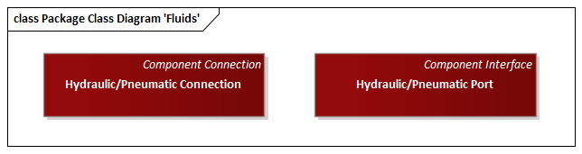

Figure Package Class Diagram 'Fluids'

##### Hydraulic/Pneumatic Connection

Represents a hydraulic or pneumatic connection, i. e. a tube or hose



Figure Icon

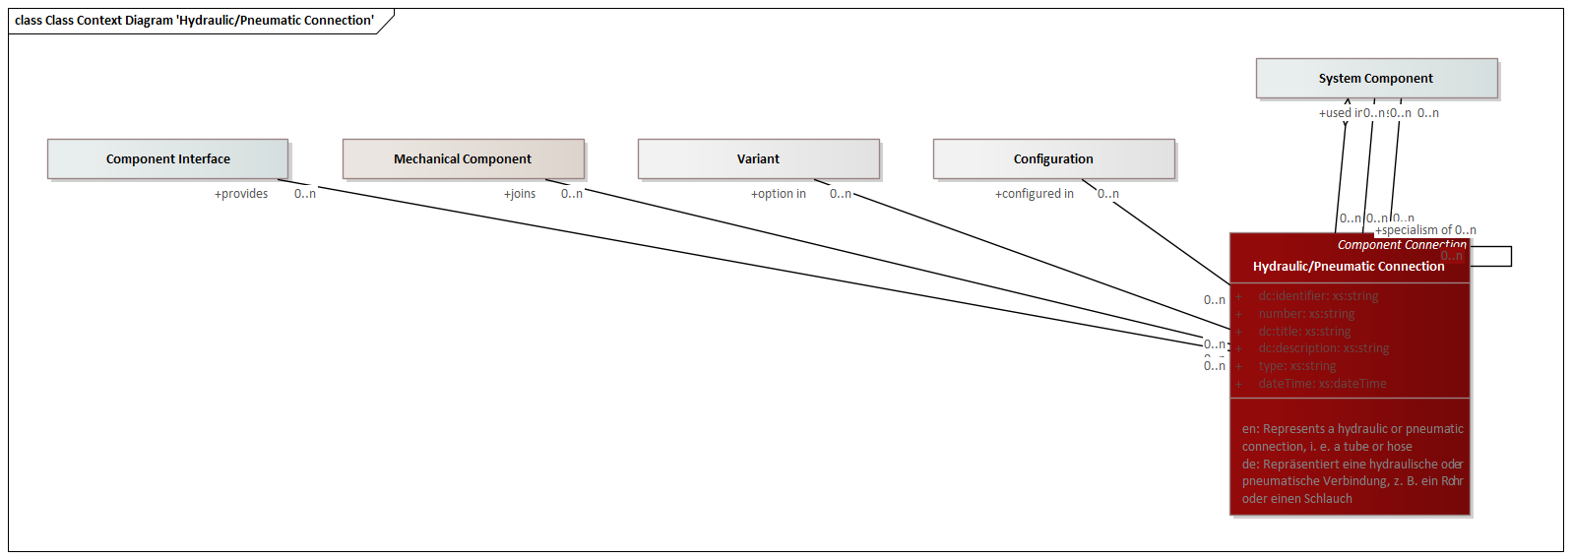

Figure Class Context Diagram 'Hydraulic Pneumatic Connection'

|  |  |
| --- | --- |
| **Generalizations** | Component Connection |
| **Delivered by** | Mechanical Design |
| **Delivered to** | Plan and prepare Simulation  Prepare Testing  Process Planning  Packaging & Logistics  Product Usage  Maintenance & Service  Disassembly & Recycling |

Attributes

|  |  |  |
| --- | --- | --- |
| Identifier | xs:string | Unambiguous identifier of the element |
| Number | xs:string | Legible number or name of the element, i. e. part number |
| Title | xs:string | Title of the element |
| Description | xs:string | Description of the element |
| Type | xs:string | Type of an element |
| DateTime | xs:dateTime | Date and time of the element |

Outbound Relations

|  |  |  |
| --- | --- | --- |
| part of | System Component | Parent system component |
| used in | System Component | Context system component of the usage |
| specialism of | Hydraulic/Pneumatic Connection | More generic item |
| configured in | Configuration | Relation to a configuration |
| option in | Variant | Relation to a variant |
| joins | System Component | Represents the system components joined by this component connection. |
| joins | Mechanical Component | Represents the system components joined by this component connection. |
| provides | Component Interface |  |

Inbound Relations

|  |  |  |
| --- | --- | --- |
|  |  | More generic item |

##### Hydraulic/Pneumatic Port

Represents a hydraulic or pneumatic port on a mechanical component



Figure Icon

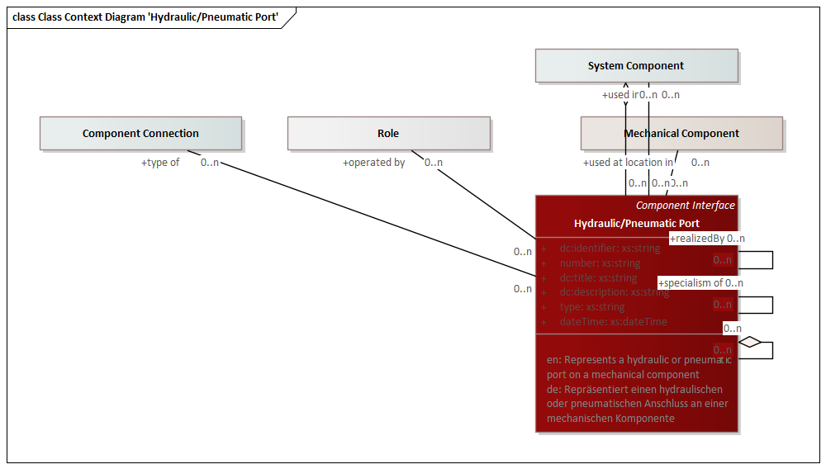

Figure Class Context Diagram 'Hydraulic Pneumatic Port'

|  |  |
| --- | --- |
| **Generalizations** | Component Interface |
| **Delivered by** | Mechanical Design |
| **Delivered to** | Plan and prepare Simulation  Prepare Testing  Process Planning  Packaging & Logistics  Product Usage  Maintenance & Service  Disassembly & Recycling |

Attributes

|  |  |  |
| --- | --- | --- |
| Identifier | xs:string | Unambiguous identifier of the element |
| Number | xs:string | Legible number or name of the element, i. e. part number |
| Title | xs:string | Title of the element |
| Description | xs:string | Description of the element |
| Type | xs:string | Type of an element |
| DateTime | xs:dateTime | Date and time of the element |

Outbound Relations

|  |  |  |
| --- | --- | --- |
| part of | Hydraulic/Pneumatic Port | Parent element |
| part of | System Component | Parent system component |
| used in | System Component | Context system component of the usage |
| used at location in | Mechanical Component | Context element of a located usage |
| specialism of | Hydraulic/Pneumatic Port | More generic item |
| operated by | Role | Interacting role |
| type of | Component Connection |  |

Inbound Relations

|  |  |  |
| --- | --- | --- |
|  |  | Parent element |
|  |  | More generic item |

### Product Verification

Verification of a component or the overall product using virtual (simulation) or physical methods (test, inspection)



Figure Icon

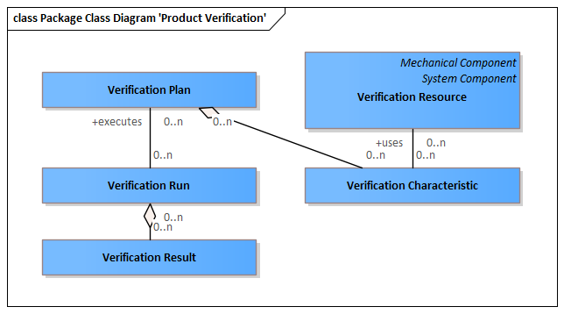

Figure Package Class Diagram 'Product Verification'

#### Verification Characteristic

Represents a characteristic that must be inspected to ensure product function.

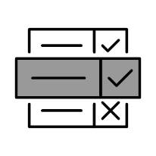

Figure Icon

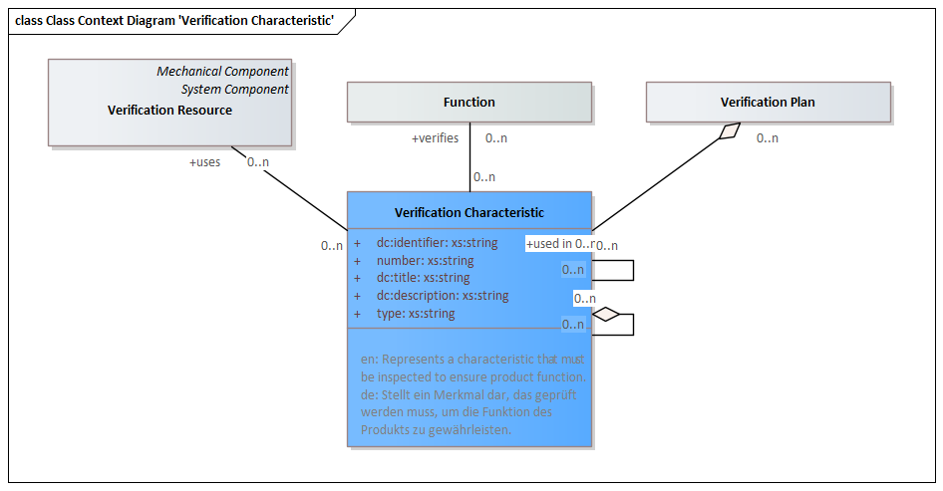

Figure Class Context Diagram 'Verification Characteristic'

|  |  |
| --- | --- |
| **Delivered by** | Plan and prepare Simulation  Prepare Testing  Inspection Planning |
| **Delivered to** | Quality Inspection |

Attributes

|  |  |  |
| --- | --- | --- |
| Identifier | xs:string | Unambiguous identifier of the element |
| Number | xs:string | Legible number or name of the element, i. e. part number |
| Title | xs:string | Title of the element |
| Description | xs:string | Description of the element |
| Type | xs:string | Type of an element |

Outbound Relations

|  |  |  |
| --- | --- | --- |
| part of | Verification Characteristic | Parent element |
| part of | Verification Plan | Parent verification plan this characteristic is allocated to |
| used in | Verification Characteristic | Context element of the usage |
| verifies | Function | Function verified by this verification characteristic |
| uses | Verification Resource |  |

Inbound Relations

|  |  |  |
| --- | --- | --- |
|  |  | Parent element |
|  |  | Context element of the usage |

#### Verification Plan

Specifies what characteristics must be inspected using which equipment for which purpose.

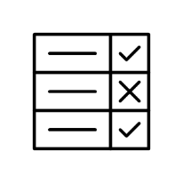

Figure Icon

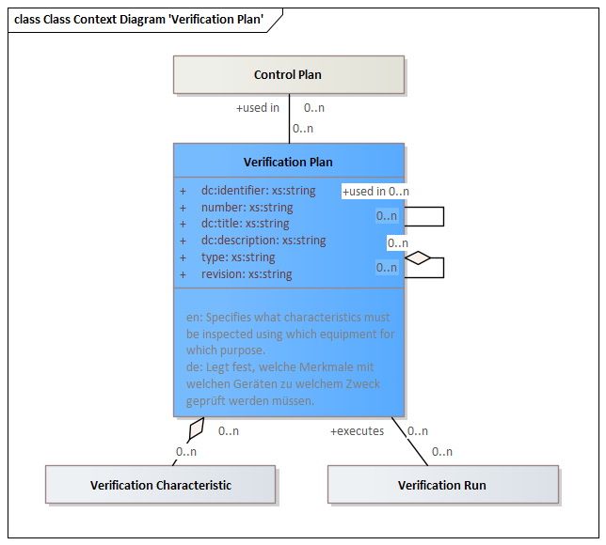

Figure Class Context Diagram 'Verification Plan'

|  |  |
| --- | --- |
| **Delivered by** | Plan and prepare Simulation  Prepare Testing  Inspection Planning |
| **Delivered to** | Quality Inspection |

Attributes

|  |  |  |
| --- | --- | --- |
| Identifier | xs:string | Unambiguous identifier of the element |
| Number | xs:string | Legible number or name of the element, i. e. part number |
| Title | xs:string | Title of the element |
| Description | xs:string | Description of the element |
| Type | xs:string | Type of an element |
| Revision | xs:string | Revisionskennung des Elements |

Outbound Relations

|  |  |  |
| --- | --- | --- |
| part of | Verification Plan | Parent element |
| used in | Verification Plan | Context element of the usage |
| used in | Control Plan | Used in a control plan |

Inbound Relations

|  |  |  |
| --- | --- | --- |
| Verification Characteristic | part of | Parent verification plan this characteristic is allocated to |
|  |  | Parent element |
|  |  | Context element of the usage |
| Verification Run | executes | Verification plan executed by the verification run |

#### Verification Resource

Represents a mechanical component used as an inspection resource

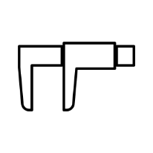

Figure Icon

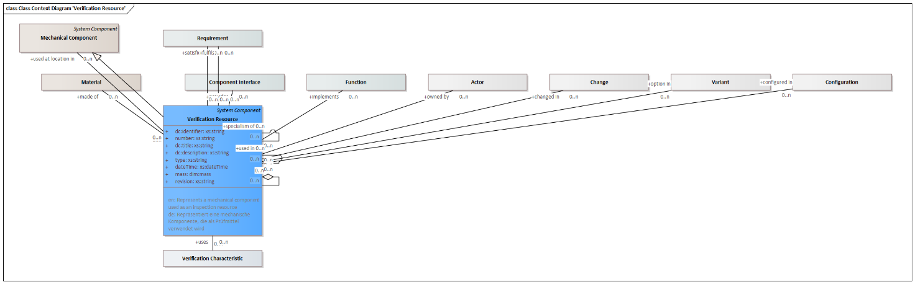

Figure Class Context Diagram 'Verification Resource'

|  |  |
| --- | --- |
| **Generalizations** | System Component  Mechanical Component |
| **Delivered by** | Plan and prepare Simulation  Prepare Testing  Inspection Planning |
| **Delivered to** | Quality Inspection |

Attributes

|  |  |  |
| --- | --- | --- |
| Identifier | xs:string | Unambiguous identifier of the element |
| Number | xs:string | Legible number or name of the element, i. e. part number |
| Title | xs:string | Title of the element |
| Description | xs:string | Description of the element |
| Type | xs:string | Type of an element |
| DateTime | xs:dateTime | Date and time of the element |
| Mass | dim:Mass | Mass of the mechanical component |
| Revision | xs:string | Revisionskennung des Elements |

Outbound Relations

|  |  |  |
| --- | --- | --- |
| part of | Verification Resource | Parent element |
| used in | Verification Resource | Context element of the usage |
| used at location in | Mechanical Component | Context element of a located usage |
| specialism of | Verification Resource | More generic item |
| configured in | Configuration | Relation to a configuration |
| option in | Variant | Relation to a variant |
| changed in | Change | Relation to a change |
| owned by | Actor | Actor owning this element |
| implements | Function | Product function implemented by the component |
| satisfies | Requirement | Requirement satisfied by this system component |
| fulfils | Requirement | Requirement implemented by the component. According to systems engineering best-practice, a requirement should first be answered by a function, and the function will be implemented by a component. This direct relation should therefore only be used if no functions have been defined. |
| provides | Component Interface |  |
| made of | Material | Material assigned to the mechanical component |

Inbound Relations

|  |  |  |
| --- | --- | --- |
| Verification Characteristic | uses |  |
|  |  | Parent element |
|  |  | Context element of the usage |
|  |  | More generic item |

#### Verification Run

Represents an inspection run that collects inspection results for each inspection characteristic allocated to an inspection plan.

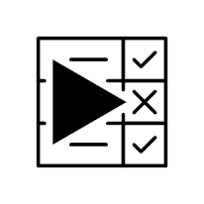

Figure Icon

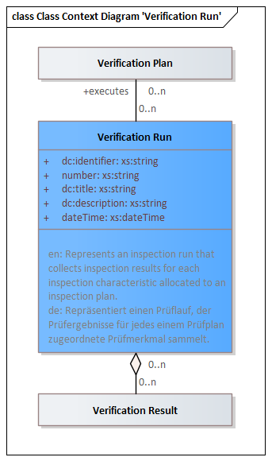

Figure Class Context Diagram 'Verification Run'

|  |  |
| --- | --- |
| **Delivered by** | Perform and document Simulation  Perform and document Testing |
| **Delivered to** | Long-Term Archiving |

Attributes

|  |  |  |
| --- | --- | --- |
| Identifier | xs:string | Unambiguous identifier of the element |
| Number | xs:string | Legible number or name of the element, i. e. part number |
| Title | xs:string | Title of the element |
| Description | xs:string | Description of the element |
| DateTime | xs:dateTime | Date and time of the element |

Outbound Relations

|  |  |  |
| --- | --- | --- |
| executes | Verification Plan | Verification plan executed by the verification run |

Inbound Relations

|  |  |  |
| --- | --- | --- |
| Verification Result | part of | Parent verification run |

#### Verification Result

Represents an inspection result for an inspection criterium



Figure Icon

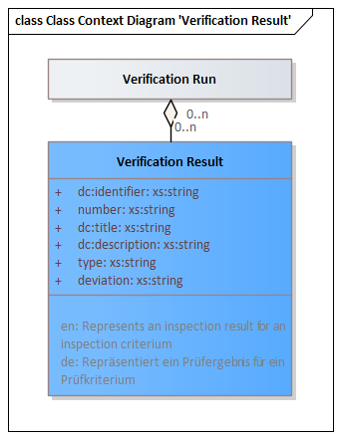

Figure Class Context Diagram 'Verification Result'

|  |  |
| --- | --- |
| **Delivered by** | Perform and document Simulation  Perform and document Testing |
| **Delivered to** | Long-Term Archiving |

Attributes

|  |  |  |
| --- | --- | --- |
| Identifier | xs:string | Unambiguous identifier of the element |
| Number | xs:string | Legible number or name of the element, i. e. part number |
| Title | xs:string | Title of the element |
| Description | xs:string | Description of the element |
| Type | xs:string | Type of an element |
| Deviation | xs:string | Deviation from specification |

Outbound Relations

|  |  |  |
| --- | --- | --- |
| part of | Verification Run | Parent verification run |

### Product Validation

Validation of a component or the overall product using virtual (simulation) or physical methods (test)



Figure Icon

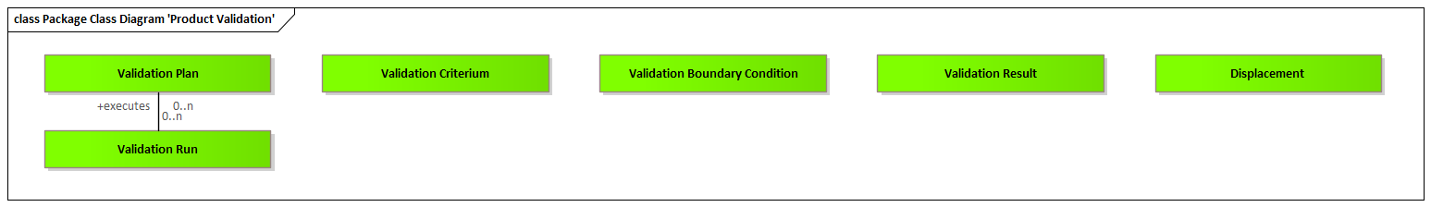

Figure Package Class Diagram 'Product Validation'

#### Validation Criterium

A specific validation criterium as part of a validation plan.



Figure Icon

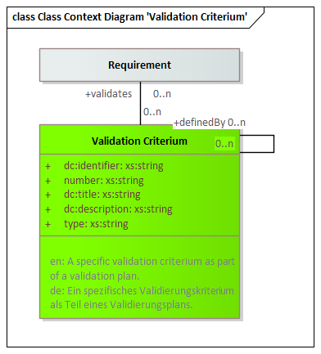

Figure Class Context Diagram 'Validation Criterium'

|  |  |
| --- | --- |
| **Delivered by** | Plan and prepare Simulation  Prepare Testing |
| **Delivered to** | Perform and document Simulation  Perform and document Testing |

Attributes

|  |  |  |
| --- | --- | --- |
| Identifier | xs:string | Unambiguous identifier of the element |
| Number | xs:string | Legible number or name of the element, i. e. part number |
| Title | xs:string | Title of the element |
| Description | xs:string | Description of the element |
| Type | xs:string | Type of an element |

Outbound Relations

|  |  |  |
| --- | --- | --- |
| validates | Requirement | Requirement validated by this validation criterium |

#### Validation Plan

A specific executable test that examines all aspects including inputs and outputs of a system and then provides a detailed description of the steps that should be taken, the results that should be achieved, and other elements that should be identified. Steps explained in a test case include all details even if they are assumed to be common knowledge. Test cases are used as a technical explanation and reference guide for systems.

https://intranet.prostep.org/display/PROJ/Glossary



Figure Icon

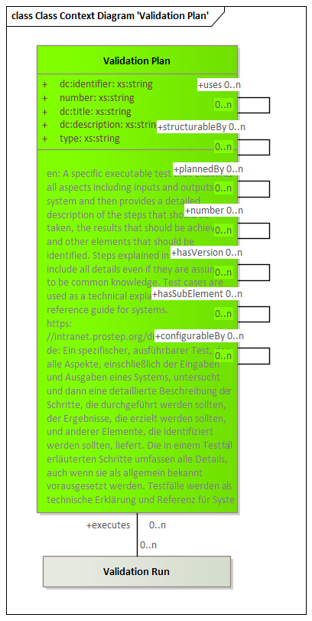

Figure Class Context Diagram 'Validation Plan'

|  |  |
| --- | --- |
| **Delivered by** | Plan and prepare Simulation  Prepare Testing |
| **Delivered to** | Perform and document Simulation  Perform and document Testing |

Attributes

|  |  |  |
| --- | --- | --- |
| Identifier | xs:string | Unambiguous identifier of the element |
| Number | xs:string | Legible number or name of the element, i. e. part number |
| Title | xs:string | Title of the element |
| Description | xs:string | Description of the element |
| Type | xs:string | Type of an element |

Inbound Relations

|  |  |  |
| --- | --- | --- |
| Validation Run | executes | Validation plan executed by the validation run |

#### Validation Boundary Condition

Validation boundary condition, i. e. force, pressure, temperature or time.

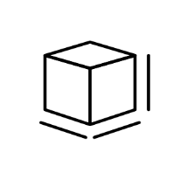

Figure Icon

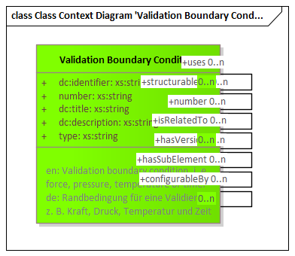

Figure Class Context Diagram 'Validation Boundary Condition'

|  |  |
| --- | --- |
| **Delivered by** | Plan and prepare Simulation  Prepare Testing |
| **Delivered to** | Perform and document Simulation  Perform and document Testing |

Attributes

|  |  |  |
| --- | --- | --- |
| Identifier | xs:string | Unambiguous identifier of the element |
| Number | xs:string | Legible number or name of the element, i. e. part number |
| Title | xs:string | Title of the element |
| Description | xs:string | Description of the element |
| Type | xs:string | Type of an element |

#### Validation Run

Vorgang einer Validierung



Figure Icon

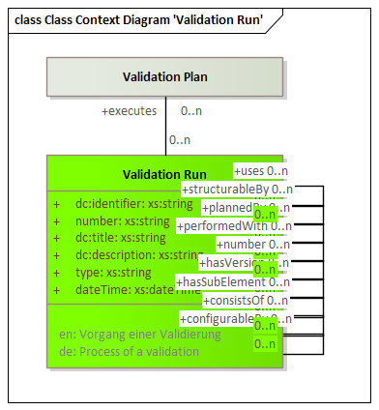

Figure Class Context Diagram 'Validation Run'

|  |  |
| --- | --- |
| **Delivered by** | Perform and document Simulation  Perform and document Testing |
| **Delivered to** | Perform and document Simulation  Perform and document Testing  Long-Term Archiving |

Attributes

|  |  |  |
| --- | --- | --- |
| Identifier | xs:string | Unambiguous identifier of the element |
| Number | xs:string | Legible number or name of the element, i. e. part number |
| Title | xs:string | Title of the element |
| Description | xs:string | Description of the element |
| Type | xs:string | Type of an element |
| DateTime | xs:dateTime | Date and time of the element |

Outbound Relations

|  |  |  |
| --- | --- | --- |
| executes | Validation Plan | Validation plan executed by the validation run |

#### Validation Result

Ergebnis einer Validierung



Figure Icon

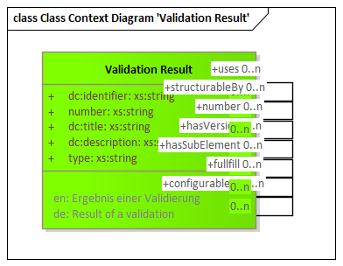

Figure Class Context Diagram 'Validation Result'

|  |  |
| --- | --- |
| **Delivered by** | Perform and document Simulation  Perform and document Testing |
| **Delivered to** | Long-Term Archiving |

Attributes

|  |  |  |
| --- | --- | --- |
| Identifier | xs:string | Unambiguous identifier of the element |
| Number | xs:string | Legible number or name of the element, i. e. part number |
| Title | xs:string | Title of the element |
| Description | xs:string | Description of the element |
| Type | xs:string | Type of an element |

#### Displacement

Displaced point coordinates

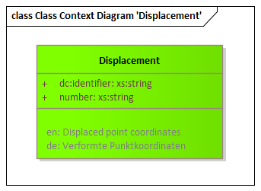

Figure Class Context Diagram 'Displacement'

|  |  |
| --- | --- |
| **Delivered to** | Long-Term Archiving |

Attributes

|  |  |  |
| --- | --- | --- |
| Identifier | xs:string | Unambiguous identifier of the element |
| Number | xs:string | Legible number or name of the element, i. e. part number |

### Manufacturing & Supply Chain

Includes all entities relevant to manufacturing and supply chain



Figure Icon

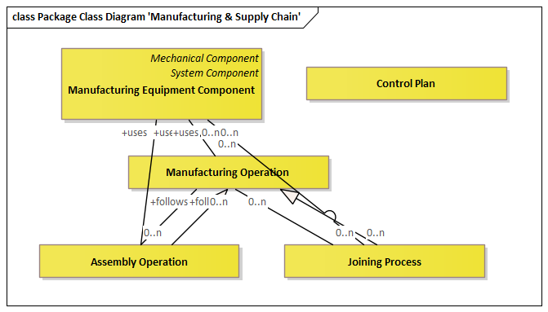

Figure Package Class Diagram 'Manufacturing & Supply Chain'

#### Manufacturing Process

Includes all manufacturing process operations



Figure Icon

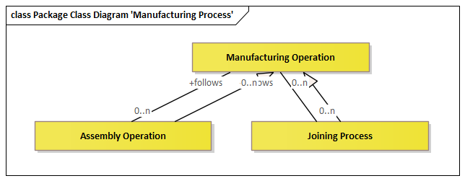

Figure Package Class Diagram 'Manufacturing Process'

##### Manufacturing Operation

Represents a single or a group of manufacturing operations that lead to a finished, assembled product.

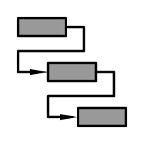

Figure Icon

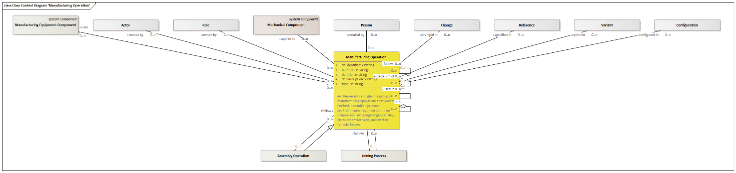

Figure Class Context Diagram 'Manufacturing Operation'

|  |  |
| --- | --- |
| **Specializations** | Assembly Operation  Heat Treatment  Joining Process |
| **Delivered by** | Process Planning |
| **Delivered to** | Cost Calculation  Parts Manufacturing  Product Assembly |

Attributes

|  |  |  |
| --- | --- | --- |
| Identifier | xs:string | Unambiguous identifier of the element |
| Number | xs:string | Legible number or name of the element, i. e. part number |
| Title | xs:string | Title of the element |
| Description | xs:string | Description of the element |
| Type | xs:string | Type of an element |

Outbound Relations

|  |  |  |
| --- | --- | --- |
| part of | Manufacturing Operation | Parent element |
| used in | Manufacturing Operation | Context element of the usage |
| specialism of | Manufacturing Operation | More generic item |
| configured in | Configuration | Relation to a configuration |
| option in | Variant | Relation to a variant |
| specified in | Reference | Relation to a variant |
| changed in | Change | Relation to a change |
| created by | Person | The person who created this element |
| applies to | Mechanical Component | Mechanical or electrical component this manufacturing operation applies to |
| owned by | Role | Role owning this element |
| owned by | Actor | Actor owning this element |
| follows | Manufacturing Operation | Preceding manufacturing operation |
| uses | Manufacturing Equipment Component | Any tools and fixtures used to perform the manufacturing operation. |

Inbound Relations

|  |  |  |
| --- | --- | --- |
|  |  | Parent element |
|  |  | Context element of the usage |
|  |  | More generic item |
|  |  | Preceding manufacturing operation |
| Assembly Operation | follows | Preceding manufacturing operation |
| Heat Treatment | follows | Preceding manufacturing operation |
| Joining Process | follows | Preceding manufacturing operation |

##### Assembly Operation

Operation of adding a single part or sub-assembly to an existing single part or sub-assembly

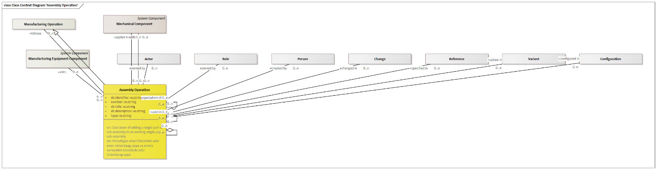

Figure Class Context Diagram 'Assembly Operation'

|  |  |
| --- | --- |
| **Generalizations** | Manufacturing Operation |

Attributes

|  |  |  |
| --- | --- | --- |
| Identifier | xs:string | Unambiguous identifier of the element |
| Number | xs:string | Legible number or name of the element, i. e. part number |
| Title | xs:string | Title of the element |
| Description | xs:string | Description of the element |
| Type | xs:string | Type of an element |

Outbound Relations

|  |  |  |
| --- | --- | --- |
| part of | Assembly Operation | Parent element |
| used in | Assembly Operation | Context element of the usage |
| specialism of | Assembly Operation | More generic item |
| configured in | Configuration | Relation to a configuration |
| option in | Variant | Relation to a variant |
| specified in | Reference | Relation to a variant |
| changed in | Change | Relation to a change |
| created by | Person | The person who created this element |
| applies to | Mechanical Component | Mechanical or electrical component this manufacturing operation applies to |
| owned by | Role | Role owning this element |
| owned by | Actor | Actor owning this element |
| follows | Manufacturing Operation | Preceding manufacturing operation |
| uses | Manufacturing Equipment Component | Any tools and fixtures used to perform the manufacturing operation. |
| adds | Mechanical Component | Mechanical or electrical components added by this manufacturing operation |

Inbound Relations

|  |  |  |
| --- | --- | --- |
|  |  | Parent element |
|  |  | Context element of the usage |
|  |  | More generic item |

##### Heat Treatment



Figure Icon



Figure Class Context Diagram 'Heat Treatment'

|  |  |
| --- | --- |
| **Generalizations** | Manufacturing Operation |

Attributes

|  |  |  |
| --- | --- | --- |
| Identifier | xs:string | Unambiguous identifier of the element |
| Number | xs:string | Legible number or name of the element, i. e. part number |
| Title | xs:string | Title of the element |
| Description | xs:string | Description of the element |
| Type | xs:string | Type of an element |
| Temperature | xs:string |  |
| Duration | xs:string | Duration of the heat treatment |

Outbound Relations

|  |  |  |
| --- | --- | --- |
| part of | Heat Treatment | Parent element |
| used in | Heat Treatment | Context element of the usage |
| specialism of | Heat Treatment | More generic item |
| configured in | Configuration | Relation to a configuration |
| option in | Variant | Relation to a variant |
| specified in | Reference | Relation to a variant |
| changed in | Change | Relation to a change |
| created by | Person | The person who created this element |
| applies to | Mechanical Component | Mechanical or electrical component this manufacturing operation applies to |
| owned by | Role | Role owning this element |
| owned by | Actor | Actor owning this element |
| follows | Manufacturing Operation | Preceding manufacturing operation |
| uses | Manufacturing Equipment Component | Any tools and fixtures used to perform the manufacturing operation. |

Inbound Relations

|  |  |  |
| --- | --- | --- |
| Heat Treatment Area | applies | Heat treatment operation used for this heat treatment specification |
|  |  | Parent element |
|  |  | Context element of the usage |
|  |  | More generic item |

##### Joining Process

Represents a joining process type such as welding, riveting, etc.

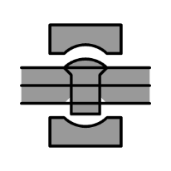

Figure Icon

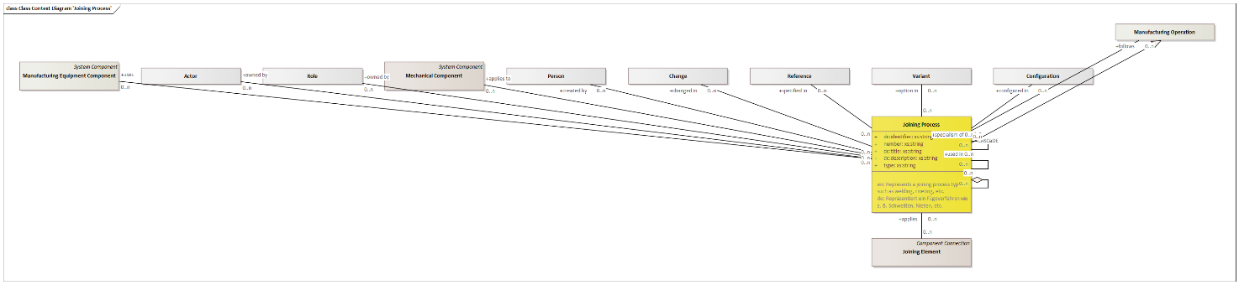

Figure Class Context Diagram 'Joining Process'

|  |  |
| --- | --- |
| **Generalizations** | Manufacturing Operation |
| **Delivered by** | Mechanical Design |
| **Delivered to** | Define Joining Elements  Plan and prepare Simulation  Prepare Testing  Process Planning  Inspection Planning  Cost Calculation  Tools & Equipment Design  Product Assembly  Quality Inspection  Packaging & Logistics  Maintenance & Service  Disassembly & Recycling  Procurement  Long-Term Archiving |

Attributes

|  |  |  |
| --- | --- | --- |
| Identifier | xs:string | Unambiguous identifier of the element |
| Number | xs:string | Legible number or name of the element, i. e. part number |
| Title | xs:string | Title of the element |
| Description | xs:string | Description of the element |
| Type | xs:string | Type of an element |

Outbound Relations

|  |  |  |
| --- | --- | --- |
| part of | Joining Process | Parent element |
| used in | Joining Process | Context element of the usage |
| specialism of | Joining Process | More generic item |
| configured in | Configuration | Relation to a configuration |
| option in | Variant | Relation to a variant |
| specified in | Reference | Relation to a variant |
| changed in | Change | Relation to a change |
| created by | Person | The person who created this element |
| applies to | Mechanical Component | Mechanical or electrical component this manufacturing operation applies to |
| owned by | Role | Role owning this element |
| owned by | Actor | Actor owning this element |
| follows | Manufacturing Operation | Preceding manufacturing operation |
| uses | Manufacturing Equipment Component | Any tools and fixtures used to perform the manufacturing operation. |

Inbound Relations

|  |  |  |
| --- | --- | --- |
| Joining Element | applies | Joining process used for this joining element |
|  |  | Parent element |
|  |  | Context element of the usage |
|  |  | More generic item |

#### Manufacturing Equipment Component

Represents all kinds of tools and equipment used to manufacture parts and assemble the product.

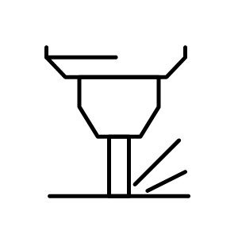

Figure Manufacturing Equipment Component

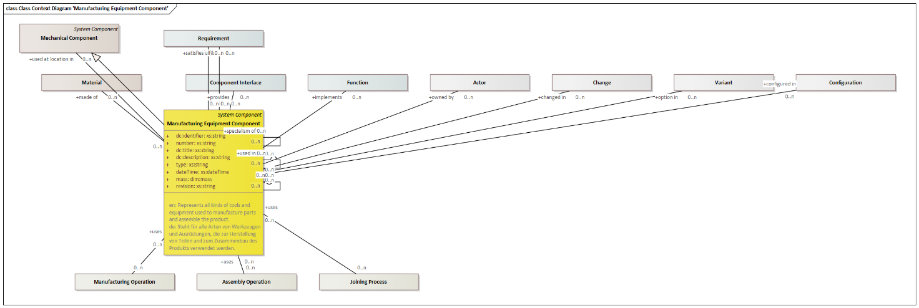

Figure Class Context Diagram 'Manufacturing Equipment Component'

|  |  |
| --- | --- |
| **Generalizations** | System Component  Mechanical Component |
| **Delivered by** | Plant Layout  Tools & Equipment Design |
| **Delivered to** | Cost Calculation  Parts Manufacturing  Product Assembly |

Attributes

|  |  |  |
| --- | --- | --- |
| Identifier | xs:string | Unambiguous identifier of the element |
| Number | xs:string | Legible number or name of the element, i. e. part number |
| Title | xs:string | Title of the element |
| Description | xs:string | Description of the element |
| Type | xs:string | Type of an element |
| DateTime | xs:dateTime | Date and time of the element |
| Mass | dim:Mass | Mass of the mechanical component |
| Revision | xs:string | Revisionskennung des Elements |

Outbound Relations

|  |  |  |
| --- | --- | --- |
| part of | Manufacturing Equipment Component | Parent element |
| used in | Manufacturing Equipment Component | Context element of the usage |
| used at location in | Mechanical Component | Context element of a located usage |
| specialism of | Manufacturing Equipment Component | More generic item |
| configured in | Configuration | Relation to a configuration |
| option in | Variant | Relation to a variant |
| changed in | Change | Relation to a change |
| owned by | Actor | Actor owning this element |
| implements | Function | Product function implemented by the component |
| satisfies | Requirement | Requirement satisfied by this system component |
| fulfils | Requirement | Requirement implemented by the component. According to systems engineering best-practice, a requirement should first be answered by a function, and the function will be implemented by a component. This direct relation should therefore only be used if no functions have been defined. |
| provides | Component Interface |  |
| made of | Material | Material assigned to the mechanical component |

Inbound Relations

|  |  |  |
| --- | --- | --- |
| Manufacturing Operation | uses | Any tools and fixtures used to perform the manufacturing operation. |
| Assembly Operation | uses | Any tools and fixtures used to perform the manufacturing operation. |
| Heat Treatment | uses | Any tools and fixtures used to perform the manufacturing operation. |
| Joining Process | uses | Any tools and fixtures used to perform the manufacturing operation. |
|  |  | Parent element |
|  |  | Context element of the usage |
|  |  | More generic item |

#### Control Plan

Defines what verification and validation measures are used from product development through ramp-up to series production.

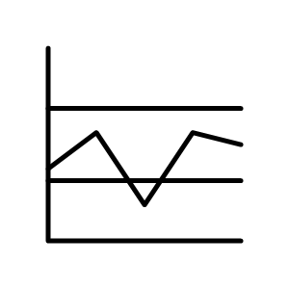

Figure Control Plan

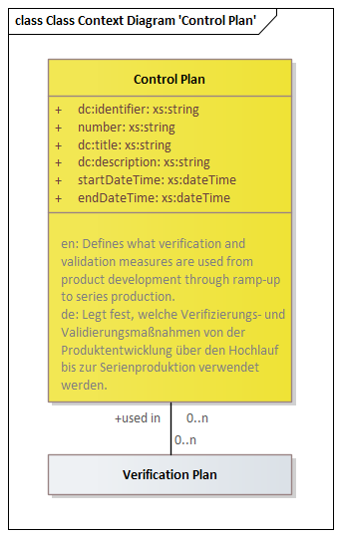

Figure Class Context Diagram 'Control Plan'

|  |  |
| --- | --- |
| **Delivered to** | Cost Calculation  Quality Inspection |

Attributes

|  |  |  |
| --- | --- | --- |
| Identifier | xs:string | Unambiguous identifier of the element |
| Number | xs:string | Legible number or name of the element, i. e. part number |
| Title | xs:string | Title of the element |
| Description | xs:string | Description of the element |
| StartDateTime | xs:dateTime | Start date and time of the element |
| EndDateTime | xs:dateTime | End date and time of the element |

Inbound Relations

|  |  |  |
| --- | --- | --- |
| Verification Plan | used in | Used in a control plan |

### Operation

Includes all entities relevant to product operations



Figure Icon

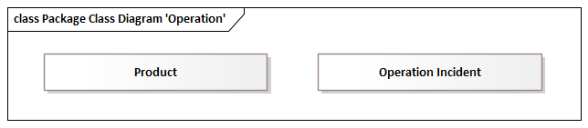

Figure Package Class Diagram 'Operation'

#### Product

Represents the commercial view of a product,

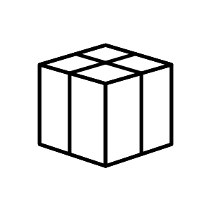

Figure Product

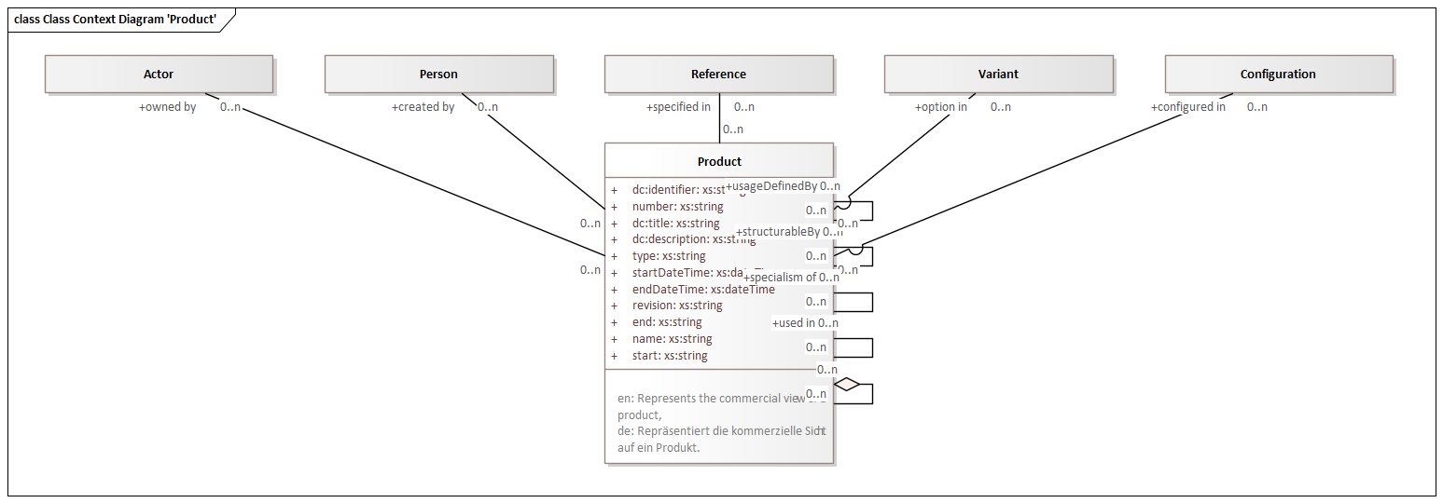

Figure Class Context Diagram 'Product'

Attributes

|  |  |  |
| --- | --- | --- |
| Identifier | xs:string | Unambiguous identifier of the element |
| Number | xs:string | Legible number or name of the element, i. e. part number |
| Title | xs:string | Title of the element |
| Description | xs:string | Description of the element |
| Type | xs:string | Type of an element |
| StartDateTime | xs:dateTime | Start date and time of the element |
| EndDateTime | xs:dateTime | End date and time of the element |
| Revision | xs:string | Revisionskennung des Elements |

Outbound Relations

|  |  |  |
| --- | --- | --- |
| part of | Product | Parent element |
| used in | Product | Context element of the usage |
| specialism of | Product | More generic item |
| configured in | Configuration | Relation to a configuration |
| option in | Variant | Relation to a variant |
| specified in | Reference | Relation to a variant |
| created by | Person | The person who created this element |
| owned by | Actor | Actor owning this element |

Inbound Relations

|  |  |  |
| --- | --- | --- |
|  |  | Parent element |
|  |  | Context element of the usage |
|  |  | More generic item |

#### Operation Incident

Represents an incident during product operation, i. e. failure, maintenance, etc.

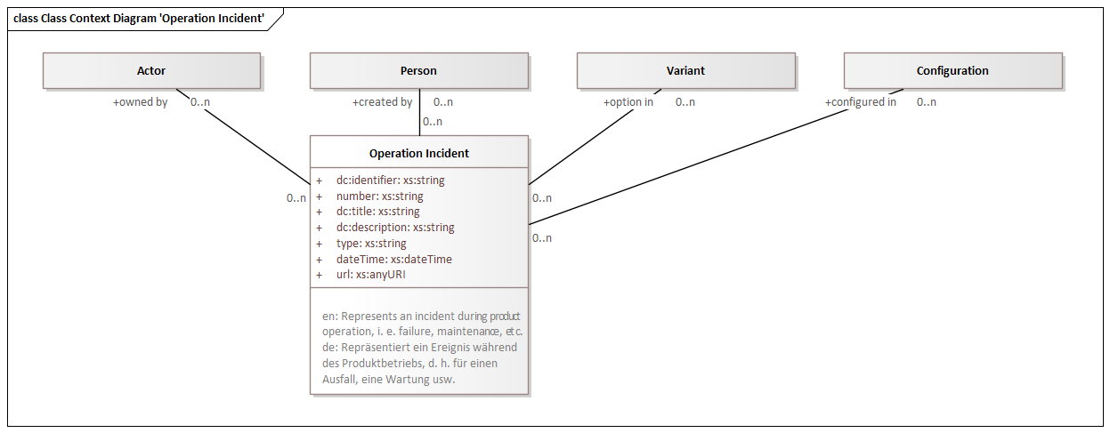

Figure Class Context Diagram 'Operation Incident'

|  |  |
| --- | --- |
| **Delivered by** | Product Usage |

Attributes

|  |  |  |
| --- | --- | --- |
| Identifier | xs:string | Unambiguous identifier of the element |
| Number | xs:string | Legible number or name of the element, i. e. part number |
| Title | xs:string | Title of the element |
| Description | xs:string | Description of the element |
| Type | xs:string | Type of an element |
| DateTime | xs:dateTime | Date and time of the element |
| URL | xs:anyURI | Unique resource locator of an element |

Outbound Relations

|  |  |  |
| --- | --- | --- |
| configured in | Configuration | Relation to a configuration |
| option in | Variant | Relation to a variant |
| created by | Person | The person who created this element |
| owned by | Actor | Actor owning this element |

### Context Elements

Includes entities that provide context in which related elements are valid, i. e. Revision or Configuration.



Figure Icon

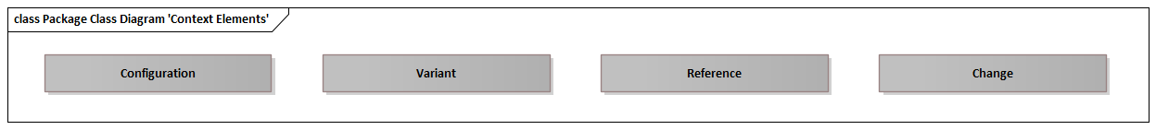

Figure Package Class Diagram 'Context Elements'

#### Configuration

Represents a configuration as a context for other elements to be valid. The datamodel allows selected elements to be related to a revision, i. e. mechanical components

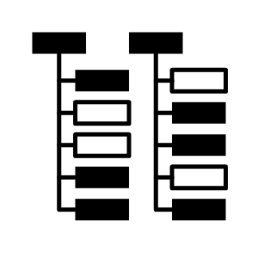

Figure Configuration



Figure Class Context Diagram 'Configuration'

|  |  |
| --- | --- |
| **Delivered by** | Mechanical Design  Electrical/Electronical Design  Software Engineering |

Attributes

|  |  |  |
| --- | --- | --- |
| Identifier | xs:string | Unambiguous identifier of the element |
| Number | xs:string | Legible number or name of the element, i. e. part number |
| Title | xs:string | Title of the element |
| Description | xs:string | Description of the element |
| Type | xs:string | Type of an element |
| StartDateTime | xs:dateTime | Start date and time of the element |
| EndDateTime | xs:dateTime | End date and time of the element |

Outbound Relations

|  |  |  |
| --- | --- | --- |
| part of | Configuration | Parent element |
| specialism of | Configuration | More generic item |

Inbound Relations

|  |  |  |
| --- | --- | --- |
| Use Case | configured in | Relation to a configuration |
| Requirement | configured in | Relation to a configuration |
| Stakeholder Requirement | configured in | Relation to a configuration |
| System Requirement | configured in | Relation to a configuration |
| Function | configured in | Relation to a configuration |
| Function Failure | configured in | Relation to a configuration |
| System Component | configured in | Relation to a configuration |
| Component Connection | configured in | Relation to a configuration |
| Mechanical Component | configured in | Relation to a configuration |
| Body | configured in | Relation to a configuration |
| Material | configured in | Relation to a configuration |
| Model View | configured in | Relation to a configuration |
| Model Annotation | configured in | Relation to a configuration |
| Datum | configured in | Relation to a configuration |
| Geometric Tolerance | configured in | Relation to a configuration |
| Dimensional Size | configured in | Relation to a configuration |
| Surface Texture | configured in | Relation to a configuration |
| Kinematic Joint | configured in | Relation to a configuration |
| Joining Element | configured in | Relation to a configuration |
| Painting & Coating | configured in | Relation to a configuration |
| Marking & Labeling | configured in | Relation to a configuration |
| Heat Treatment Area | configured in | Relation to a configuration |
| Electric/Electronic Component | configured in | Relation to a configuration |
| Electric/Electronic Connection | configured in | Relation to a configuration |
| Software Class | configured in | Relation to a configuration |
| Software Component | configured in | Relation to a configuration |
| Hydraulic/Pneumatic Connection | configured in | Relation to a configuration |
| Verification Resource | configured in | Relation to a configuration |
| Manufacturing Operation | configured in | Relation to a configuration |
| Assembly Operation | configured in | Relation to a configuration |
| Heat Treatment | configured in | Relation to a configuration |
| Joining Process | configured in | Relation to a configuration |
| Manufacturing Equipment Component | configured in | Relation to a configuration |
| Product | configured in | Relation to a configuration |
| Operation Incident | configured in | Relation to a configuration |
|  |  | Parent element |
|  |  | More generic item |

#### Variant

Represents a variant as a context for other elements to be valid. The datamodel allows selected elements to be related to a variant, i. e. mechanical components

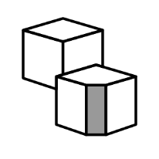

Figure Icon



Figure Class Context Diagram 'Variant'

|  |  |
| --- | --- |
| **Delivered by** | Mechanical Design  Electrical/Electronical Design  Software Engineering |

Attributes

|  |  |  |
| --- | --- | --- |
| Identifier | xs:string | Unambiguous identifier of the element |
| Number | xs:string | Legible number or name of the element, i. e. part number |
| Title | xs:string | Title of the element |
| Description | xs:string | Description of the element |
| Type | xs:string | Type of an element |

Outbound Relations

|  |  |  |
| --- | --- | --- |
| part of | Variant | Parent element |
| specialism of | Variant | More generic item |

Inbound Relations

|  |  |  |
| --- | --- | --- |
| Use Case | option in | Relation to a variant |
| Requirement | option in | Relation to a variant |
| Stakeholder Requirement | option in | Relation to a variant |
| System Requirement | option in | Relation to a variant |
| Function | option in | Relation to a variant |
| Function Failure | option in | Relation to a variant |
| System Component | option in | Relation to a variant |
| Component Connection | option in | Relation to a variant |
| Mechanical Component | option in | Relation to a variant |
| Body | option in | Relation to a variant |
| Material | option in | Relation to a variant |
| Model View | option in | Relation to a variant |
| Model Annotation | option in | Relation to a variant |
| Datum | option in | Relation to a variant |
| Geometric Tolerance | option in | Relation to a variant |
| Dimensional Size | option in | Relation to a variant |
| Surface Texture | option in | Relation to a variant |
| Kinematic Joint | option in | Relation to a variant |
| Joining Element | option in | Relation to a variant |
| Painting & Coating | option in | Relation to a variant |
| Marking & Labeling | option in | Relation to a variant |
| Heat Treatment Area | option in | Relation to a variant |
| Electric/Electronic Component | option in | Relation to a variant |
| Electric/Electronic Connection | option in | Relation to a variant |
| Software Class | option in | Relation to a variant |
| Software Component | option in | Relation to a variant |
| Hydraulic/Pneumatic Connection | option in | Relation to a variant |
| Verification Resource | option in | Relation to a variant |
| Manufacturing Operation | option in | Relation to a variant |
| Assembly Operation | option in | Relation to a variant |
| Heat Treatment | option in | Relation to a variant |
| Joining Process | option in | Relation to a variant |
| Manufacturing Equipment Component | option in | Relation to a variant |
| Product | option in | Relation to a variant |
| Operation Incident | option in | Relation to a variant |
|  |  | Parent element |
|  |  | More generic item |

#### Reference

Related resource

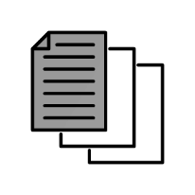

Figure Icon

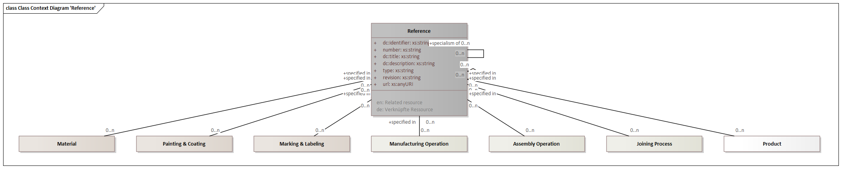

Figure Class Context Diagram 'Reference'

|  |  |
| --- | --- |
| **Delivered by** | Mechanical Design  Electrical/Electronical Design  Software Engineering |

Attributes

|  |  |  |
| --- | --- | --- |
| Identifier | xs:string | Unambiguous identifier of the element |
| Number | xs:string | Legible number or name of the element, i. e. part number |
| Title | xs:string | Title of the element |
| Description | xs:string | Description of the element |
| Type | xs:string | Type of an element |
| Revision | xs:string | Revisionskennung des Elements |
| URL | xs:anyURI | Unique resource locator of an element |

Outbound Relations

|  |  |  |
| --- | --- | --- |
| part of | Reference | Parent element |
| specialism of | Reference | More generic item |

Inbound Relations

|  |  |  |
| --- | --- | --- |
| Material | specified in | Relation to a variant |
| Painting & Coating | specified in | Relation to a variant |
| Marking & Labeling | specified in | Relation to a variant |
| Heat Treatment Area | specified in | Relation to a variant |
| Manufacturing Operation | specified in | Relation to a variant |
| Assembly Operation | specified in | Relation to a variant |
| Heat Treatment | specified in | Relation to a variant |
| Joining Process | specified in | Relation to a variant |
| Product | specified in | Relation to a variant |
|  |  | Parent element |
|  |  | More generic item |

#### Change

A change in requirements, engineering, planning or production



Figure Icon

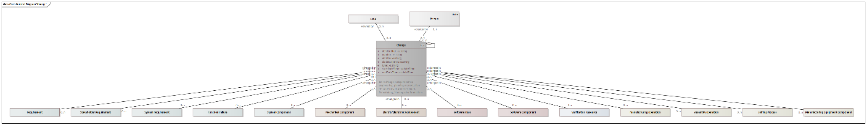

Figure Class Context Diagram 'Change'

Attributes

|  |  |  |
| --- | --- | --- |
| Identifier | xs:string | Unambiguous identifier of the element |
| Number | xs:string | Legible number or name of the element, i. e. part number |
| Title | xs:string | Title of the element |
| Description | xs:string | Description of the element |
| Type | xs:string | Type of an element |
| StartDateTime | xs:dateTime | Start date and time of the element |
| EndDateTime | xs:dateTime | End date and time of the element |

Outbound Relations

|  |  |  |
| --- | --- | --- |
| part of | Change | Parent element |
| created by | Person | The person who created this element |
| owned by | Role | Role owning this element |

Inbound Relations

|  |  |  |
| --- | --- | --- |
| Requirement | changed in | Relation to a change |
| Stakeholder Requirement | changed in | Relation to a change |
| System Requirement | changed in | Relation to a change |
| Function Failure | changed in | Relation to a change |
| System Component | changed in | Relation to a change |
| Mechanical Component | changed in | Relation to a change |
| Electric/Electronic Component | changed in | Relation to a change |
| Software Class | changed in | Relation to a change |
| Software Component | changed in | Relation to a change |
| Verification Resource | changed in | Relation to a change |
| Manufacturing Operation | changed in | Relation to a change |
| Assembly Operation | changed in | Relation to a change |
| Heat Treatment | changed in | Relation to a change |
| Joining Process | changed in | Relation to a change |
| Manufacturing Equipment Component | changed in | Relation to a change |
|  |  | Parent element |

# Use-Cases

Lists all use-cases.

## Collaboration Use-Cases

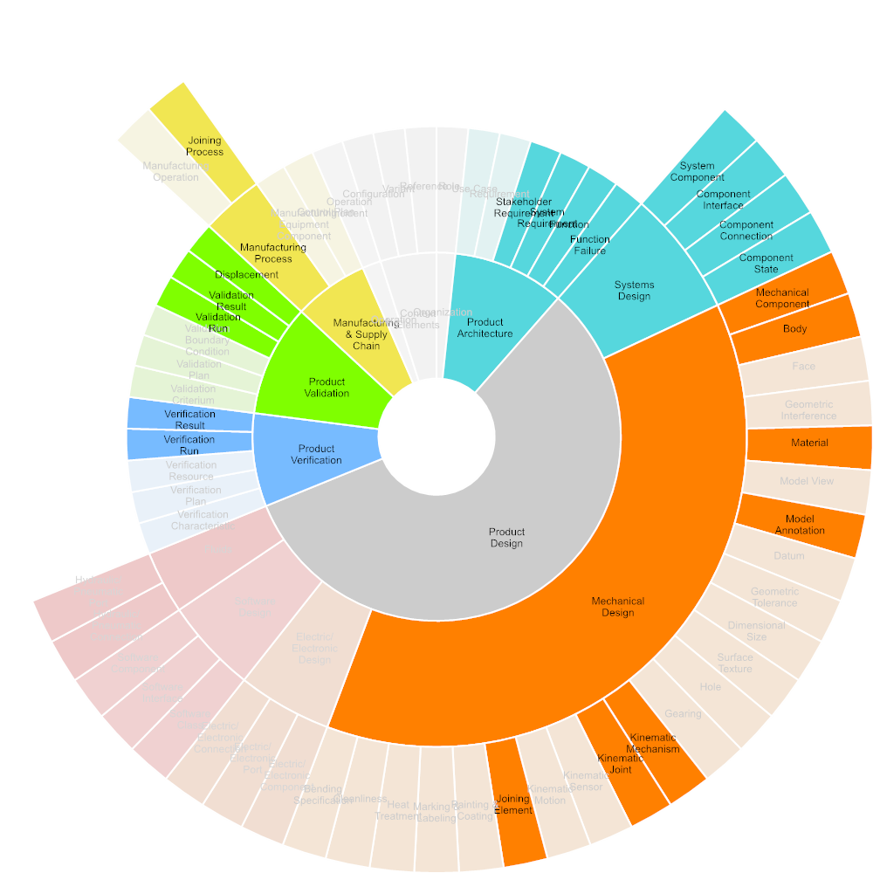

Figure Required Input



Figure Used Tools

### Product Development

Product development is the creation of products with new or modified characteristics that offer new or additional benefits to the customer, or comply with new or changed standards, rules and regulations.

Product development may involve modification of an existing product or its presentation or formulation of an entirely new product that satisfies a newly-defined or changed customer need or market segment.

Description based on: https://cio-wiki.org/wiki/Product_Development

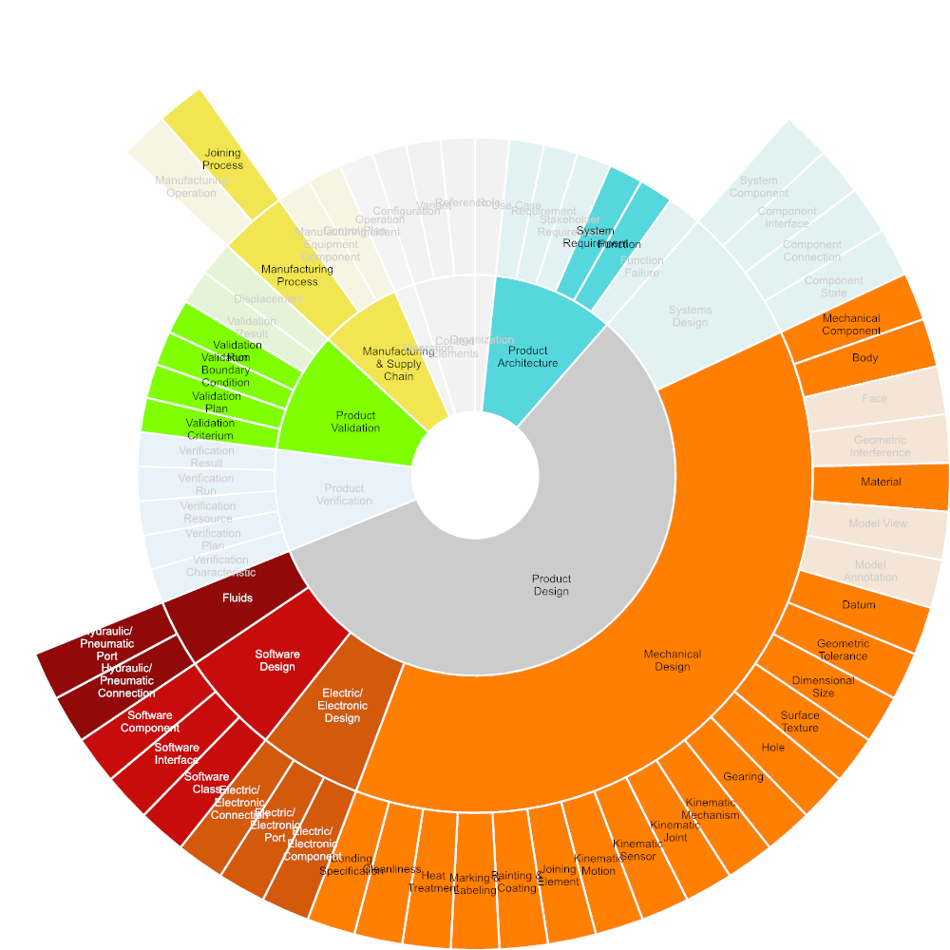

Figure Required Input

#### Concept definition

In conceptual design, new products or systems are defined through requirements and specified through a functional structure in mechanical, electrics/electronics, and software domains. A logical structure specifies the future product architecture in order to implement the specified functions.

Besides new products, existing products may be changed or modified significantly to better comply with customer needs, or to attract new customers. Eventually, the product may be changed or adopted to comply to new standards, regulations or laws.

Conceptual design is usually performed at a high abstraction level and low level of detail, using parameter studies, system models, and rough geometry, if any.

For the Digital Data Package, model-based methods and data for product conceptual design are assumed.

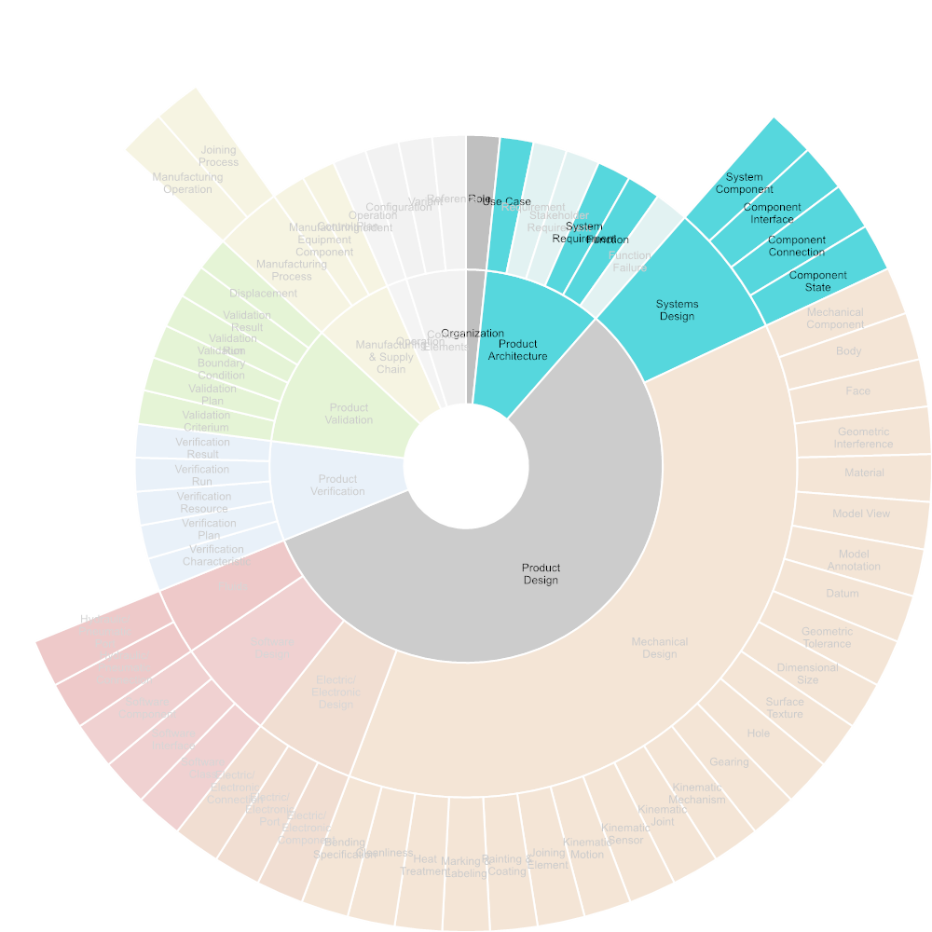

Figure Required Input

##### Business or Mission Analysis

Product Planning is the ongoing process of identifying and articulating market requirements that define a product's feature set. Product planning serves as the basis for decisions about price, distribution and promotion.

Product planning is the process of creating a product idea and following through on it until the product is introduced to the market. Additionally, a small company must have an exit strategy for its product in case the product does not sell.

Product planning entails managing the product throughout its life using various marketing strategies, including product extensions or improvements, increased distribution, price changes and promotions.

Also includes the identification of relevant legal requirements as well as customs and tax regulations applicable to the product and the respective target markets.

Description based on: https://en.wikipedia.org/wiki/Product_planning

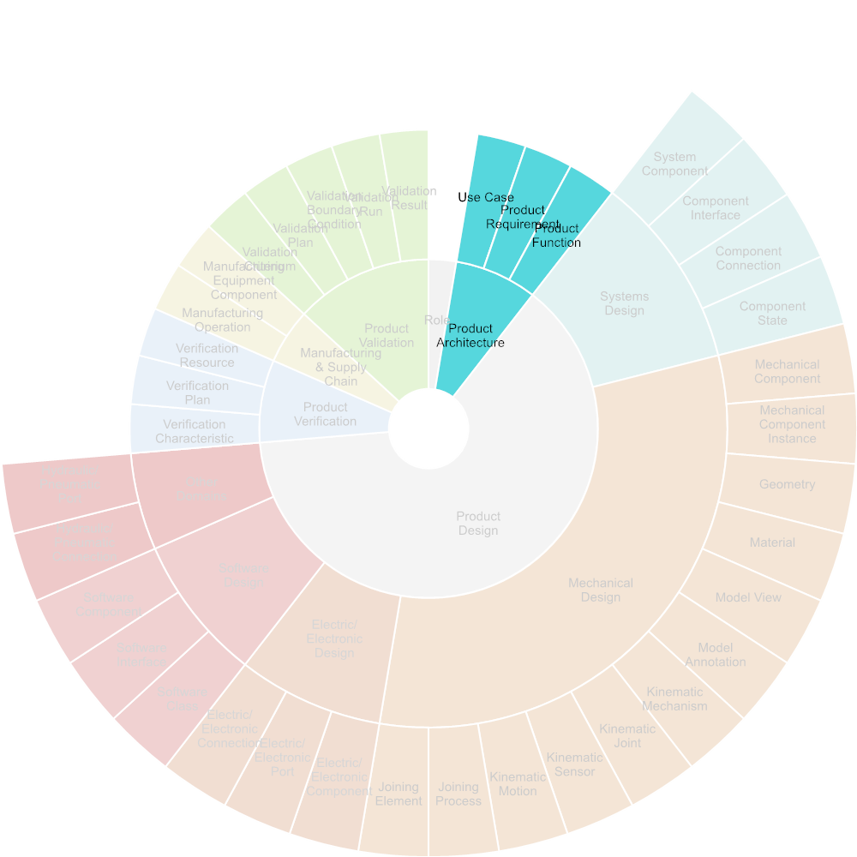

Figure Required Input

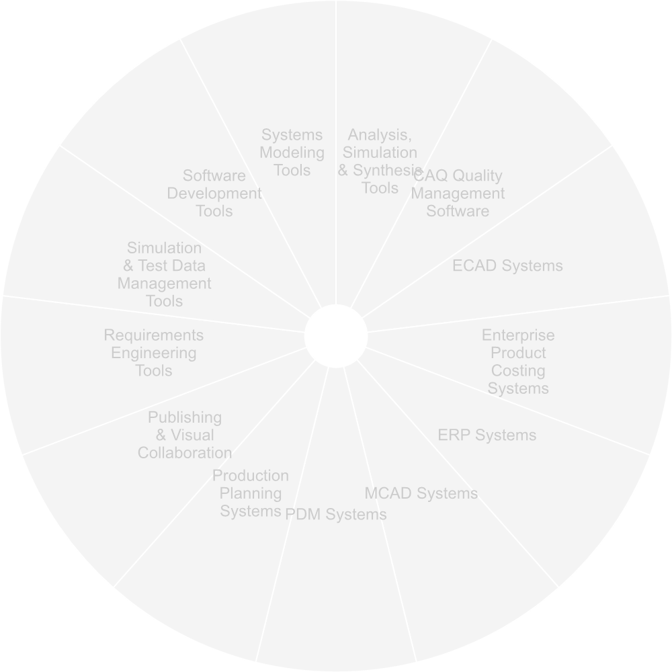

Figure Used Tools

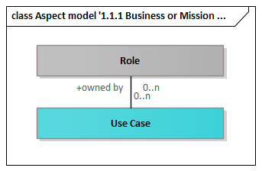

Figure Aspect model '1.1.1 Business or Mission Analysis'

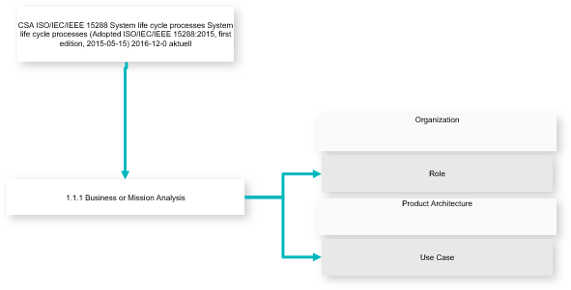

Figure Use-case Diagram

|  |  |
| --- | --- |
| **Inputs** | Role  Use Case |

##### Requirements Engineering

Requirements engineering is the process of defining, eliciting, documenting, and maintaining requirements in the engineering design process.

Description based on: https://en.wikipedia.org/wiki/Requirements_engineering

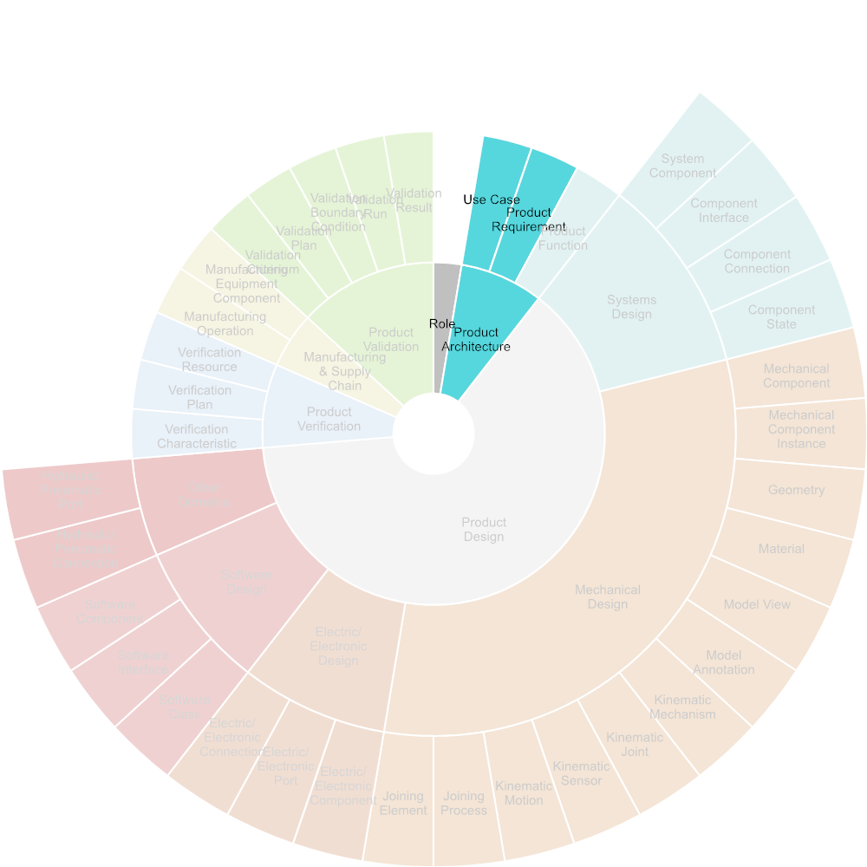

Figure Required Input

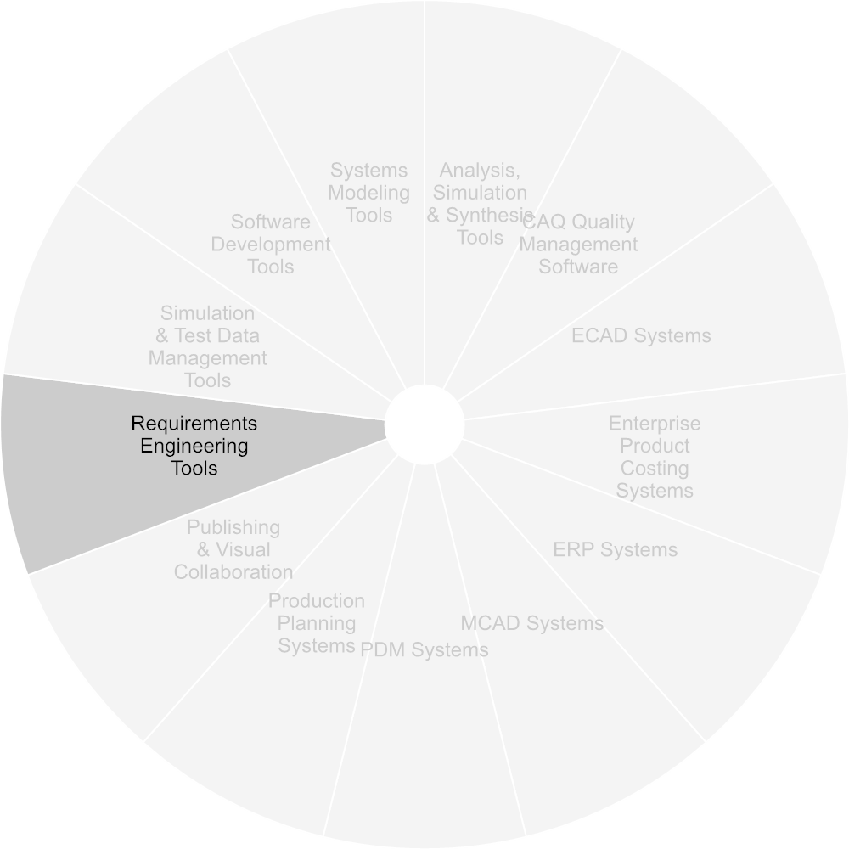

Figure Used Tools

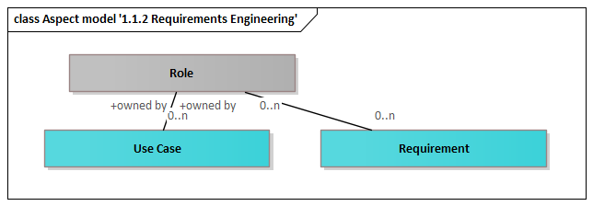

Figure Aspect model '1.1.2 Requirements Engineering'

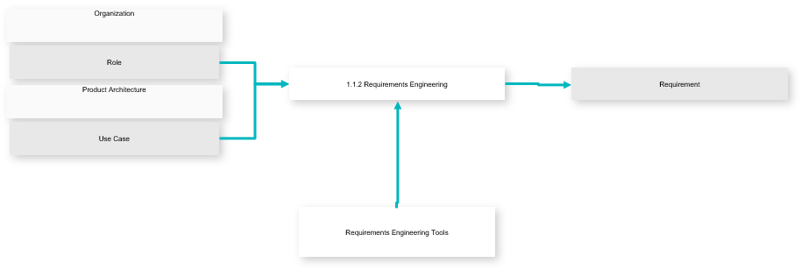

Figure Use-case Diagram

|  |  |
| --- | --- |
| **Inputs** | Requirement |
| **Outputs** | Role  Use Case |

##### Systems Architecture

Systems architecture refers to the cross-domain definition of functions and logical structures at systems level, that will be pursued in detail by the individual domains mechanical design, electric/electronic design and software design.

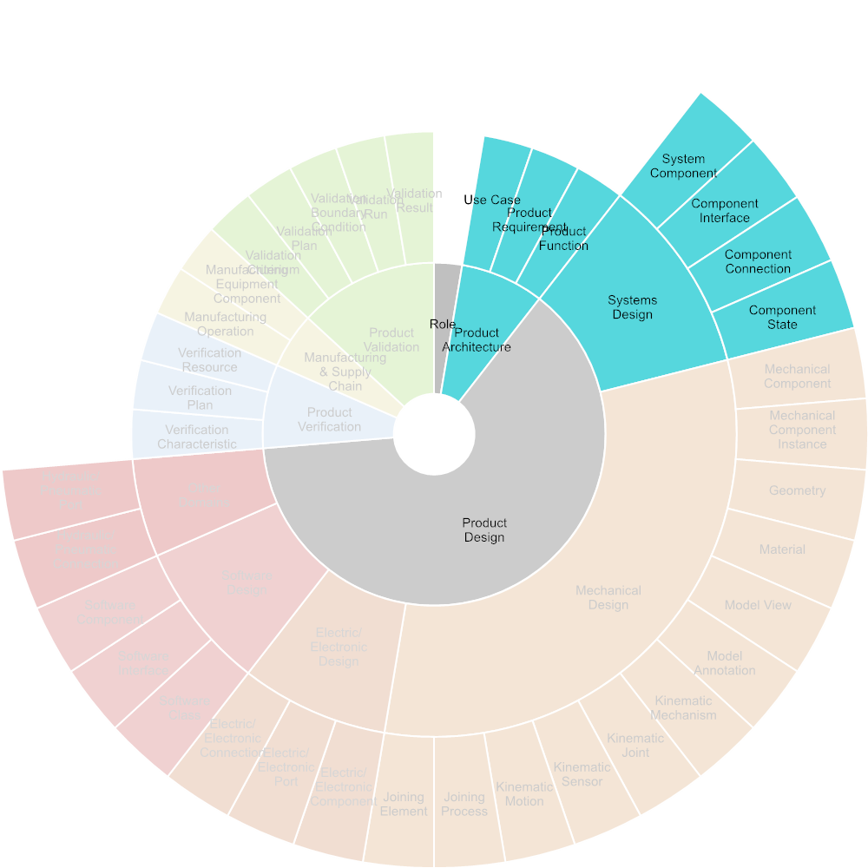

Figure Required Input

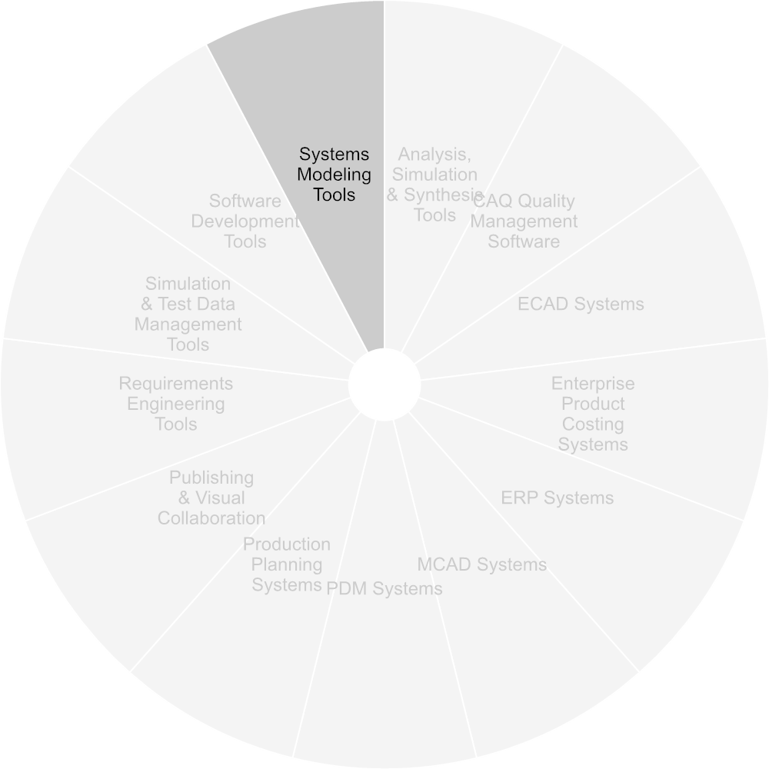

Figure Used Tools

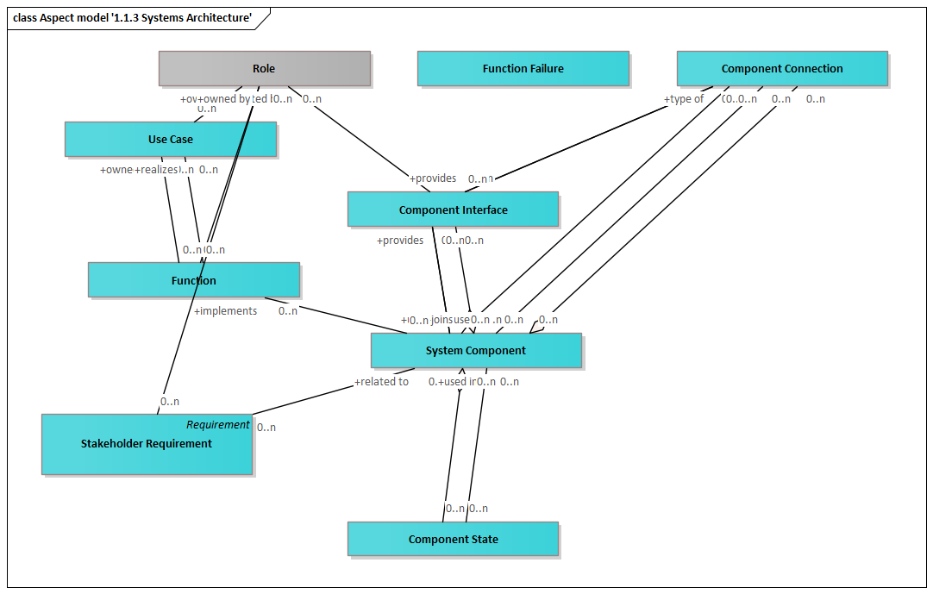

Figure Aspect model '1.1.3 Systems Architecture'

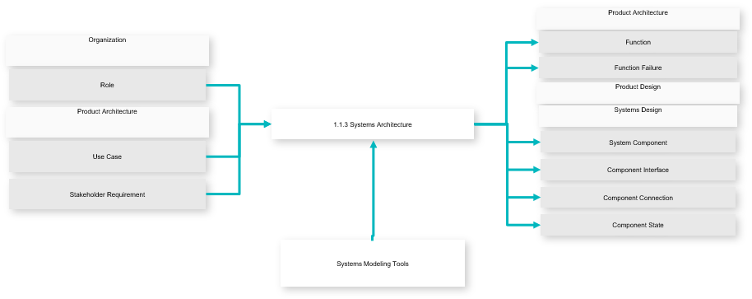

Figure Use-case Diagram

|  |  |
| --- | --- |
| **Inputs** | Function  Function Failure  System Component  Component Interface  Component Connection  Component State |
| **Outputs** | Role  Use Case  Stakeholder Requirement |

##### Functional Safety

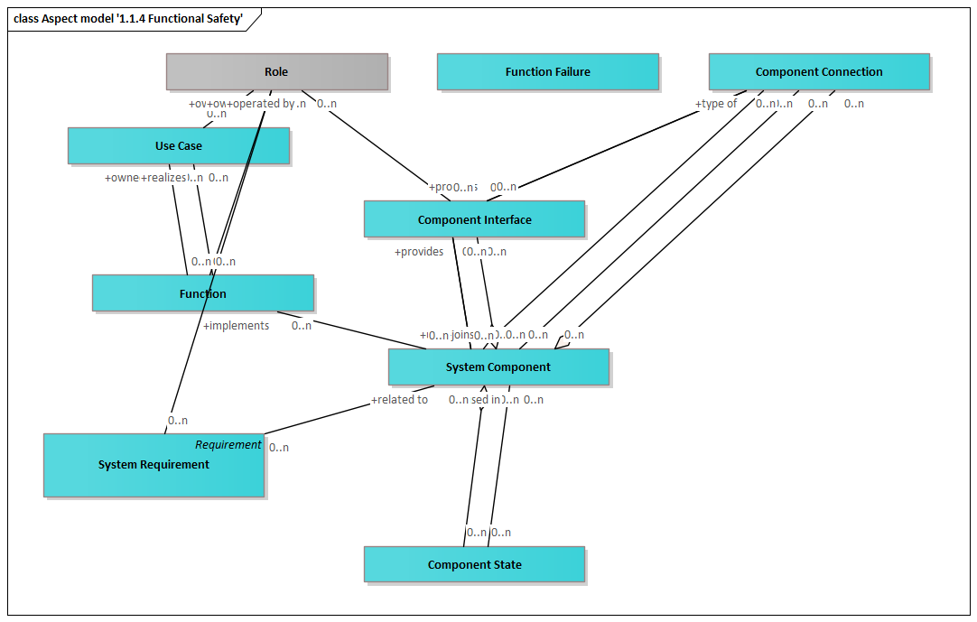

Figure Aspect model '1.1.4 Functional Safety'

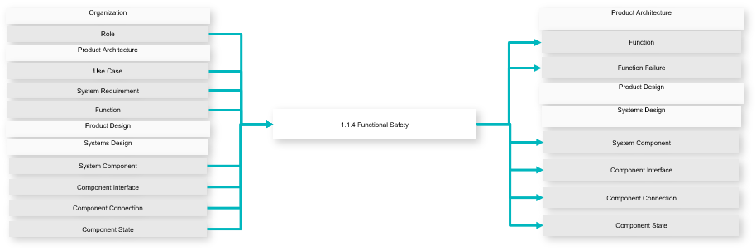

Figure Use-case Diagram

|  |  |
| --- | --- |
| **Inputs** | Function  Function Failure  System Component  Component Interface  Component Connection  Component State |
| **Outputs** | Role  Use Case  System Requirement  Function  System Component  Component Interface  Component Connection  Component State |

#### Product Design

Product Design is the specific synthesis, implentation and documentation of design solutions suggested by systems engineering.

Product design comprises the domain-specific design processes of mechanical, electrical/electronical design, and software engineering.

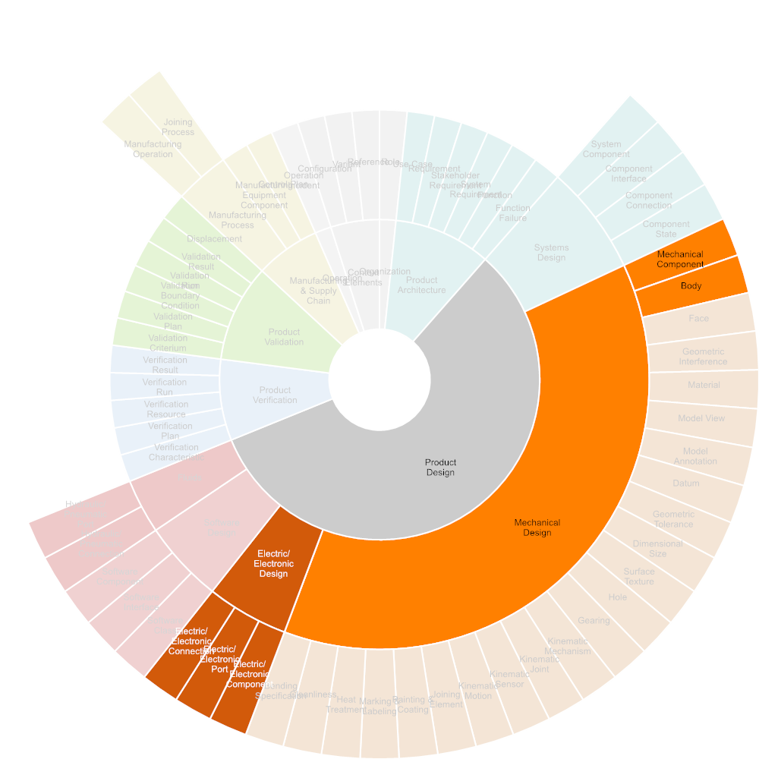

Figure Required Input

##### Mechanical Design

In Mechanical Design, physical product structure, product geometry, as well as all specifications are defined.

This includes shape, dimensioning and tolerancing, material (including semi-finished parts and treatment), surface and edge specifications.

Mechanical design is usually conducted using a mechanical CAD system.

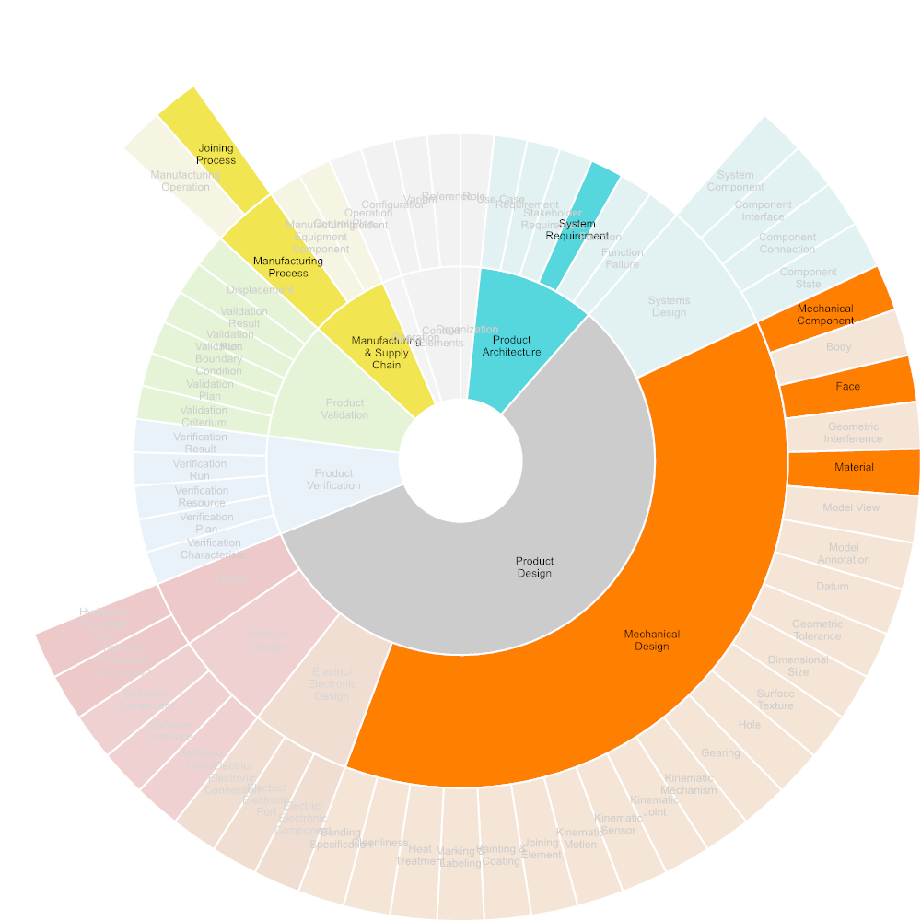

Figure Required Input

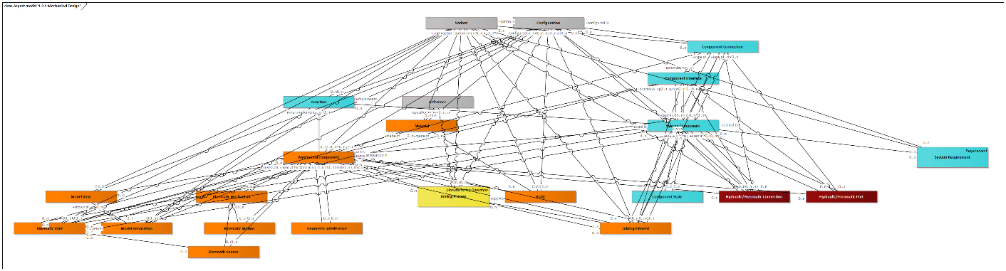

Figure Aspect model '1.2.1 Mechanical Design'

|  |  |
| --- | --- |
| **Inputs** | Mechanical Component  Body  Geometric Interference  Material  Model View  Model Annotation  Kinematic Mechanism  Kinematic Joint  Kinematic Sensor  Kinematic Motion  Joining Element  Hydraulic/Pneumatic Connection  Hydraulic/Pneumatic Port  Joining Process  Configuration  Variant  Reference |
| **Outputs** | System Requirement  Function  System Component  Component Interface  Component Connection  Component State |

###### Define Joining Elements

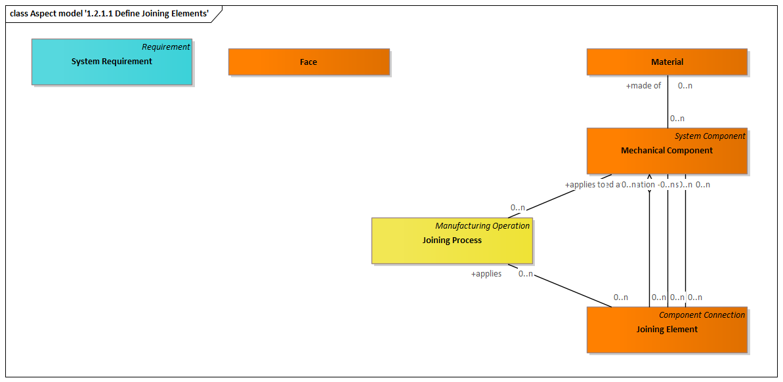

Figure Aspect model '1.2.1.1 Define Joining Elements'

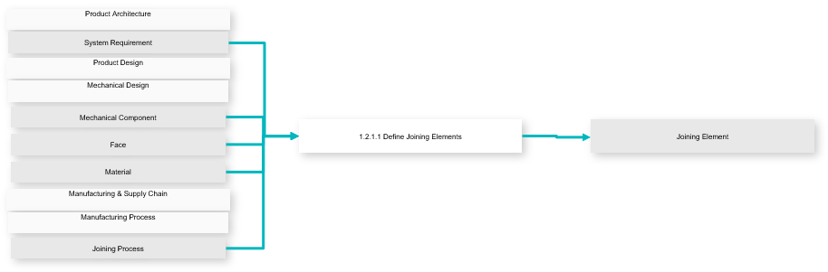

Figure Use-case Diagram

|  |  |
| --- | --- |
| **Inputs** | Joining Element |
| **Outputs** | System Requirement  Mechanical Component  Face  Material  Joining Process |

###### Define Joining Elements

see: Define Joining Elements

|  |  |
| --- | --- |
| **Inputs** | Joining Element |
| **Outputs** | System Requirement  Mechanical Component  Face  Material  Joining Process |

##### Electrical/Electronical Design

In Electrical/Electronic Design, all electrical and electronic products functions will be implemented through electrical and electonic components selection and allocation, circuit board design, and wire and harness routing.

Electrical/Electronic Design is usually performed using an electrical/electronic CAD system.

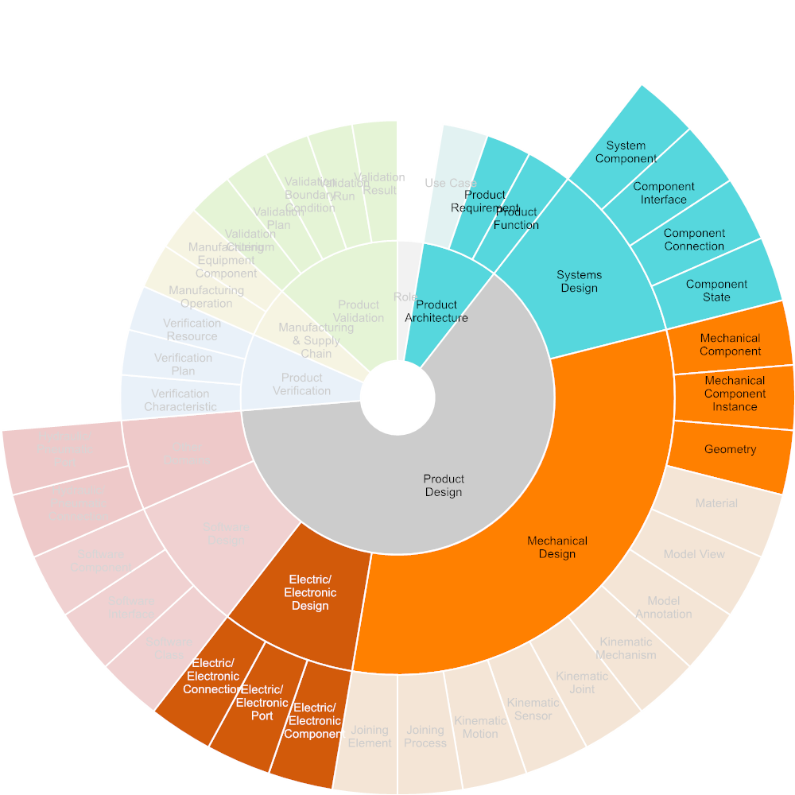

Figure Required Input

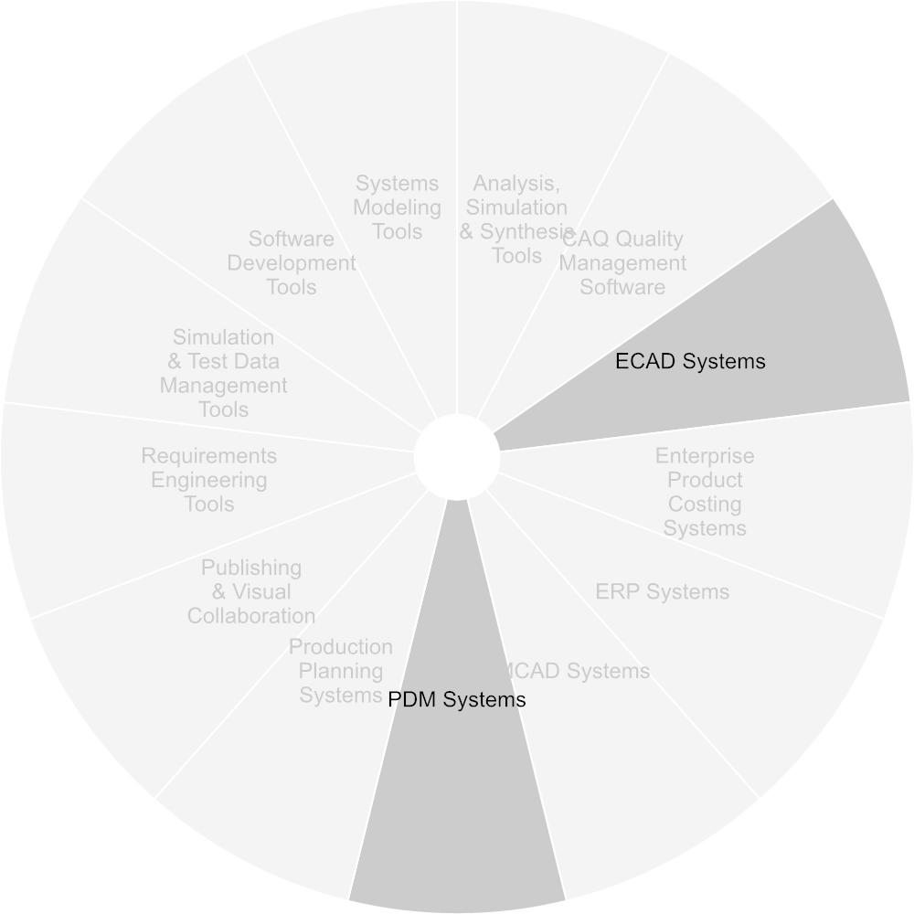

Figure Used Tools

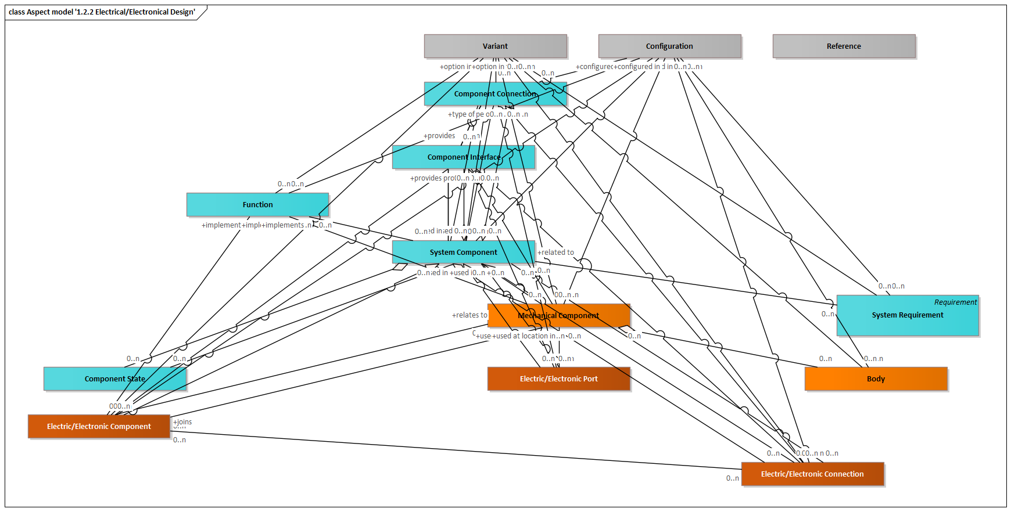

Figure Aspect model '1.2.2 Electrical Electronical Design'

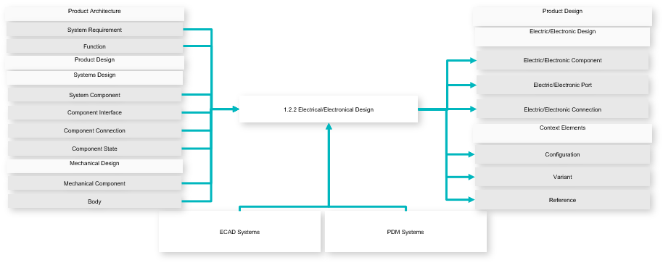

Figure Use-case Diagram

|  |  |
| --- | --- |
| **Inputs** | Electric/Electronic Component  Electric/Electronic Port  Electric/Electronic Connection  Configuration  Variant  Reference |
| **Outputs** | System Requirement  Function  System Component  Component Interface  Component Connection  Component State  Mechanical Component  Body |

##### Software Engineering

In Software Engineering, embedded software is developed that will connect the product to the user, as well as to other products and systems.

For configuration reasons it may be that software is treated a part to be considered in Bills of Material of products or systems and to be configured related to mechanical or electronic configurations of a system.

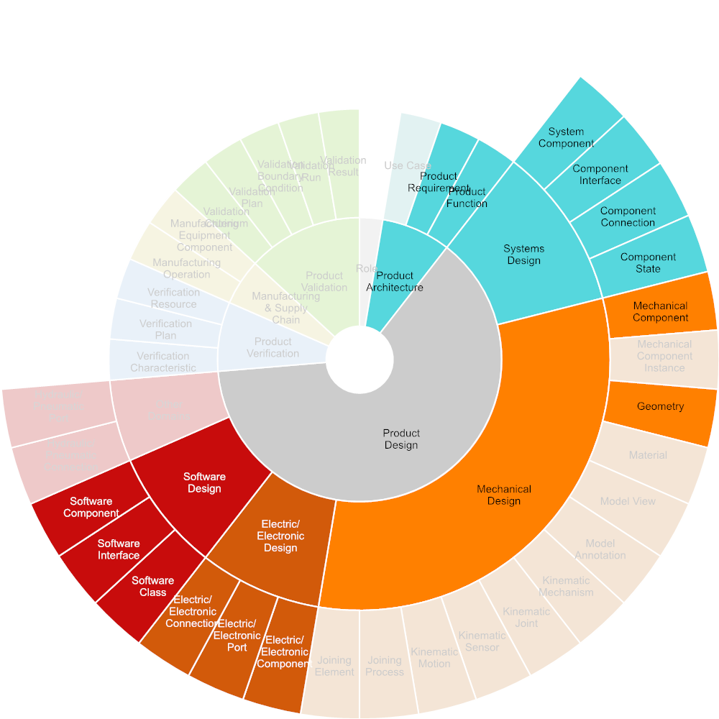

Figure Required Input

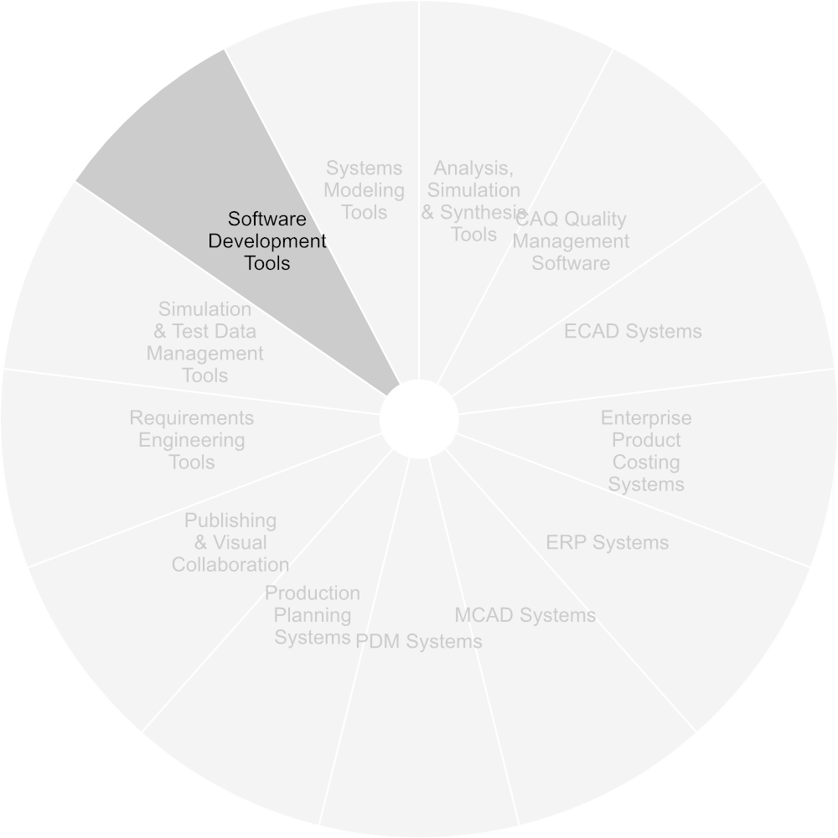

Figure Used Tools

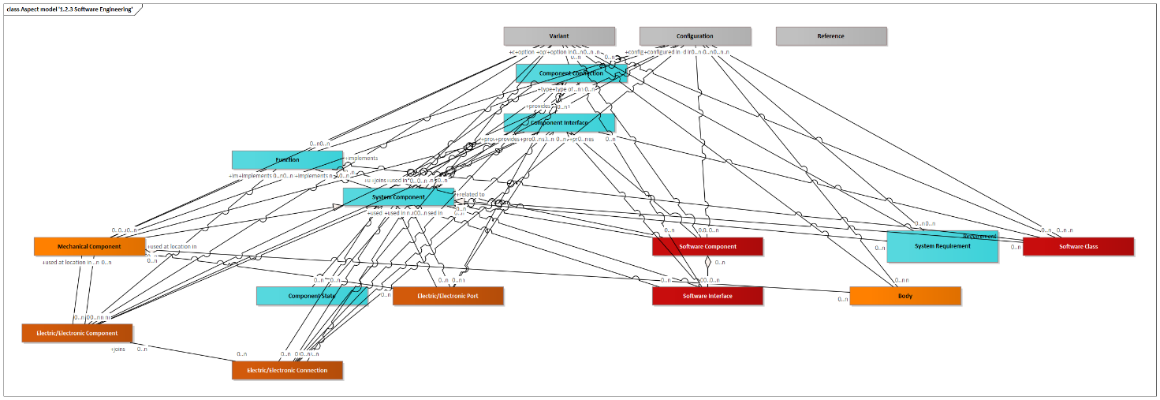

Figure Aspect model '1.2.3 Software Engineering'

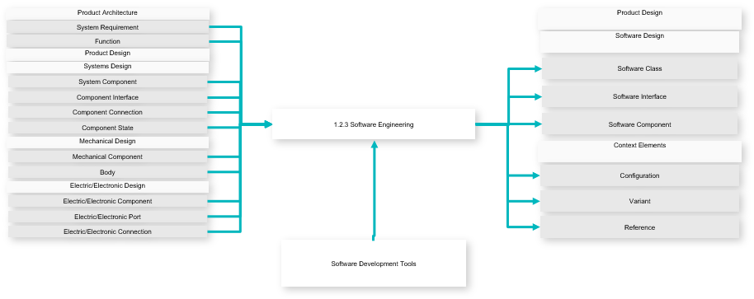

Figure Use-case Diagram

|  |  |
| --- | --- |
| **Inputs** | Software Class  Software Interface  Software Component  Configuration  Variant  Reference |
| **Outputs** | System Requirement  Function  System Component  Component Interface  Component Connection  Component State  Mechanical Component  Body  Electric/Electronic Component  Electric/Electronic Port  Electric/Electronic Connection |

##### Electrical/Mechanical Design Collaboration

In Electrical/Mechanical Design Collaboration, both design disciplines involved will collaborate in a common 3D space in order to adjust and coordinate allocation, dimensioning and positioning of components.

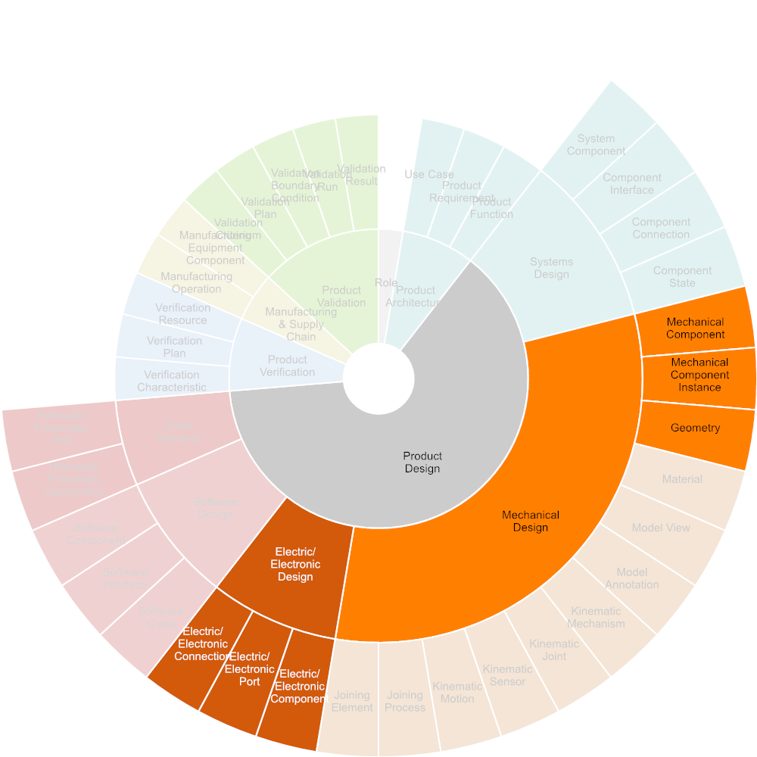

Figure Required Input

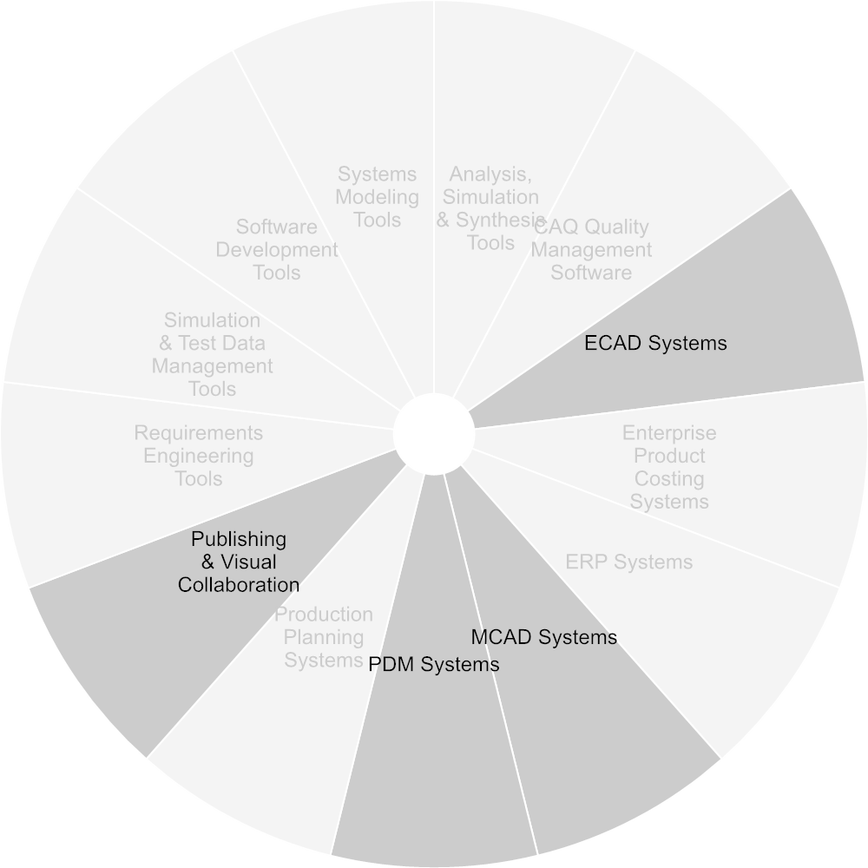

Figure Used Tools

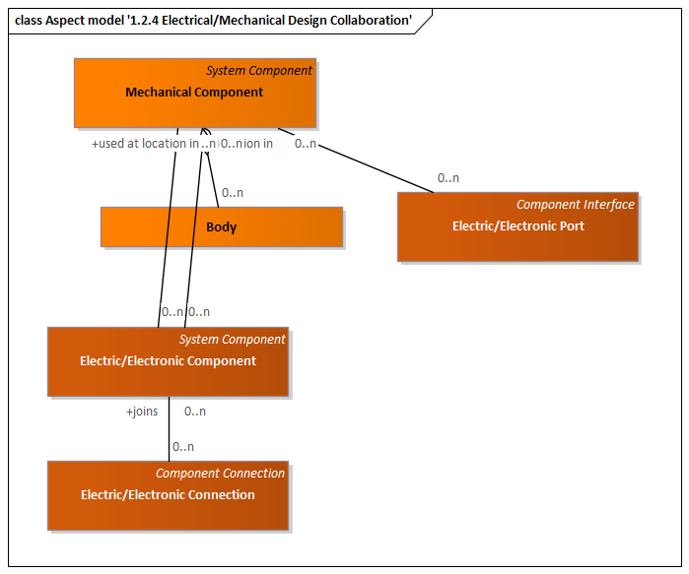

Figure Aspect model '1.2.4 Electrical Mechanical Design Collaboration'

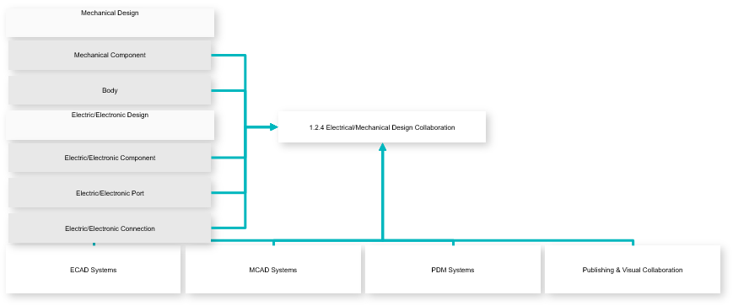

Figure Use-case Diagram

|  |  |
| --- | --- |
| **Outputs** | Mechanical Component  Body  Electric/Electronic Component  Electric/Electronic Port  Electric/Electronic Connection |

#### Verification & Validation using Simulation

Modeling and simulation (M&S) is the domain-specific use of models (e.g., physical, mathematical, or logical representation of a system, entity, phenomenon, or process) as a basis for simulations to develop data utilized for management or technical decision making.

Simulation may include finite elements analysis, fluid analysis, DMU simulation, kinematics simulation, as well as simulation based on software prototypes. It also includes X-in-the-Loop (XiL), using integrated design and simulation models and capabilities.

Verification aims at the demonstration of product compliance to the specified design requirements.

Validation aims at the demonstration of conformance to stakeholder requirements.

Description based on: https://en.wikipedia.org/wiki/Modeling_and_simulation, ISO 29148, ISO 15288

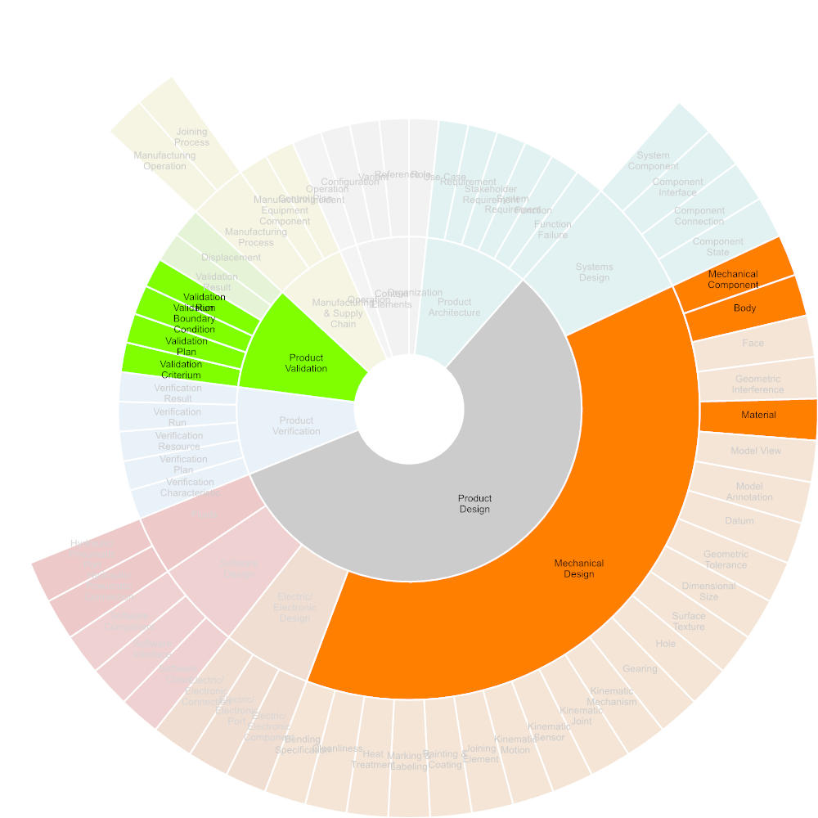

Figure Required Input

##### Plan and prepare Simulation

Planning and preparation of a simulation includes the specification of the simulation objectives based on product requirements and functions. This is followed by the definition of the simulation boundary conditions and the createion of simulation models according to simulation objectives.

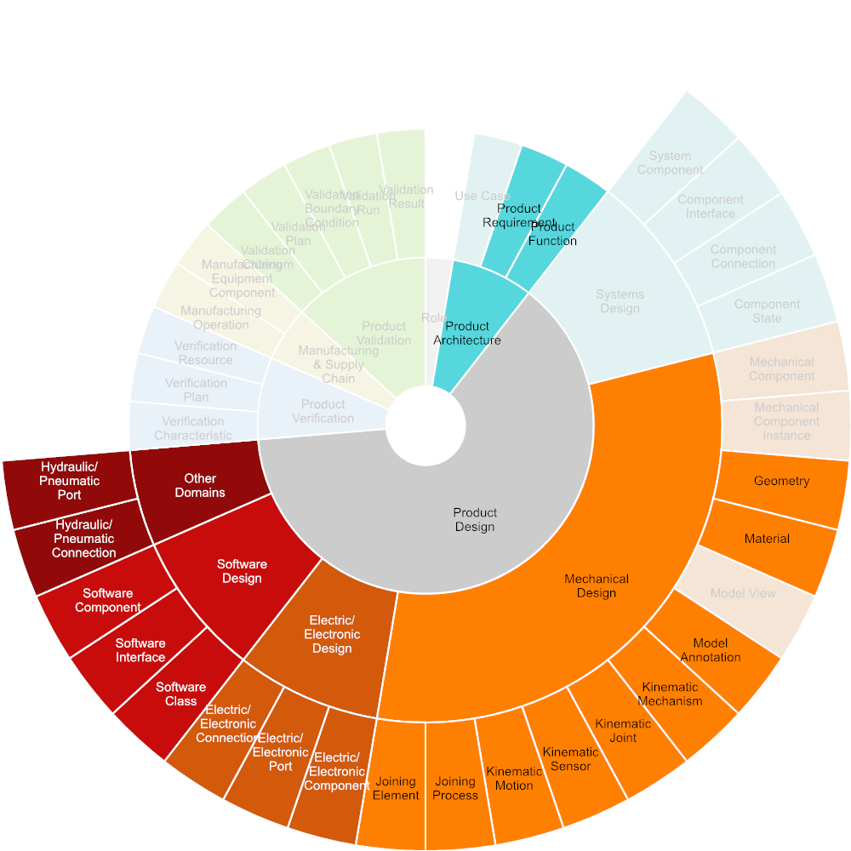

Figure Required Input

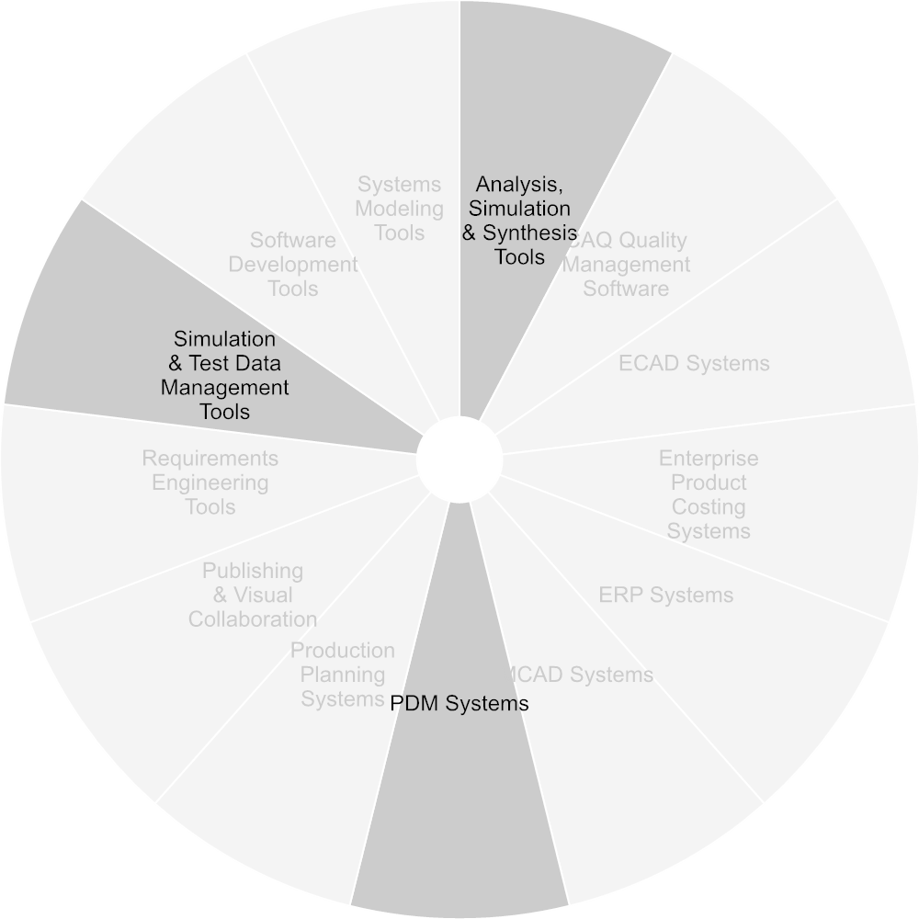

Figure Used Tools

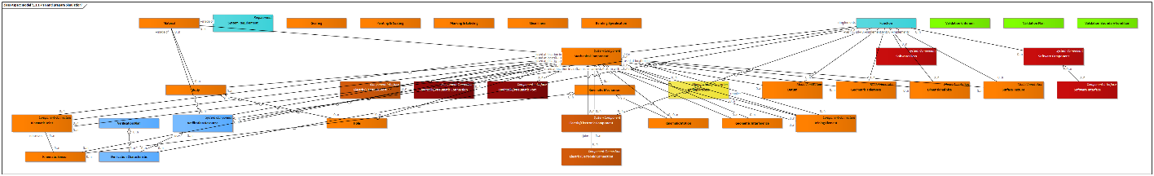

Figure Aspect model '1.3.1 Plan and prepare Simulation'

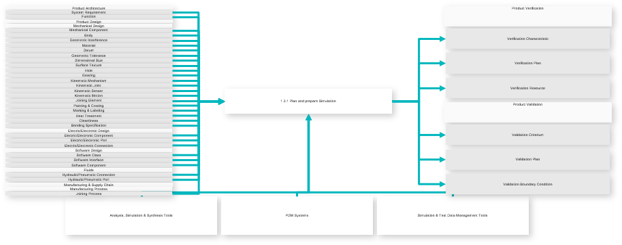

Figure Use-case Diagram

|  |  |
| --- | --- |
| **Inputs** | Verification Characteristic  Verification Plan  Verification Resource  Validation Criterium  Validation Plan  Validation Boundary Condition |
| **Outputs** | System Requirement  Function  Mechanical Component  Body  Geometric Interference  Material  Datum  Geometric Tolerance  Dimensional Size  Surface Texture  Hole  Gearing  Kinematic Mechanism  Kinematic Joint  Kinematic Sensor  Kinematic Motion  Joining Element  Painting & Coating  Marking & Labeling  Heat Treatment Area  Cleanliness  Bending Specification  Electric/Electronic Component  Electric/Electronic Port  Electric/Electronic Connection  Software Class  Software Interface  Software Component  Hydraulic/Pneumatic Connection  Hydraulic/Pneumatic Port  Joining Process |

##### Perform and document Simulation

Simulation execution includes performing the simulation as well as documenting and summarizing the simulation results.

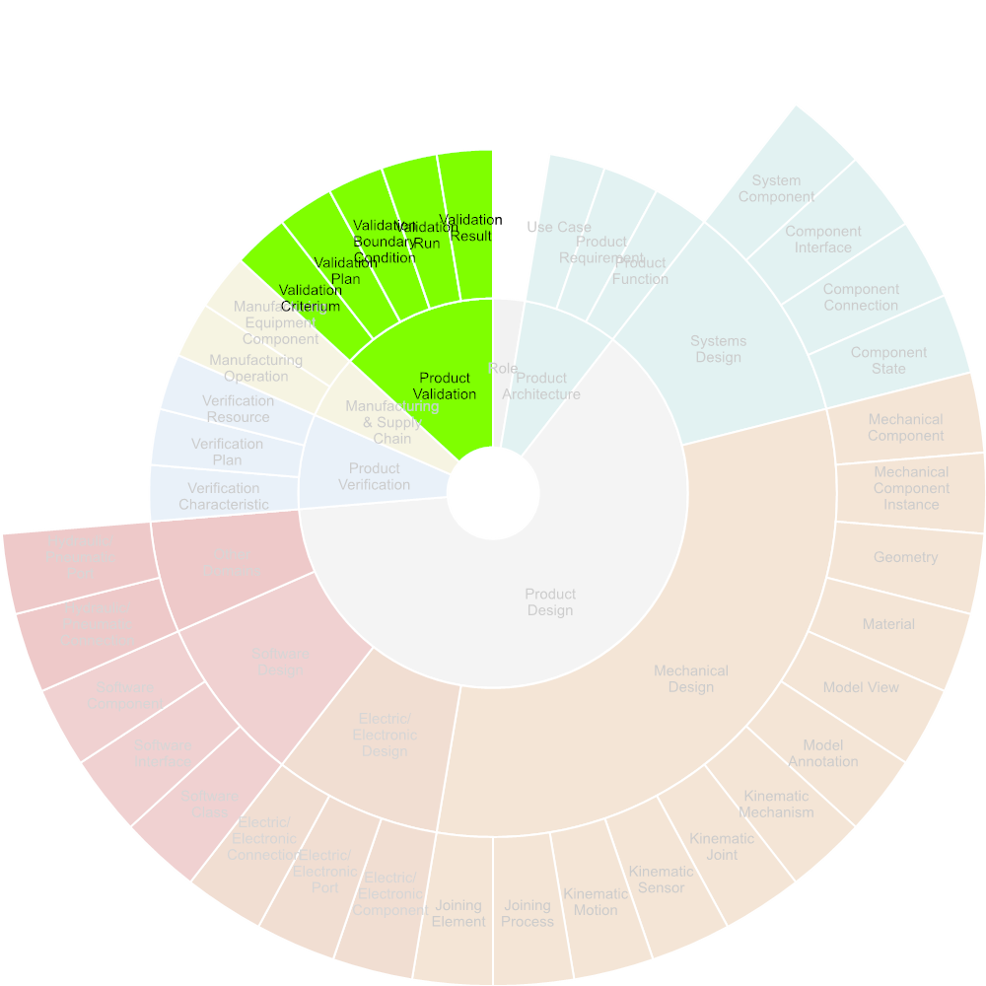

Figure Required Input

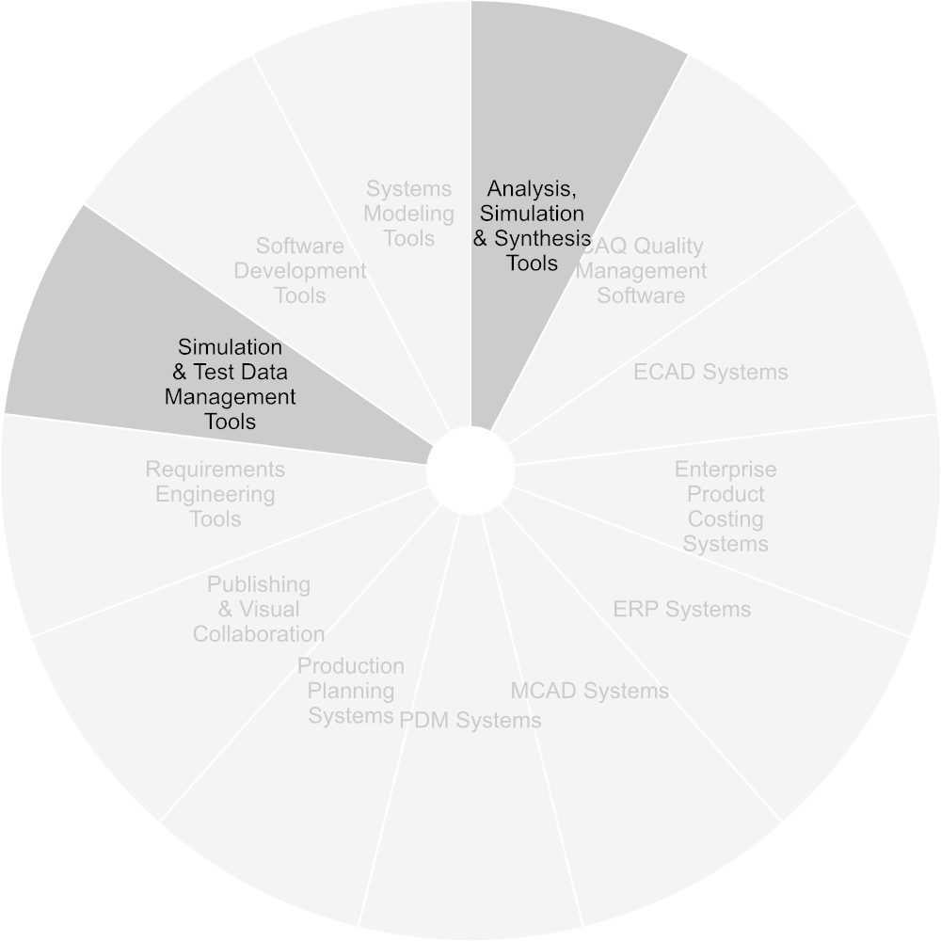

Figure Used Tools

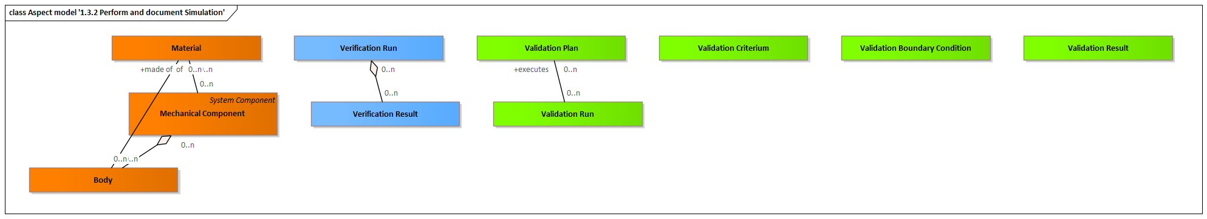

Figure Aspect model '1.3.2 Perform and document Simulation'

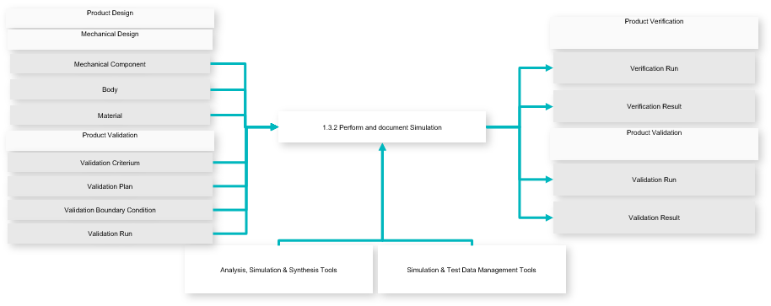

Figure Use-case Diagram

|  |  |
| --- | --- |
| **Inputs** | Verification Run  Verification Result  Validation Run  Validation Result |
| **Outputs** | Mechanical Component  Body  Material  Validation Criterium  Validation Plan  Validation Boundary Condition  Validation Run |

#### Verification & Validation using Test

While simulation is based on virtual models, testing is based on prototypes and samples.

Verification is to demonstrate product compliance to the specified design requirements. Validation is to demonstrate conformance to stakeholder requirements.

Description based on ISO 29148, resp. ISO 15288

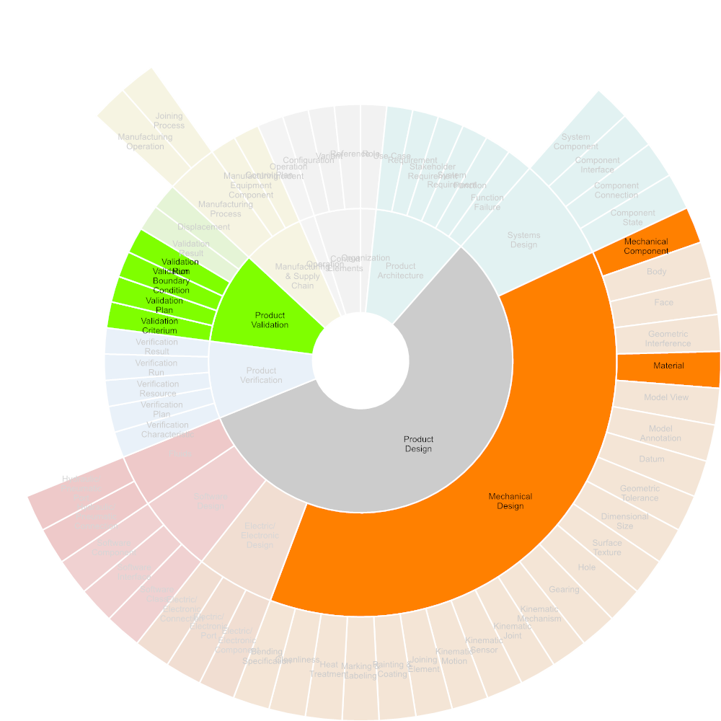

Figure Required Input

##### Prepare Testing

Testing preparation includes the definition of product requirements and functions to be validated, the specification, design and manufacturing of samples, prototypes and test rigs.



Figure Required Input

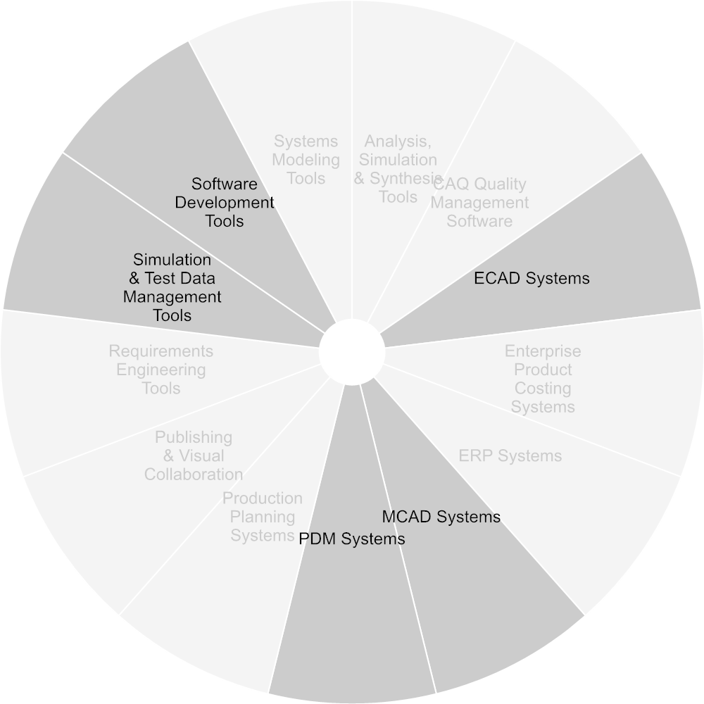

Figure Used Tools

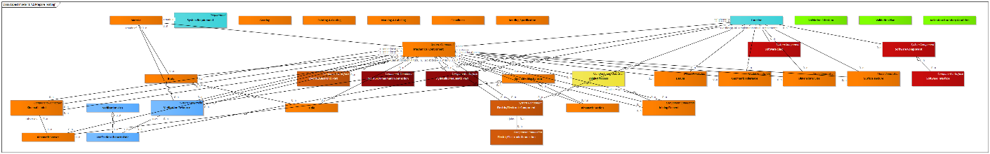

Figure Aspect model '1.4.1 Prepare Testing'

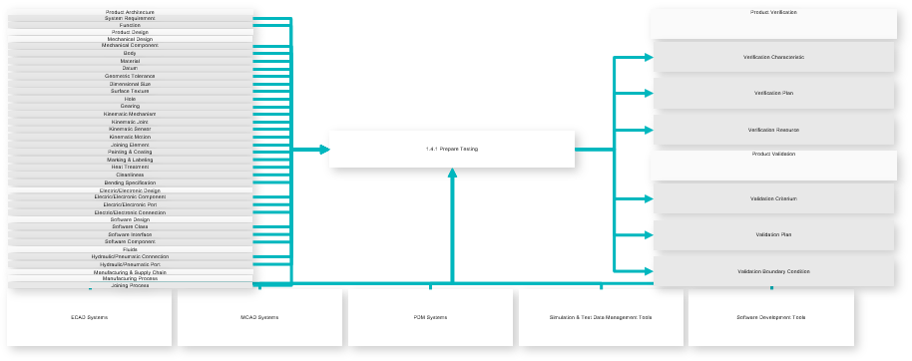

Figure Use-case Diagram

|  |  |
| --- | --- |
| **Inputs** | Verification Characteristic  Verification Plan  Verification Resource  Validation Criterium  Validation Plan  Validation Boundary Condition |
| **Outputs** | System Requirement  Function  Mechanical Component  Body  Material  Datum  Geometric Tolerance  Dimensional Size  Surface Texture  Hole  Gearing  Kinematic Mechanism  Kinematic Joint  Kinematic Sensor  Kinematic Motion  Joining Element  Painting & Coating  Marking & Labeling  Heat Treatment Area  Cleanliness  Bending Specification  Electric/Electronic Component  Electric/Electronic Port  Electric/Electronic Connection  Software Class  Software Interface  Software Component  Hydraulic/Pneumatic Connection  Hydraulic/Pneumatic Port  Joining Process |

##### Perform and document Testing

Testing execution includes scheduling tests, allocating the test rig, executing and documenting the test.



Figure Required Input

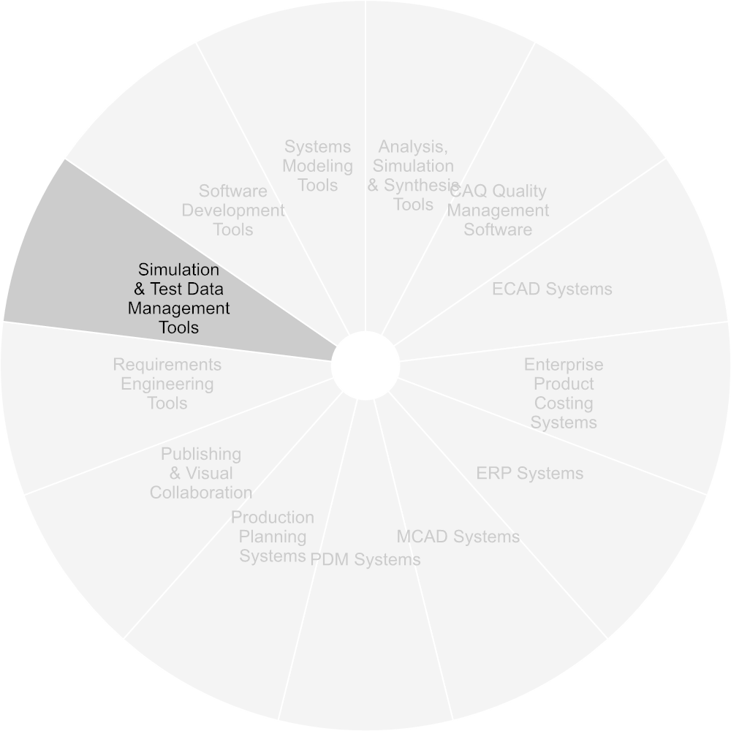

Figure Used Tools

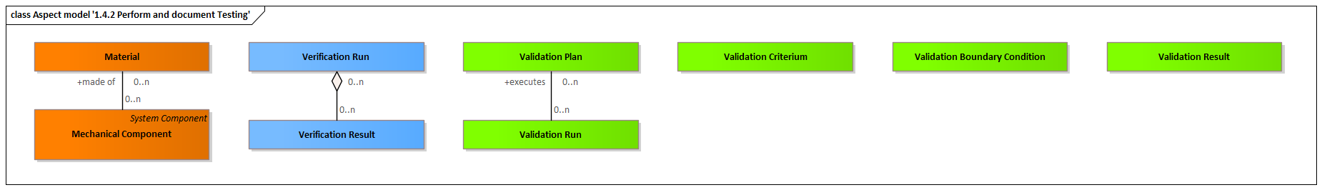

Figure Aspect model '1.4.2 Perform and document Testing'

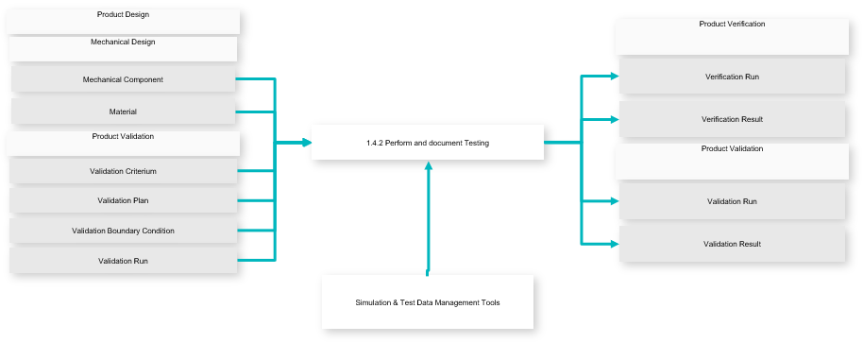

Figure Use-case Diagram

|  |  |
| --- | --- |
| **Inputs** | Verification Run  Verification Result  Validation Run  Validation Result |
| **Outputs** | Mechanical Component  Material  Validation Criterium  Validation Plan  Validation Boundary Condition  Validation Run |

### Production Development

The manufacturing or production engineer's primary focus is to turn raw material into an updated or new product in the most effective, efficient & economic way possible.

Manufacturing Engineering is based on core industrial engineering and mechanical engineering skills, adding important elements from mechatronics, commerce, economics and business management.

Source: https://en.wikipedia.org/wiki/Manufacturing_engineering

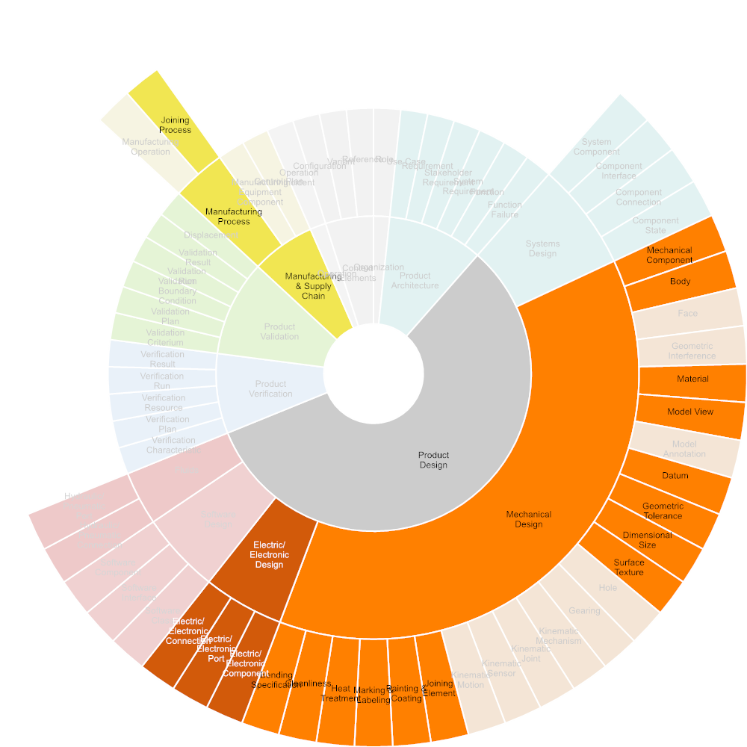

Figure Required Input



Figure Used Tools

#### Process Planning

The task in the manufacturing process planning domain is to find a plan to manufacture a set of parts.

Source: https://www.cs.cmu.edu/afs/cs/project/jair/pub/volume15/ambite01a-html/node23.html

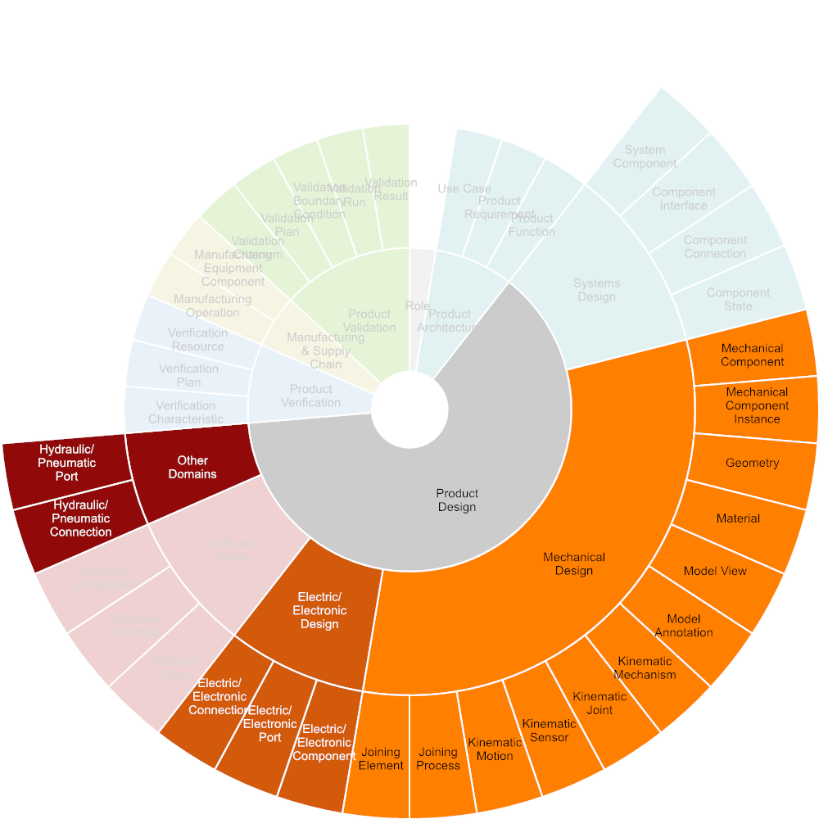

Figure Required Input

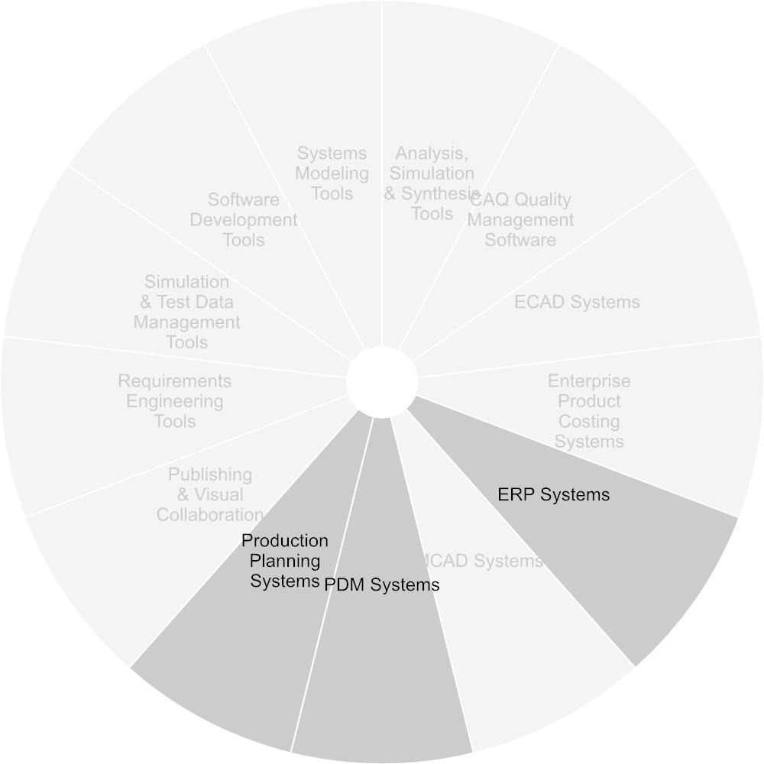

Figure Used Tools

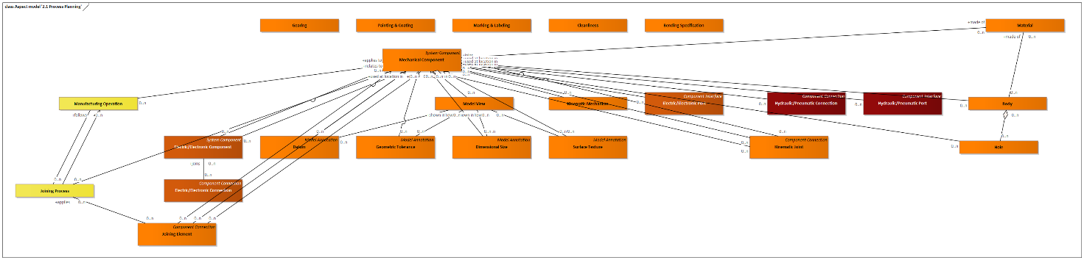

Figure Aspect model '2.1 Process Planning'

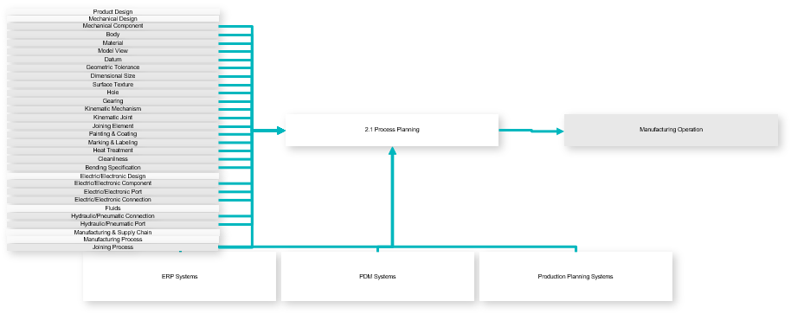

Figure Use-case Diagram

|  |  |
| --- | --- |
| **Inputs** | Manufacturing Operation |
| **Outputs** | Mechanical Component  Body  Material  Model View  Datum  Geometric Tolerance  Dimensional Size  Surface Texture  Hole  Gearing  Kinematic Mechanism  Kinematic Joint  Joining Element  Painting & Coating  Marking & Labeling  Heat Treatment Area  Cleanliness  Bending Specification  Electric/Electronic Component  Electric/Electronic Port  Electric/Electronic Connection  Hydraulic/Pneumatic Connection  Hydraulic/Pneumatic Port  Joining Process |

#### Inspection Planning

Includes the selection of relevant inspection criteria from product and production specifications, identification and assignment of appropriate inspection methods and equipment, as well as the allocation of appropriate inspection criteria per inspection event (first-article inspection, re-qualification, inspection in production, etc.)

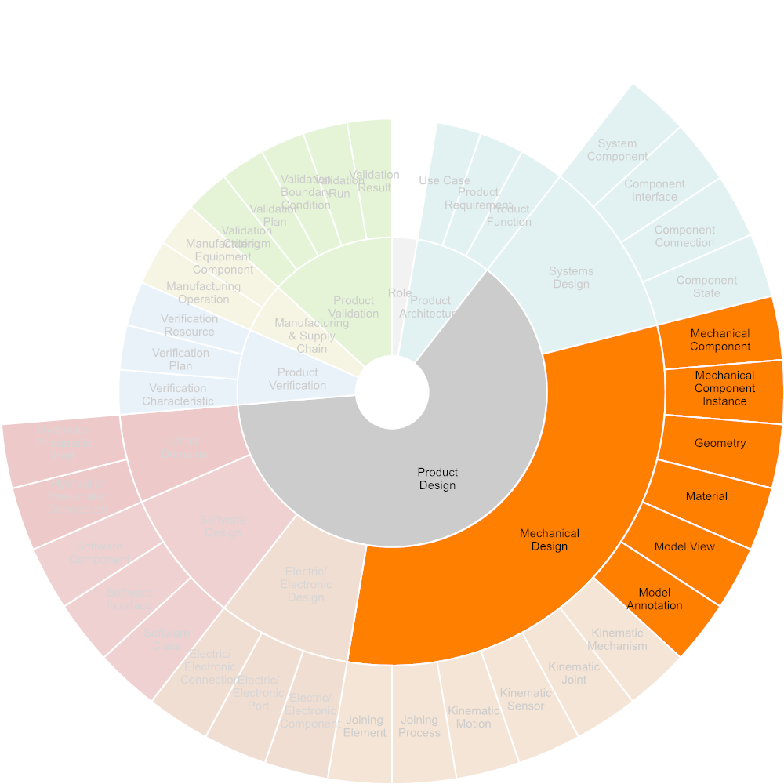

Figure Required Input

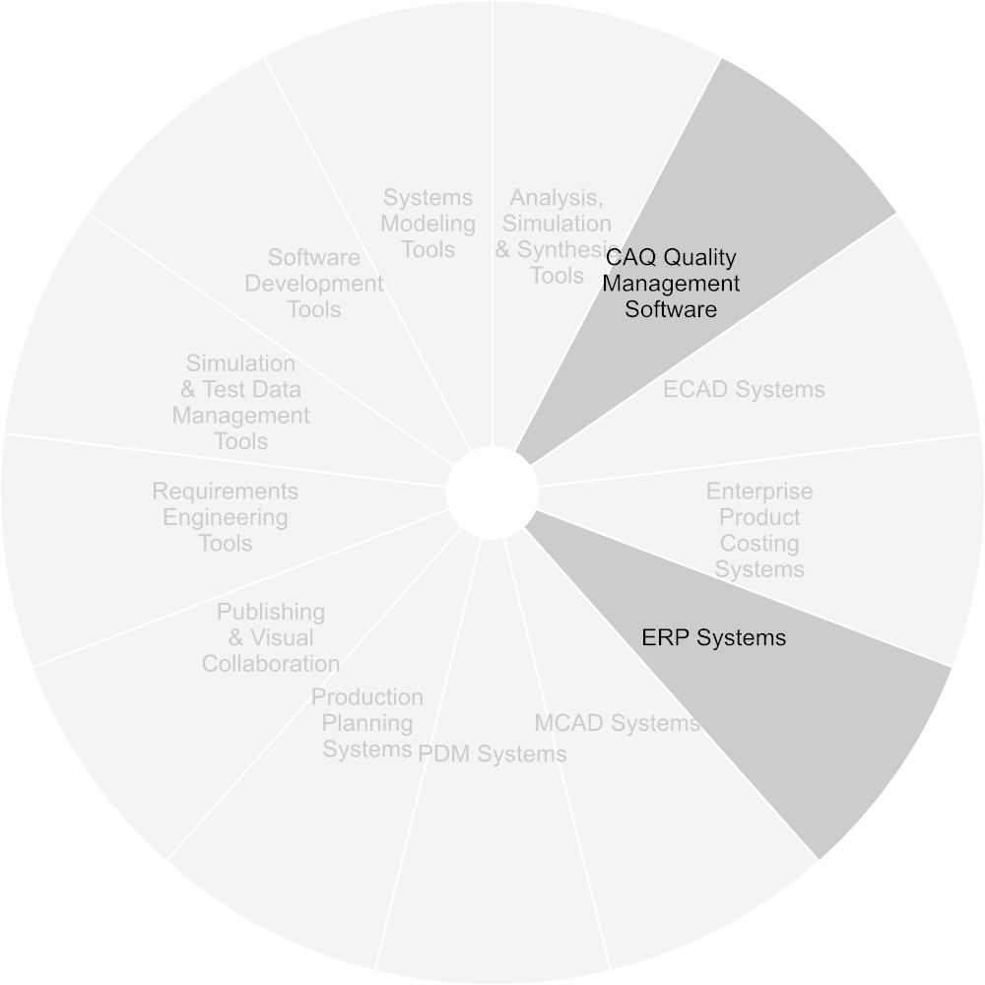

Figure Used Tools

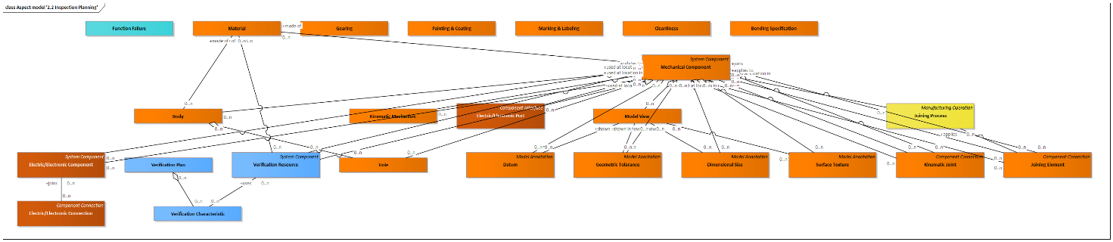

Figure Aspect model '2.2 Inspection Planning'

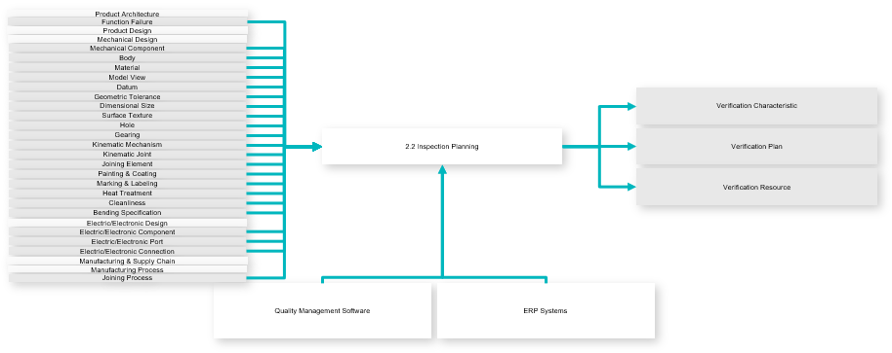

Figure Use-case Diagram

|  |  |
| --- | --- |
| **Inputs** | Verification Characteristic  Verification Plan  Verification Resource |
| **Outputs** | Function Failure  Mechanical Component  Body  Material  Model View  Datum  Geometric Tolerance  Dimensional Size  Surface Texture  Hole  Gearing  Kinematic Mechanism  Kinematic Joint  Joining Element  Painting & Coating  Marking & Labeling  Heat Treatment Area  Cleanliness  Bending Specification  Electric/Electronic Component  Electric/Electronic Port  Electric/Electronic Connection  Joining Process |

#### Cost Calculation

Includes the calculation of product cost using relevant information from product and production specifications, including dimensions, material, mass, geometric & topological complexity, surface finish including paint or coatings.

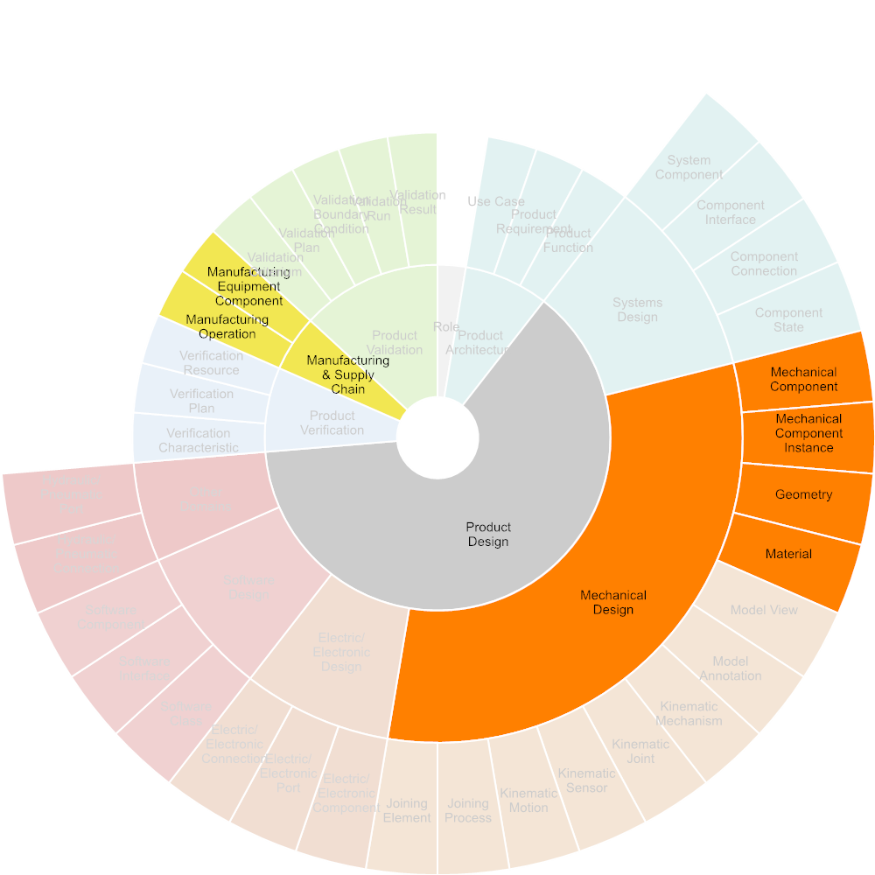

Figure Required Input

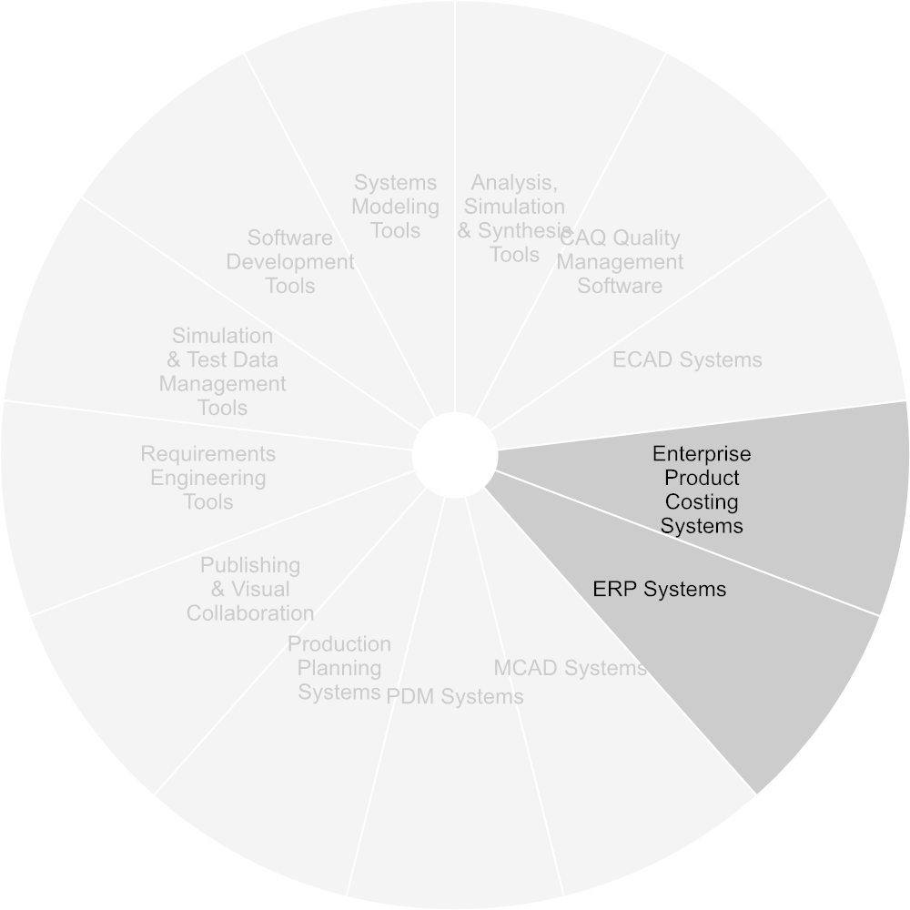

Figure Used Tools

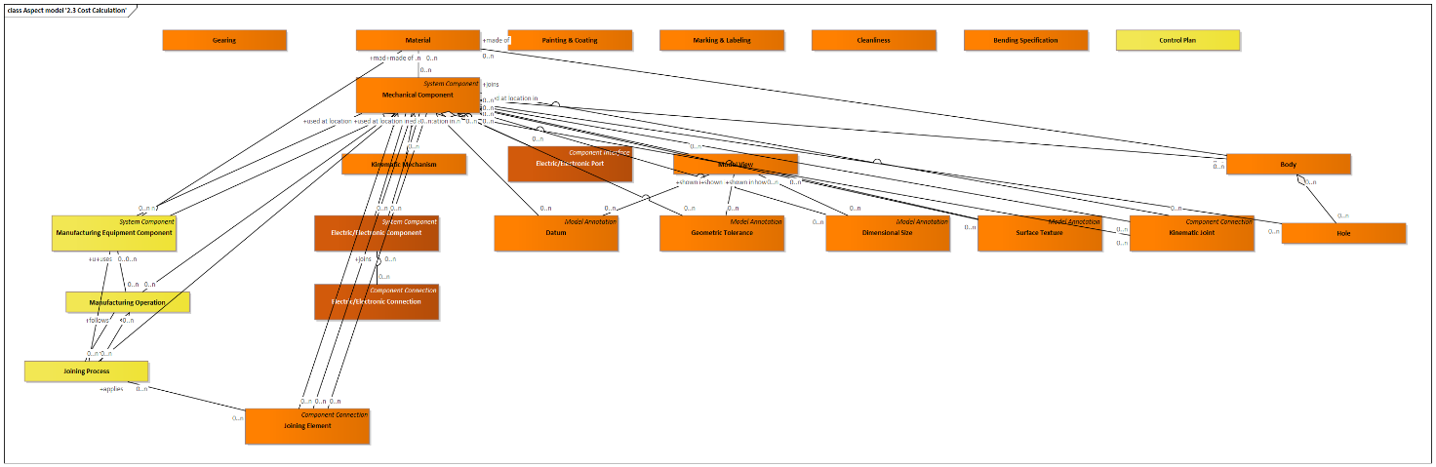

Figure Aspect model '2.3 Cost Calculation'

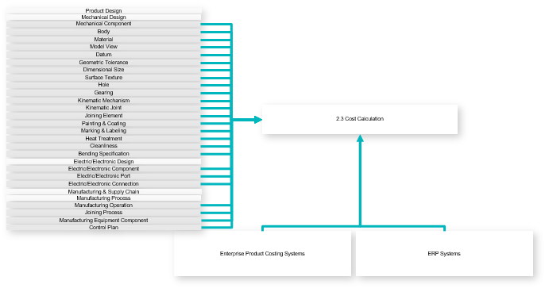

Figure Use-case Diagram

|  |  |
| --- | --- |
| **Outputs** | Mechanical Component  Body  Material  Model View  Datum  Geometric Tolerance  Dimensional Size  Surface Texture  Hole  Gearing  Kinematic Mechanism  Kinematic Joint  Joining Element  Painting & Coating  Marking & Labeling  Heat Treatment Area  Cleanliness  Bending Specification  Electric/Electronic Component  Electric/Electronic Port  Electric/Electronic Connection  Manufacturing Operation  Joining Process  Manufacturing Equipment Component  Control Plan |

#### Plant Layout

Defines the logical and physical layout of a production line in a plant or buiding using information from product and production specifications, including production steps, material handling, as well as the physical dimensions of product components, tools, fixtures and equipment within the topology and systems of the manufacturing site or building.

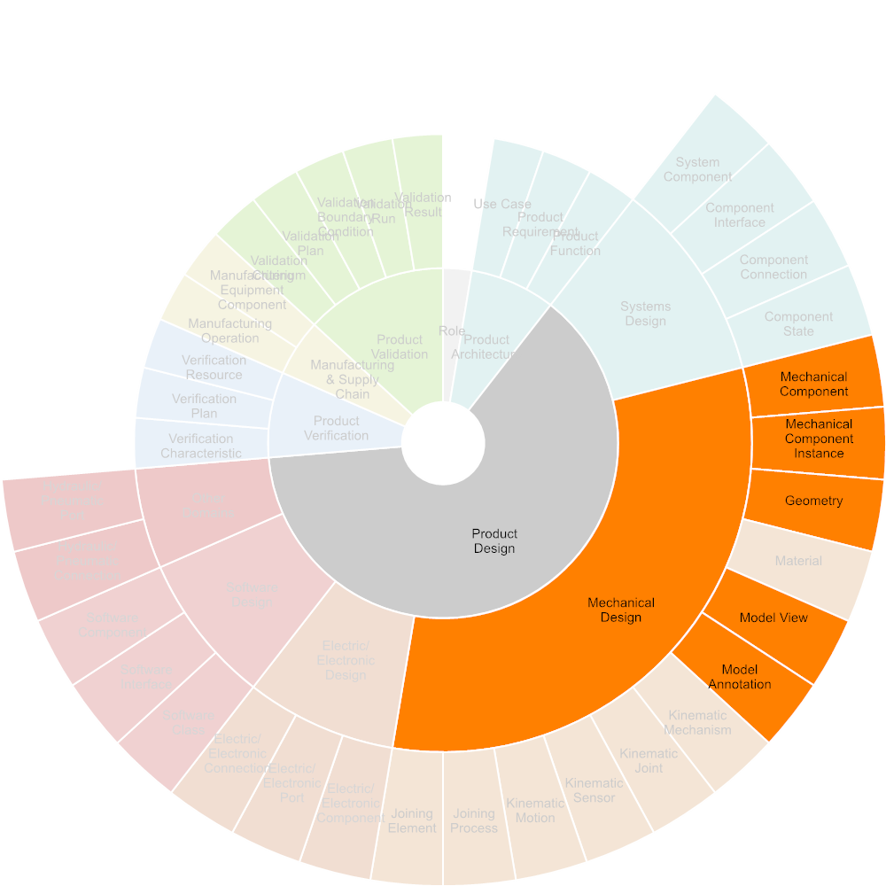

Figure Required Input



Figure Used Tools

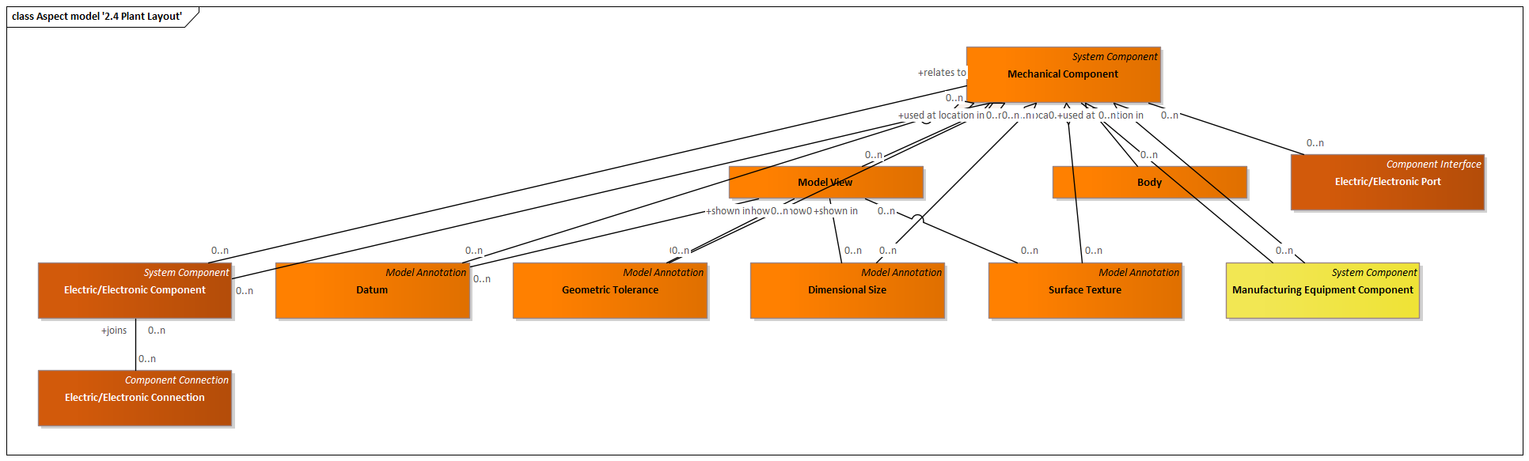

Figure Aspect model '2.4 Plant Layout'

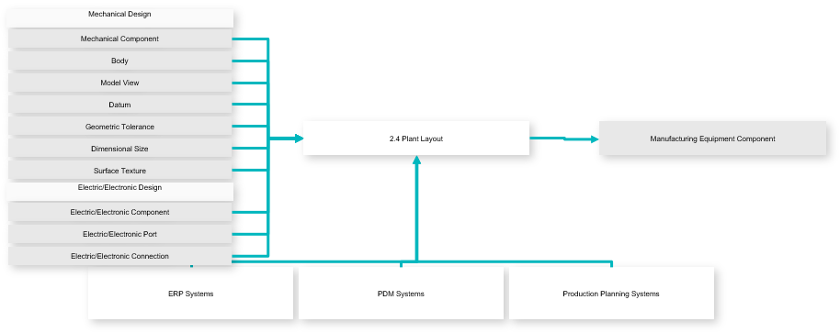

Figure Use-case Diagram

|  |  |
| --- | --- |
| **Inputs** | Manufacturing Equipment Component |
| **Outputs** | Mechanical Component  Body  Model View  Datum  Geometric Tolerance  Dimensional Size  Surface Texture  Electric/Electronic Component  Electric/Electronic Port  Electric/Electronic Connection |

#### Tools & Equipment Design

The design of tools and equipment aligned with product design, the manufacturing process plan and plant layout.

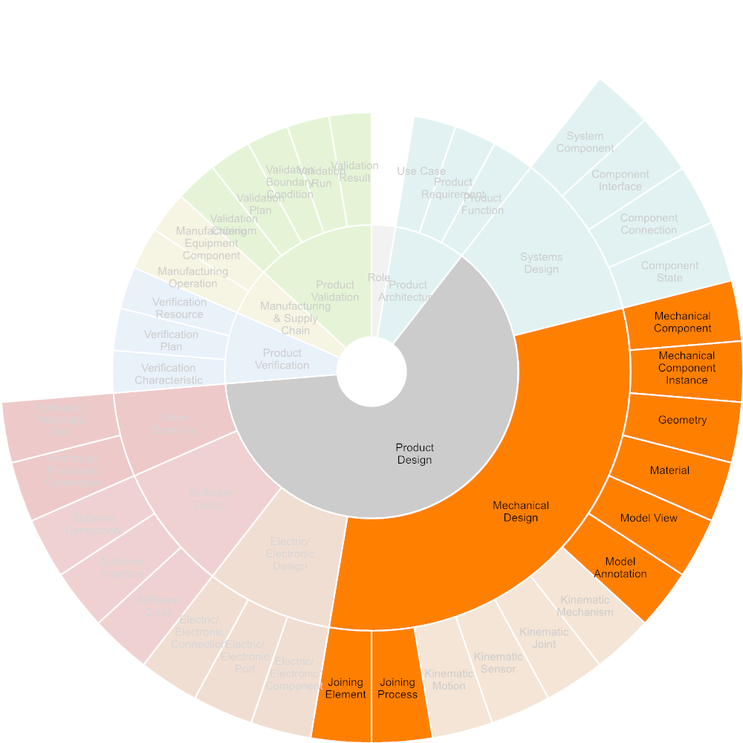

Figure Required Input

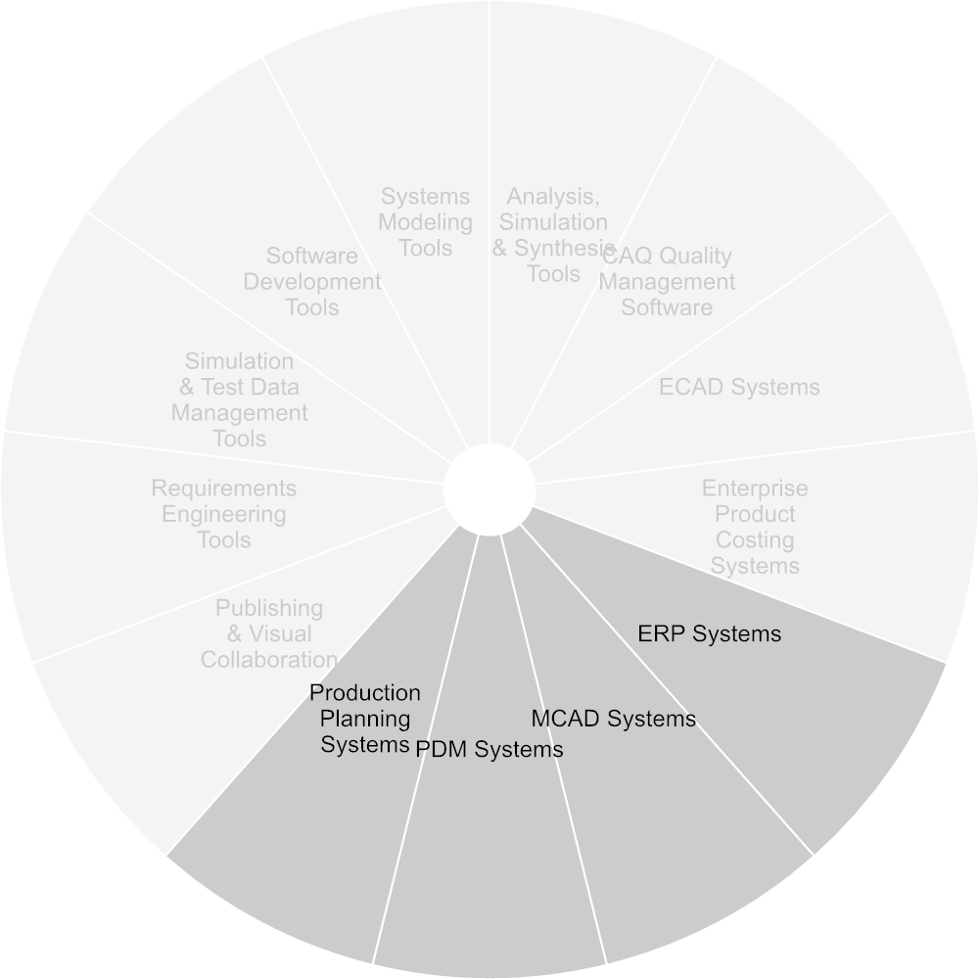

Figure Used Tools

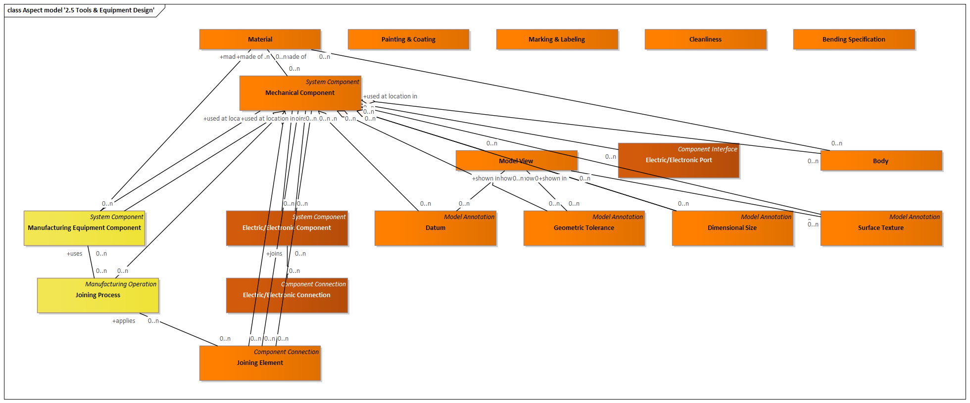

Figure Aspect model '2.5 Tools & Equipment Design'

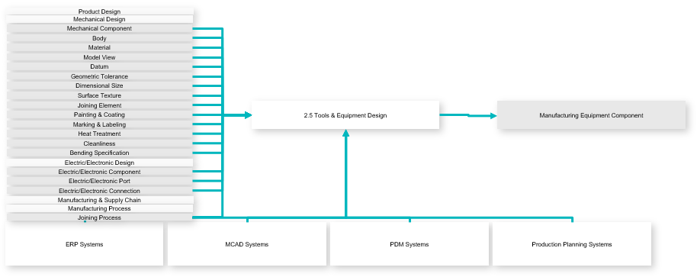

Figure Use-case Diagram

|  |  |
| --- | --- |
| **Inputs** | Manufacturing Equipment Component |
| **Outputs** | Mechanical Component  Body  Material  Model View  Datum  Geometric Tolerance  Dimensional Size  Surface Texture  Joining Element  Painting & Coating  Marking & Labeling  Heat Treatment Area  Cleanliness  Bending Specification  Electric/Electronic Component  Electric/Electronic Port  Electric/Electronic Connection  Joining Process |

### Manufacturing & Supply Chain

Includes all activities related to source and manufacture a product in different companies, plants, or locations.

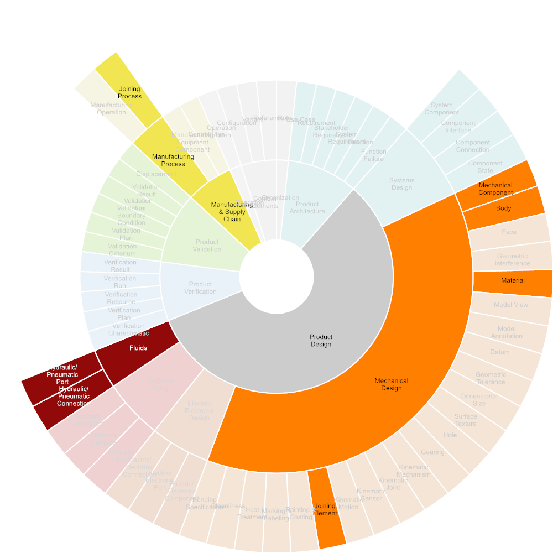

Figure Required Input

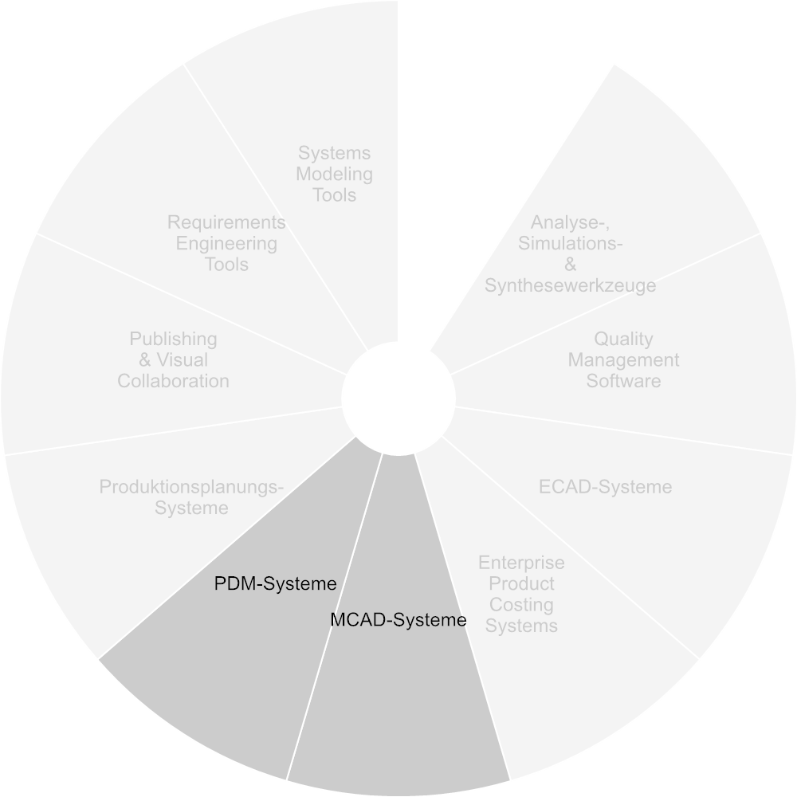

Figure Verwendete Tools

#### Parts Manufacturing

Manufacturing of single parts using a variety of production processes and methods, each with specific sets of data, such as CNC programs, bending specification, holes specifications, joining features, etc.

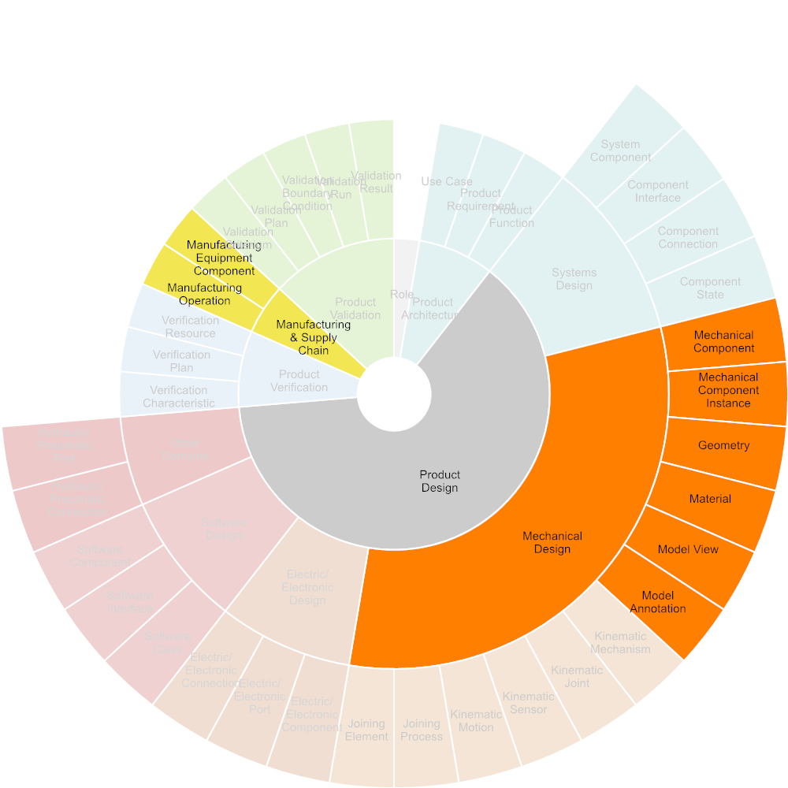

Figure Required Input

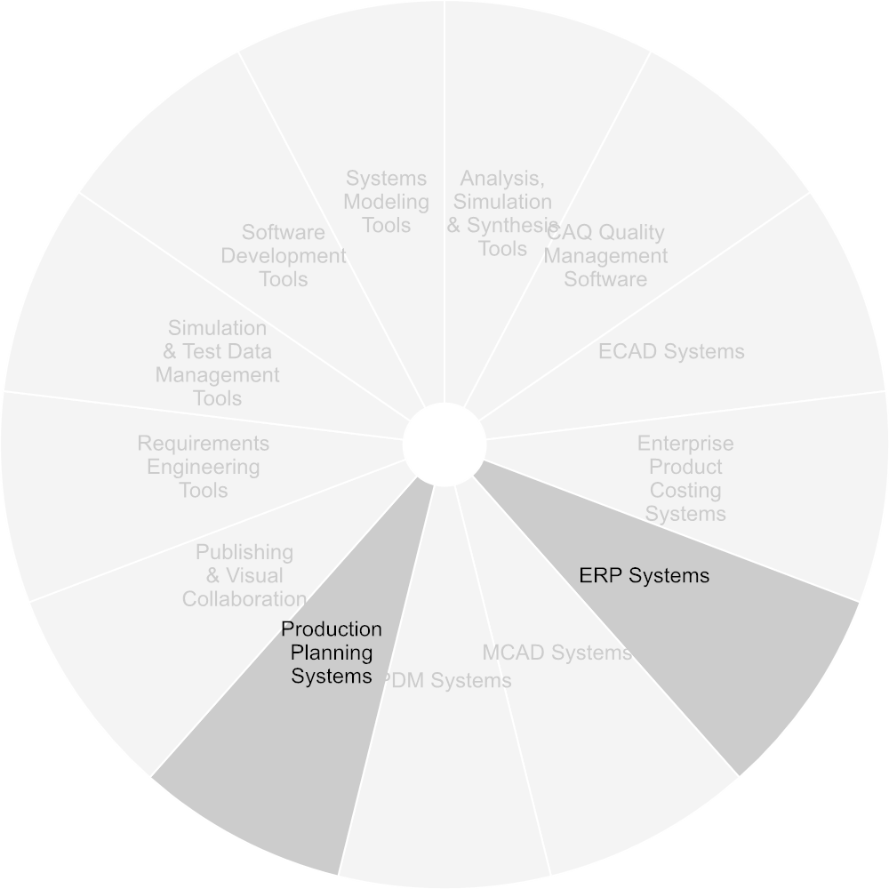

Figure Used Tools

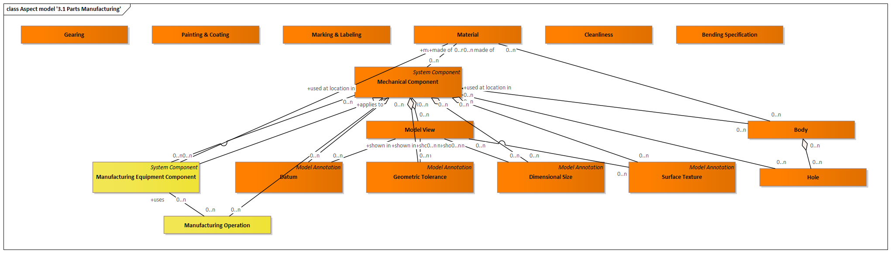

Figure Aspect model '3.1 Parts Manufacturing'

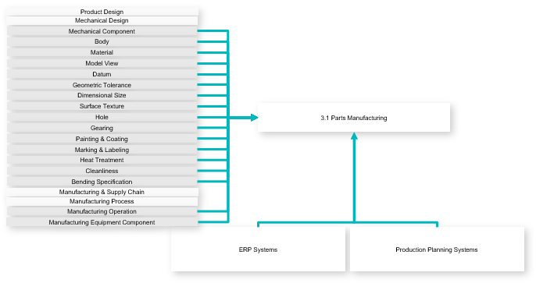

Figure Use-case Diagram

|  |  |
| --- | --- |
| **Outputs** | Mechanical Component  Body  Material  Model View  Datum  Geometric Tolerance  Dimensional Size  Surface Texture  Hole  Gearing  Painting & Coating  Marking & Labeling  Heat Treatment Area  Cleanliness  Bending Specification  Manufacturing Operation  Manufacturing Equipment Component |

#### Product Assembly

Assembly of components or products from single parts or sub-components according to a production plan, using all kinds of joinig and bonding.

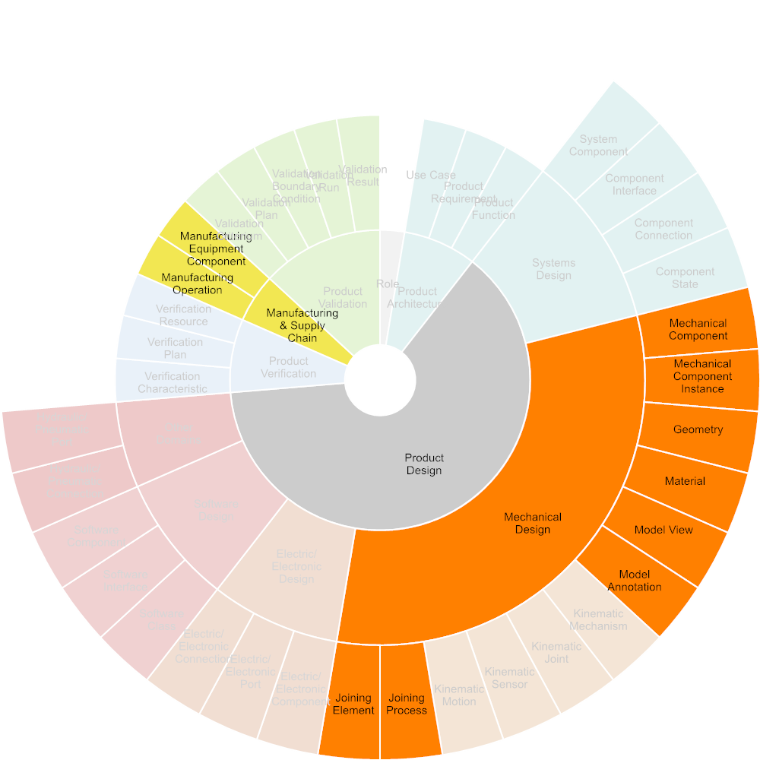

Figure Required Input



Figure Used Tools

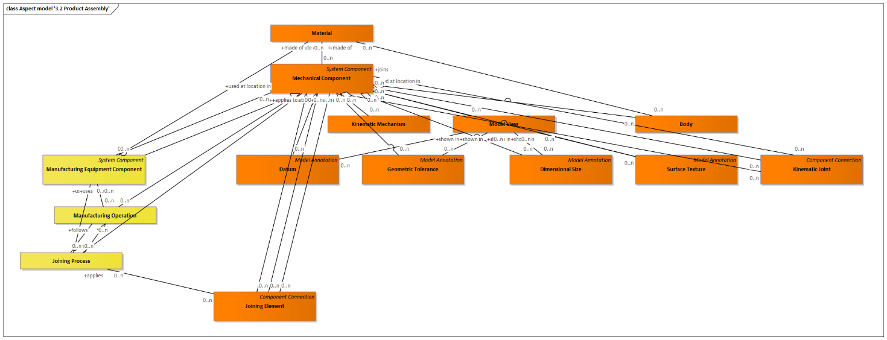

Figure Aspect model '3.2 Product Assembly'

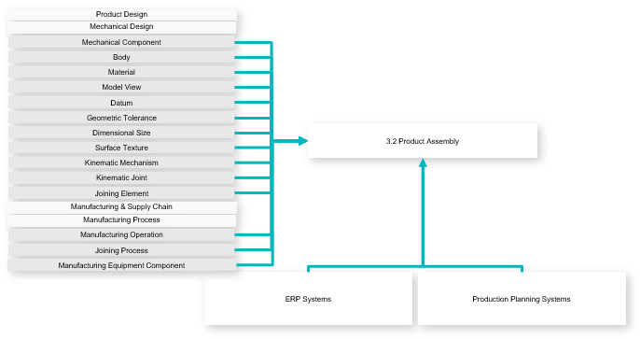

Figure Use-case Diagram

|  |  |
| --- | --- |
| **Outputs** | Mechanical Component  Body  Material  Model View  Datum  Geometric Tolerance  Dimensional Size  Surface Texture  Kinematic Mechanism  Kinematic Joint  Joining Element  Manufacturing Operation  Joining Process  Manufacturing Equipment Component |

#### Quality Inspection

Includes the inspection of single parts, components or products during or after the manufacturing process, as well as the documentation of inspection results.

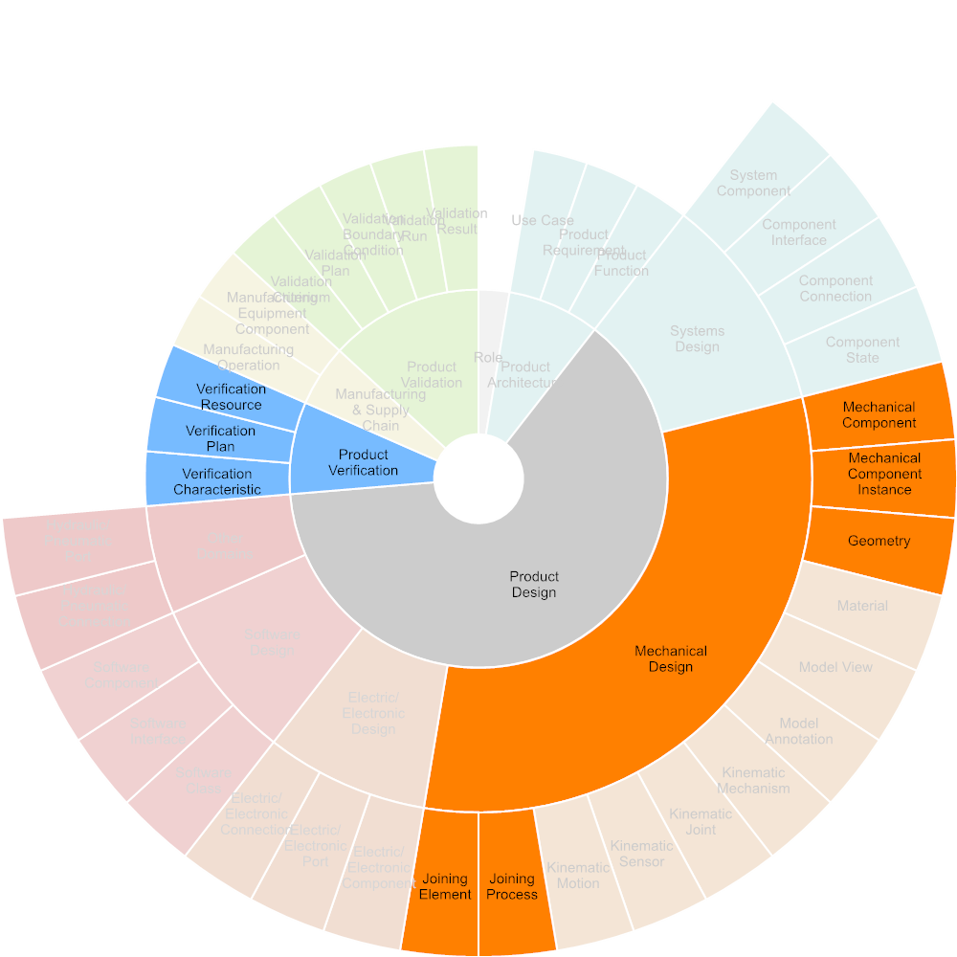

Figure Required Input



Figure Used Tools

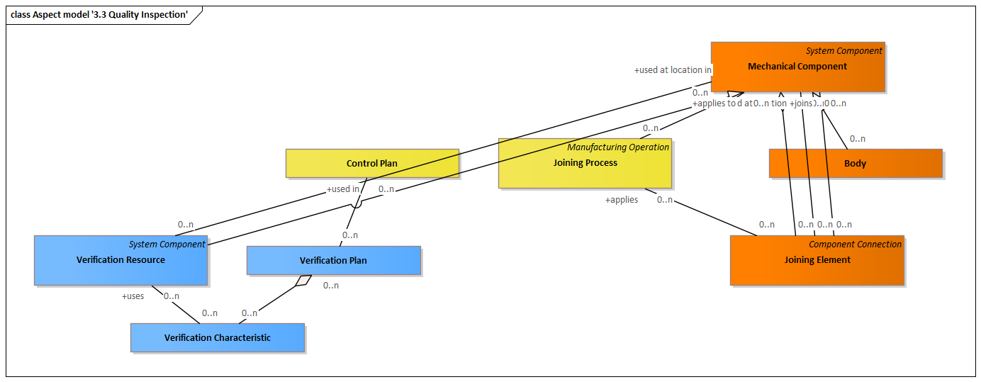

Figure Aspect model '3.3 Quality Inspection'

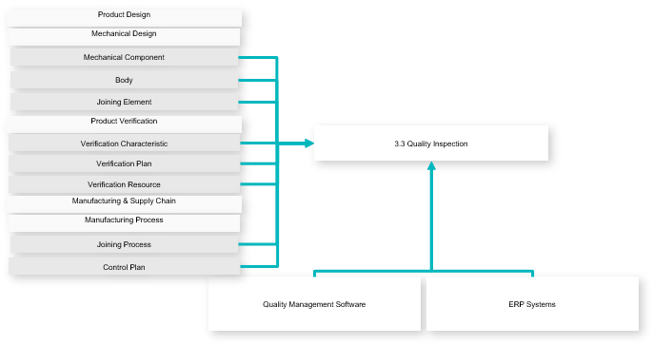

Figure Use-case Diagram

|  |  |
| --- | --- |
| **Outputs** | Mechanical Component  Body  Joining Element  Verification Characteristic  Verification Plan  Verification Resource  Joining Process  Control Plan |

#### Packaging & Logistics

Includes the definition of all kinds of packaging and transport equipment to ensure a product or its components will be supplied to their destination safely.

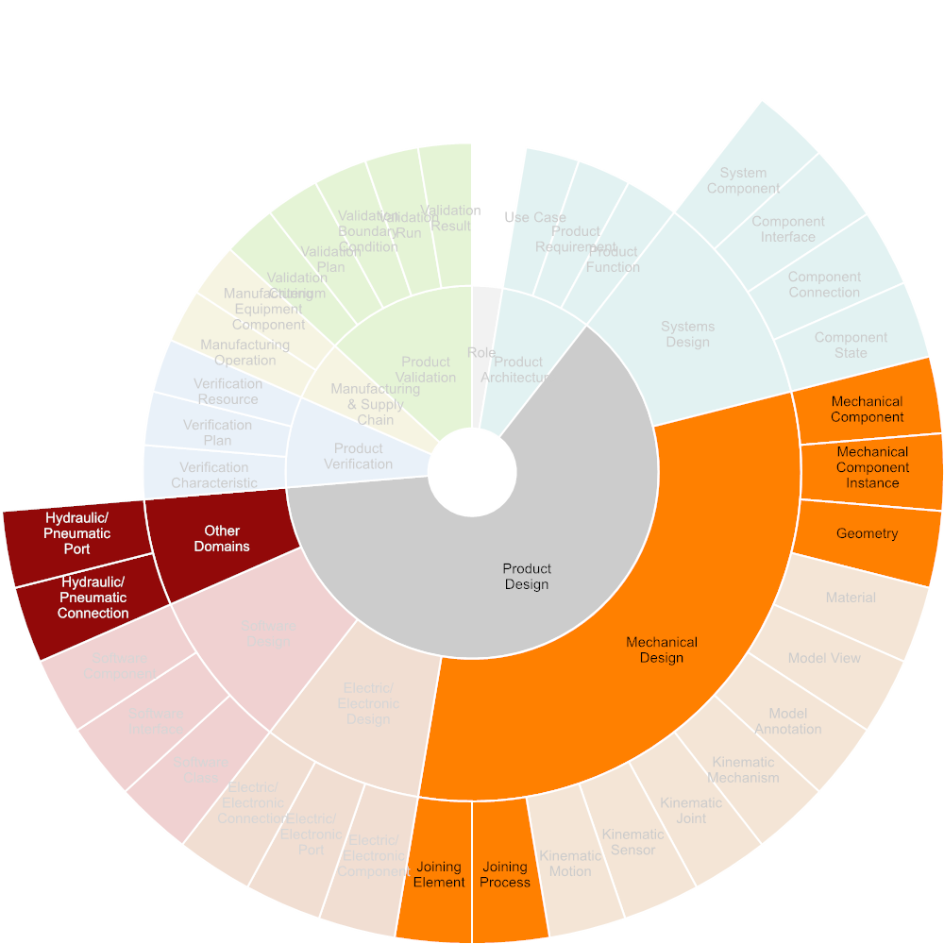

Figure Required Input

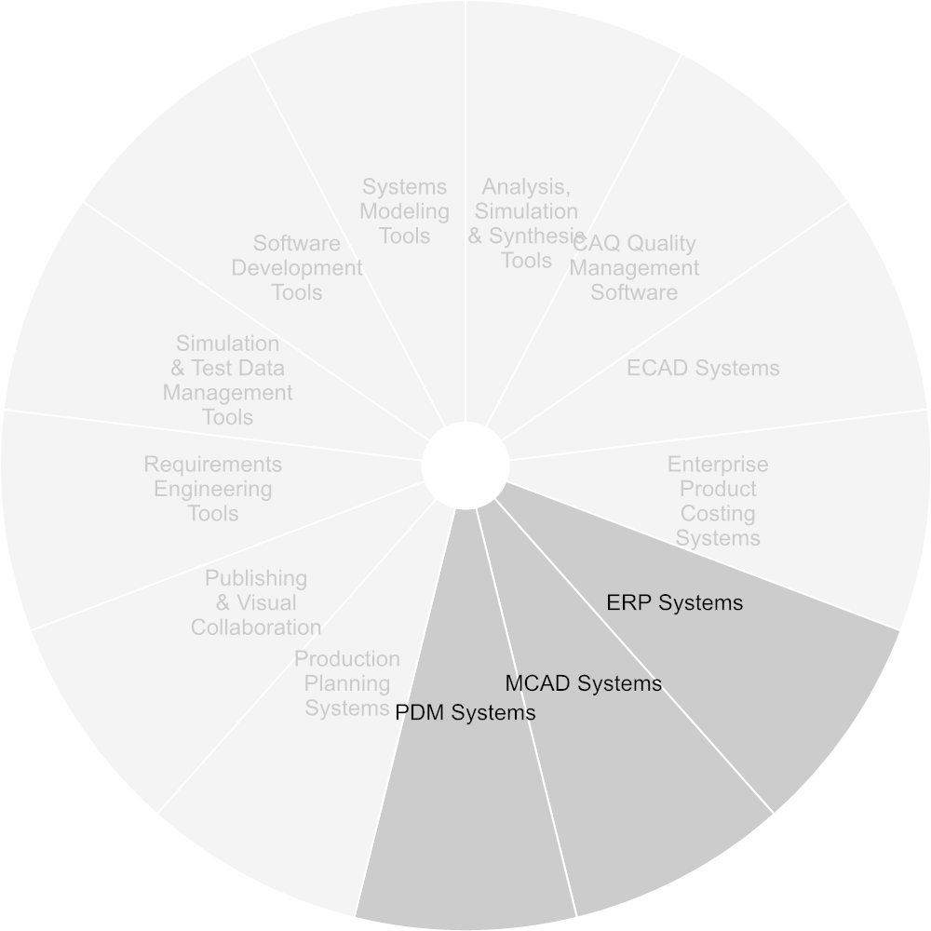

Figure Used Tools

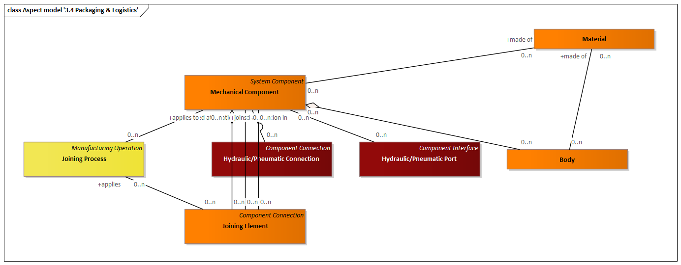

Figure Aspect model '3.4 Packaging & Logistics'

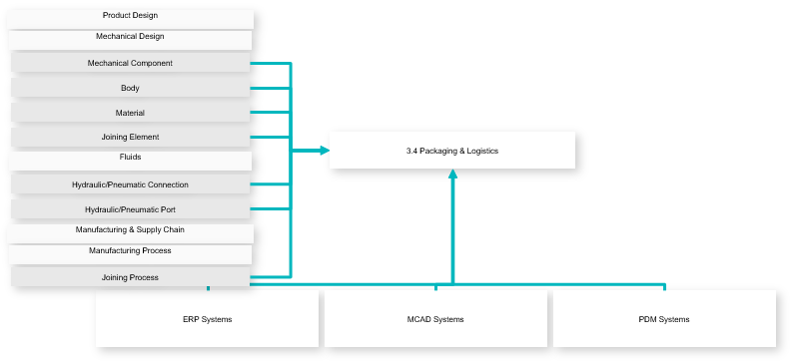

Figure Use-case Diagram

|  |  |
| --- | --- |
| **Outputs** | Mechanical Component  Body  Material  Joining Element  Hydraulic/Pneumatic Connection  Hydraulic/Pneumatic Port  Joining Process |

### Product Operation

Includes all phases and activities in the operation phase of a product.

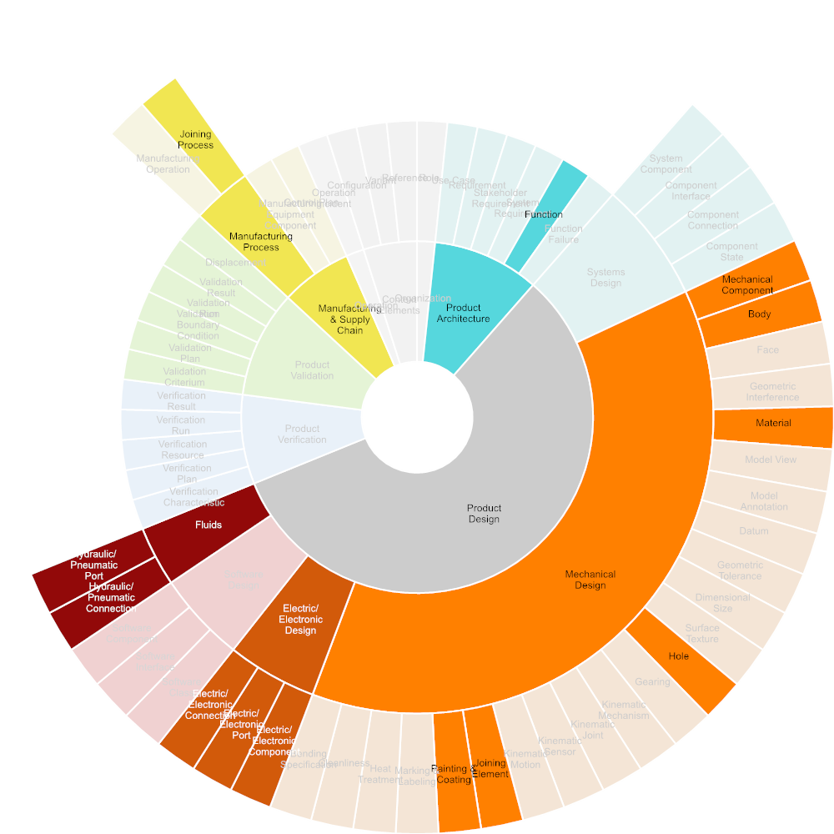

Figure Required Input

#### Product Usage

Usage of a product according to the designated purpose and function.

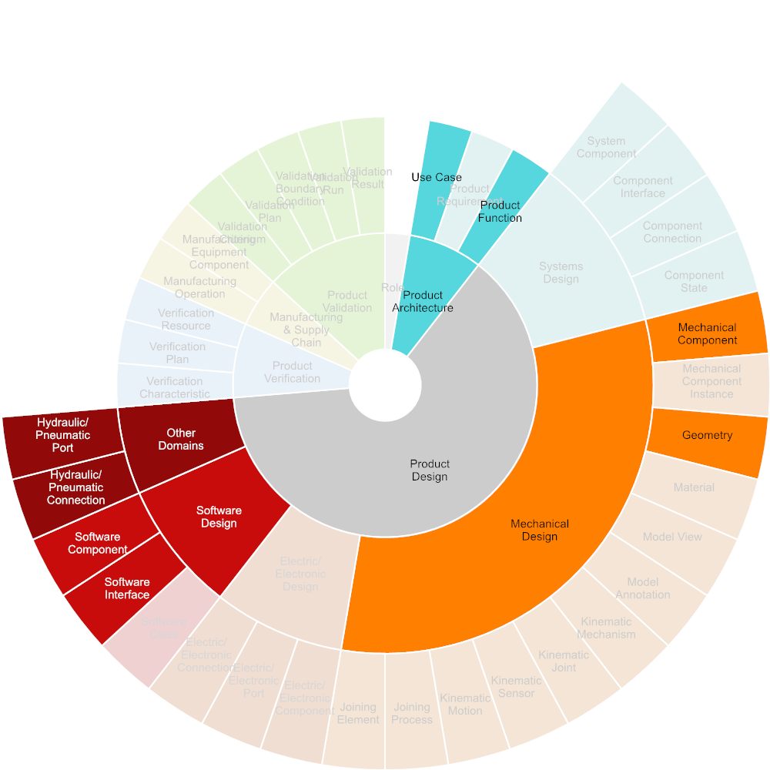

Figure Required Input

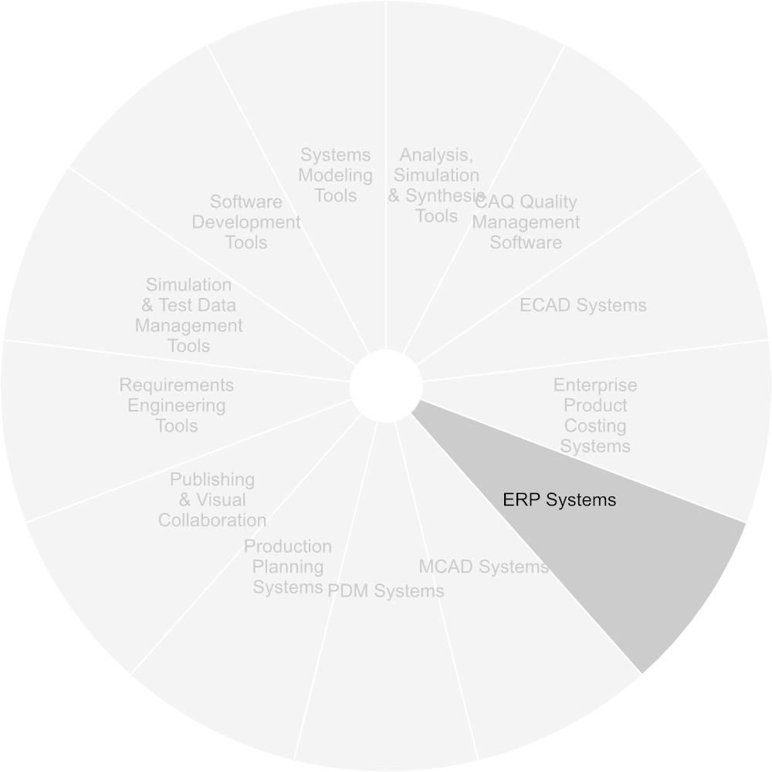

Figure Used Tools

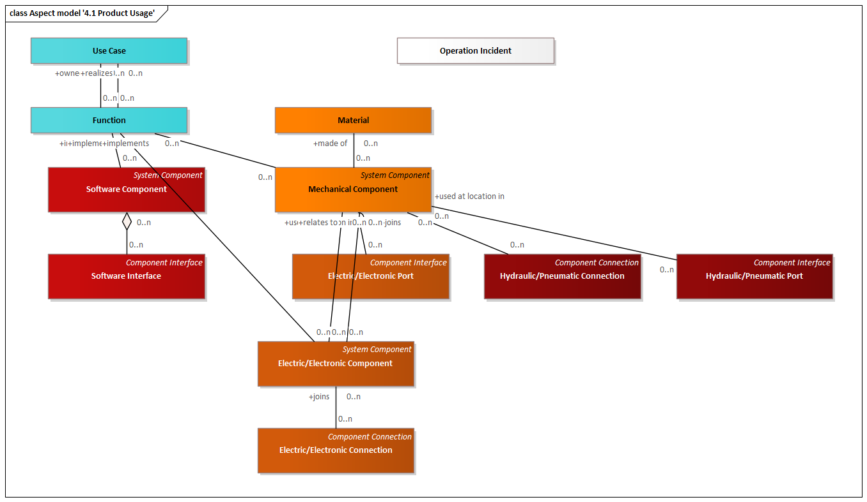

Figure Aspect model '4.1 Product Usage'

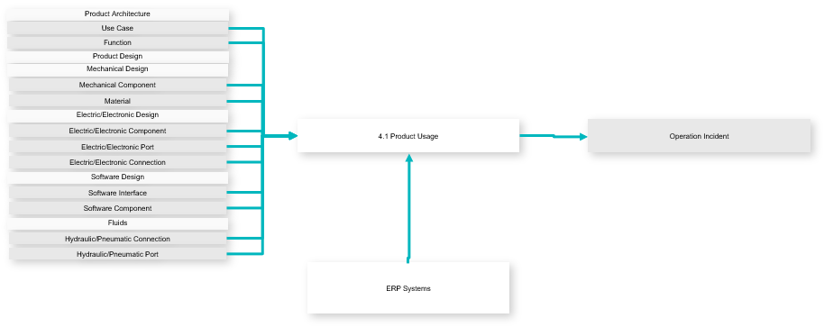

Figure Use-case Diagram

|  |  |
| --- | --- |
| **Inputs** | Operation Incident |
| **Outputs** | Use Case  Function  Mechanical Component  Material  Electric/Electronic Component  Electric/Electronic Port  Electric/Electronic Connection  Software Interface  Software Component  Hydraulic/Pneumatic Connection  Hydraulic/Pneumatic Port |

#### Maintenance & Service

Includes all activities performed in order to maintain a product in operation.

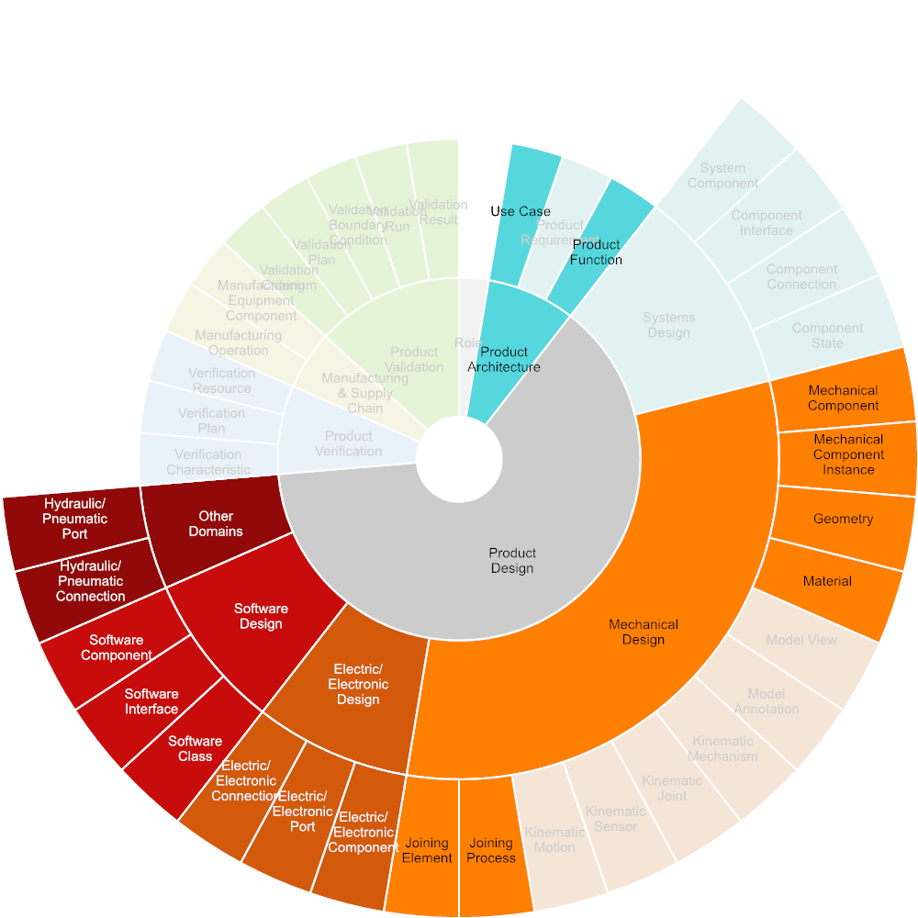

Figure Required Input



Figure Used Tools

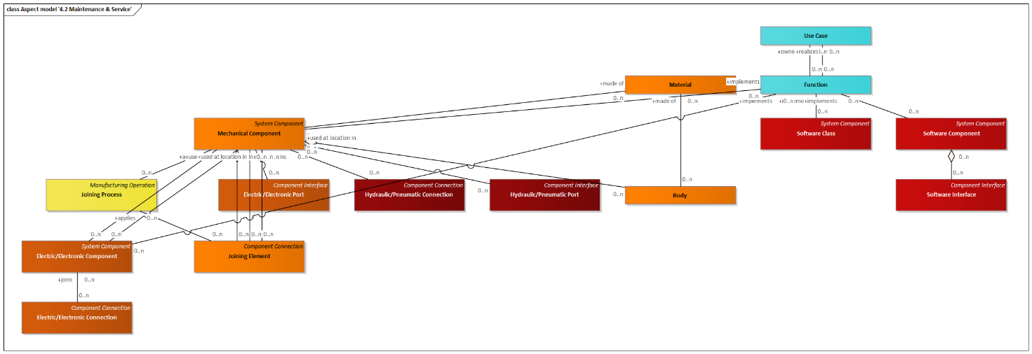

Figure Aspect model '4.2 Maintenance & Service'

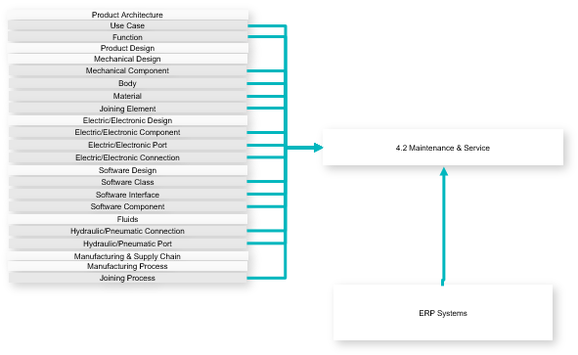

Figure Use-case Diagram

|  |  |
| --- | --- |
| **Outputs** | Use Case  Function  Mechanical Component  Body  Material  Joining Element  Electric/Electronic Component  Electric/Electronic Port  Electric/Electronic Connection  Software Class  Software Interface  Software Component  Hydraulic/Pneumatic Connection  Hydraulic/Pneumatic Port  Joining Process |

#### Disassembly & Recycling

Includes all end-of-life activities required to putting a product or its component to recycling.

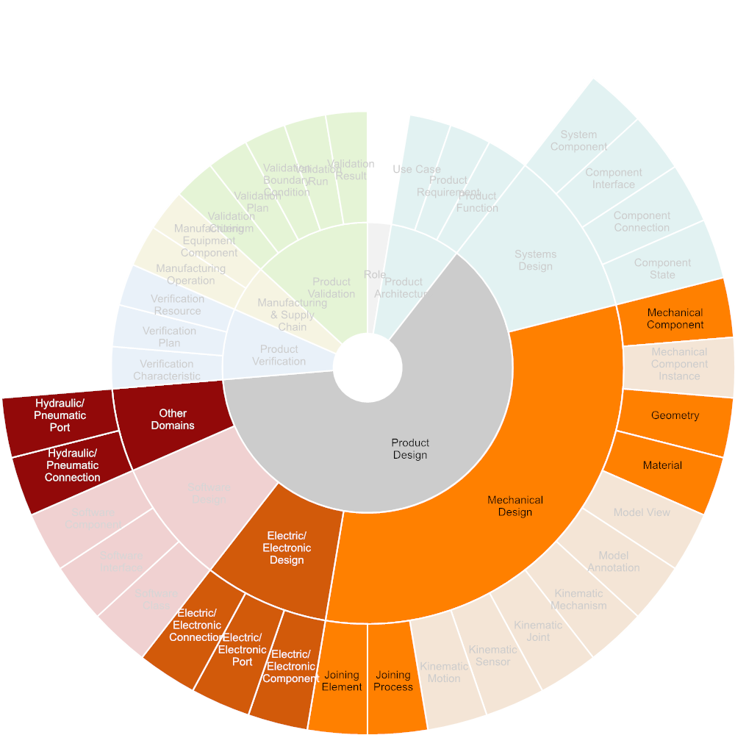

Figure Required Input



Figure Used Tools

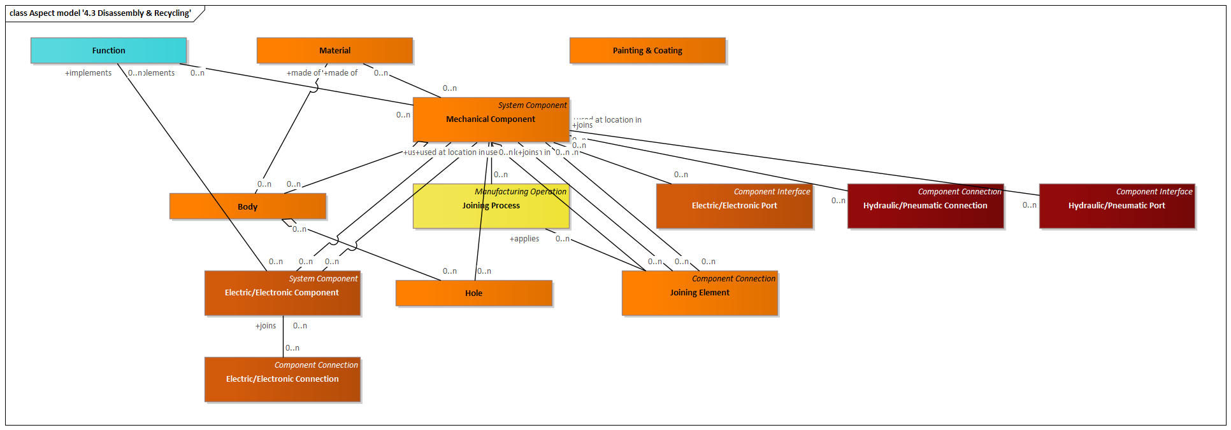

Figure Aspect model '4.3 Disassembly & Recycling'

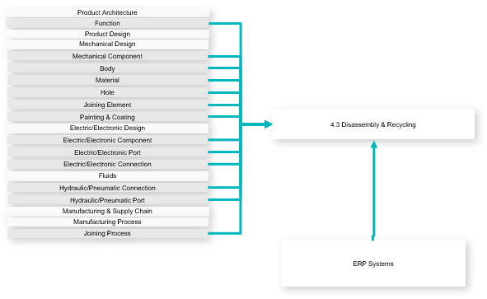

Figure Use-case Diagram

|  |  |
| --- | --- |
| **Outputs** | Function  Mechanical Component  Body  Material  Hole  Joining Element  Painting & Coating  Electric/Electronic Component  Electric/Electronic Port  Electric/Electronic Connection  Hydraulic/Pneumatic Connection  Hydraulic/Pneumatic Port  Joining Process |

### Procurement

Communication between procurement and suppliers in the bidding and iquiry phase. Supports the OMG Model-Based Aqcuisition initiative.

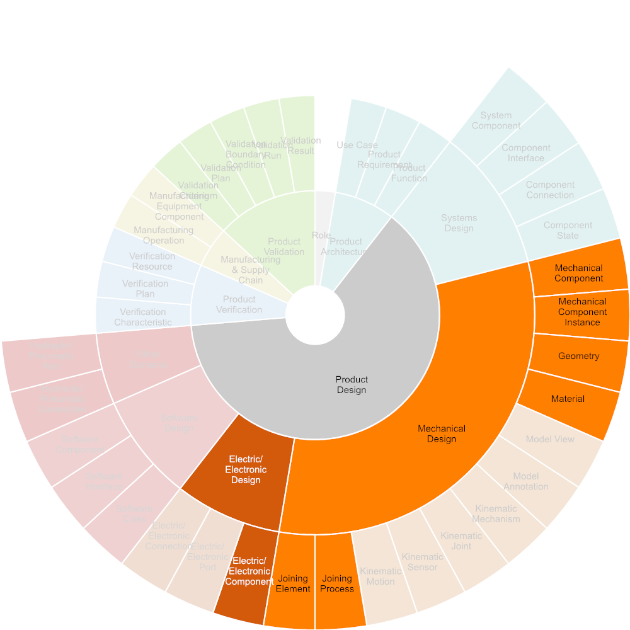

Figure Required Input

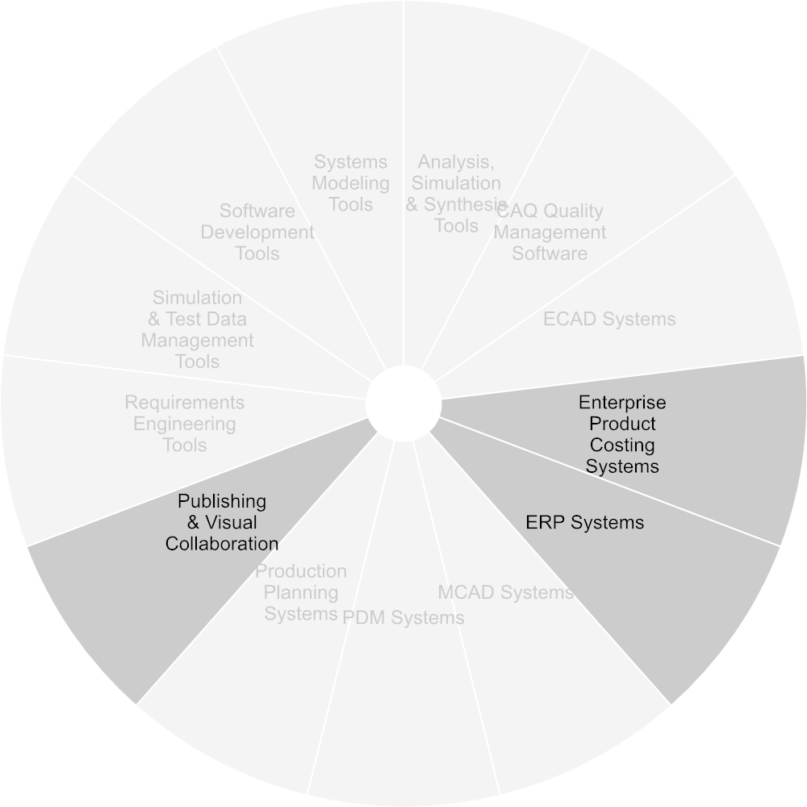

Figure Used Tools

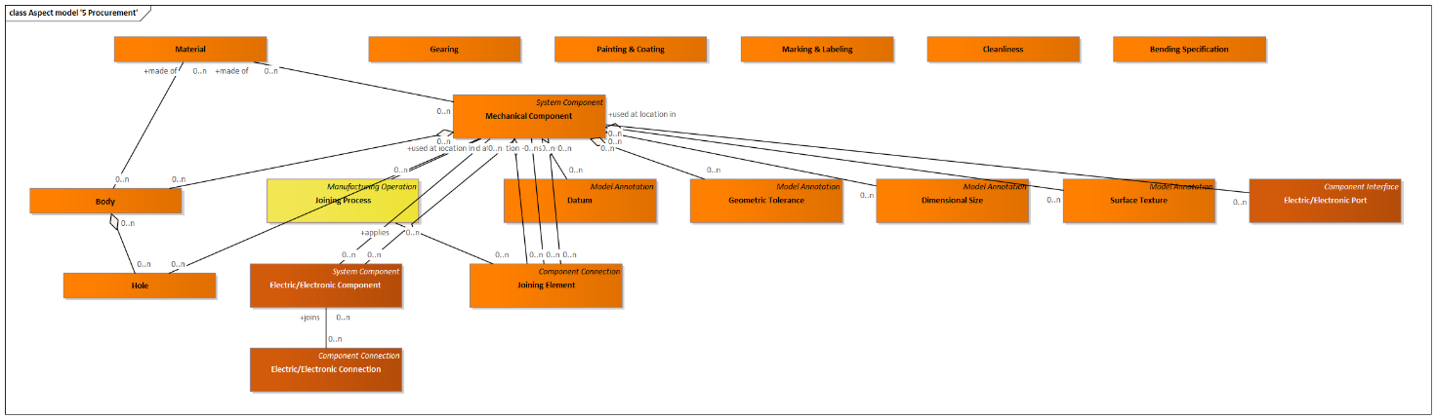

Figure Aspect model '5 Procurement'

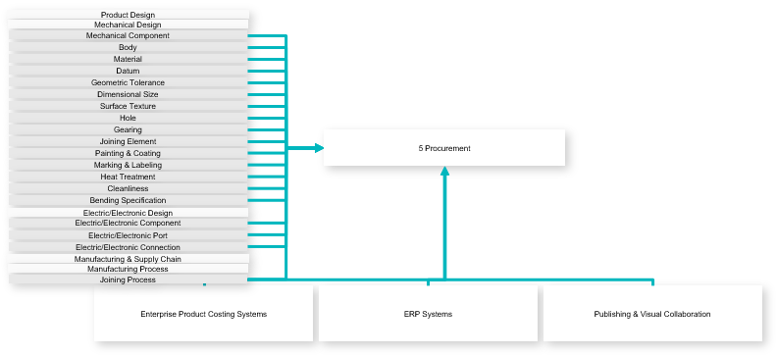

Figure Use-case Diagram

|  |  |
| --- | --- |
| **Outputs** | Mechanical Component  Body  Material  Datum  Geometric Tolerance  Dimensional Size  Surface Texture  Hole  Gearing  Joining Element  Painting & Coating  Marking & Labeling  Heat Treatment Area  Cleanliness  Bending Specification  Electric/Electronic Component  Electric/Electronic Port  Electric/Electronic Connection  Joining Process |

### Product Line Engineering

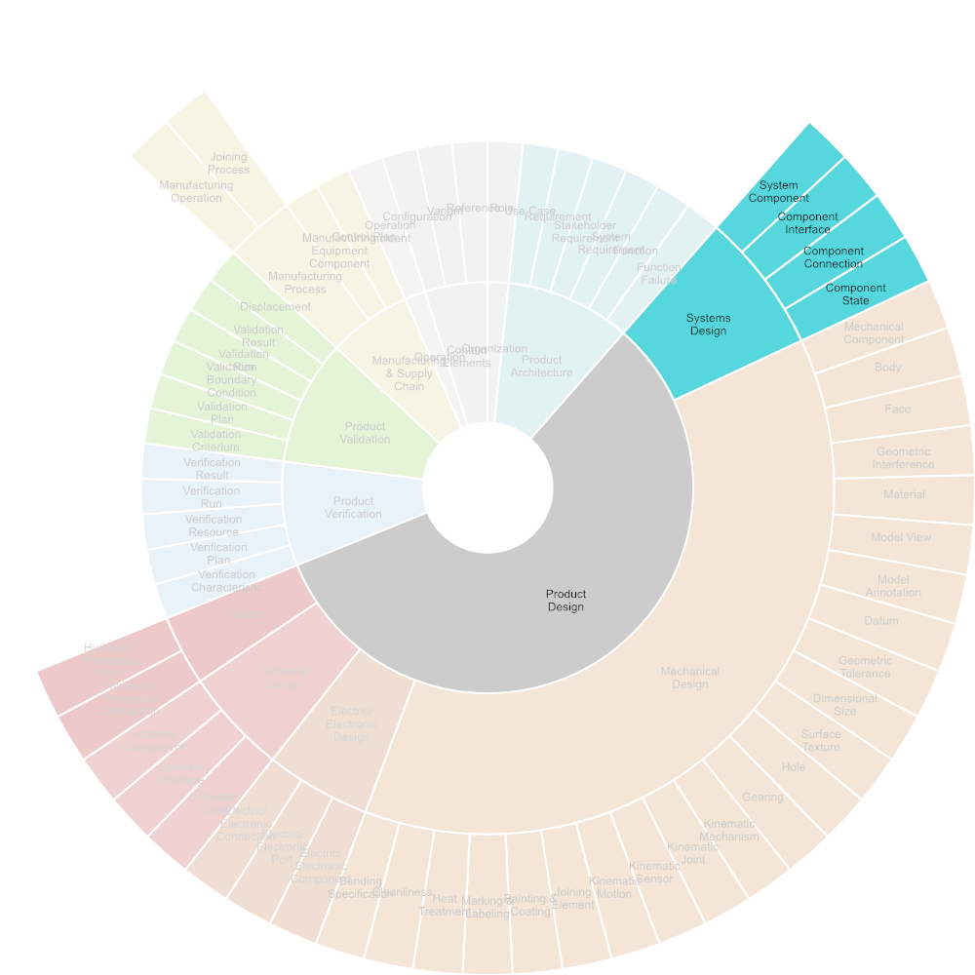

Figure Required Input

#### Design product line

Definition of the “shared asset supersets” and feature catalog: this is a collaborative effort typically involving the CU architect, customer product owner and possibly supplier tech marketing team. The goal is eventually to define the product family i.e. to identify all the assets and their potential variations that can be used to provide a solution to any given problem within the target problem domain, rather than building for each problem an ad-hoc solution. The problem domain is specified by the customer/product owner, but can be typically expanded by the tech marketing team who captures requirements from other customers and push for alignment with strategic objectives. In defining the product line the CU architect is driven by objectives as costs, reuse, IPs while the product owner wants the product family to allow for a problem solution as close as possible to an “optimal” ad-hoc architecture.

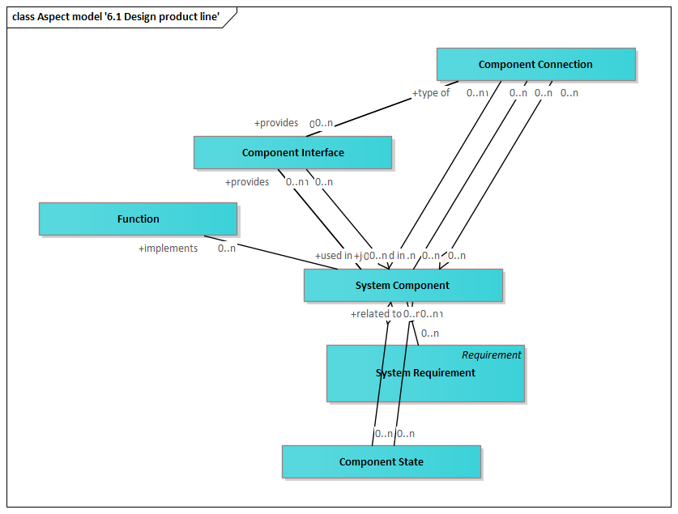

Figure Aspect model '6.1 Design product line'

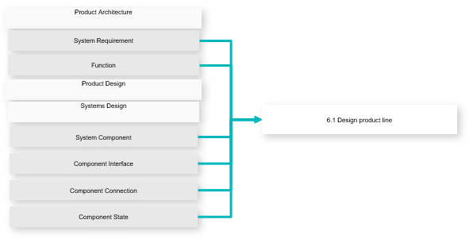

Figure Use-case Diagram

|  |  |
| --- | --- |
| **Outputs** | System Requirement  Function  System Component  Component Interface  Component Connection  Component State |

#### Design product asset instance

Design of the CU product asset instance, implying the definition of the bill of features: the ultimate goal of this collaboration use case is the specification of the features, selected from the feature catalogue, that define the solution to the specific customer problem within the solution/family portfolio. The bill of feature is basically the set of actual values assigned to the variation point, which fully determine a single specific family instance. Collaboration still happens between product and CU architects, with the former specifying requirements and high level architecture for a specific problem (within their problem domain) and the latter providing a set of potential solutions, all belonging to the same CU family.

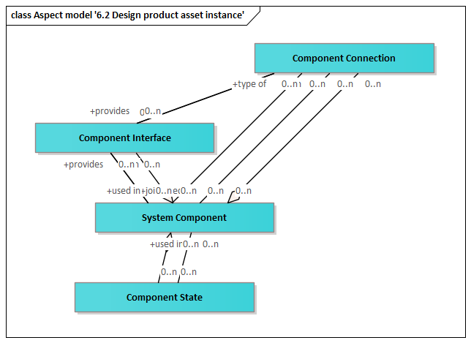

Figure Aspect model '6.2 Design product asset instance'

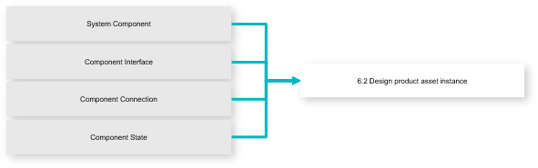

Figure Use-case Diagram

|  |  |
| --- | --- |
| **Outputs** | System Component  Component Interface  Component Connection  Component State |

#### Definition product asset instance configurability space

Definition of the CU product asset instance configurability space: the objective is to define the set of configuration options that will be made available to the CU end user for each CU instance. Typical options available for CU include clock selection, clock speed, caching and cache policy, protocol for external bus interfaces, general purpose I/O configuration (direction, active etc.) as well as dedicated options for peripherals and co-processors. A key aspect is also the definition of the configuration mechanisms that will be made available to the user including configuration protection features to prevent undesired/unauthorized changes. This is a collaborative efforts involving the same actors as Use Case 1, though driven by different criteria. The CU architect must balance the flexibility provided by configurability options with the added complexity it typically brings in terms of hardware design as well as verification effort. The product owner must balance programming complexity, potential higher cost and lower efficiency, with the capability of having their single CU instance capable of covering a broader problem space.

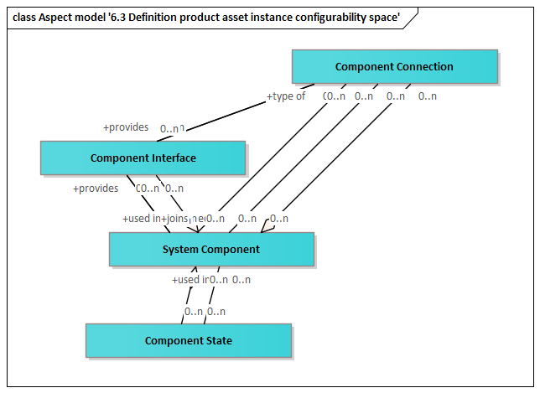

Figure Aspect model '6.3 Definition product asset instance configurability space'

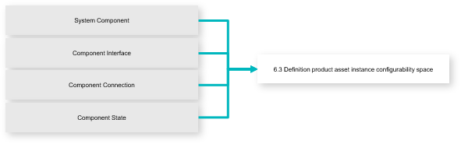

Figure Use-case Diagram

|  |  |
| --- | --- |
| **Outputs** | System Component  Component Interface  Component Connection  Component State |

### Long-Term Archiving

For long-term archiving, all product information must be configured and stored in a retrievable way. Product information includes domain-specifc models, relations between models and model entities, and meta-data about the documents and models.

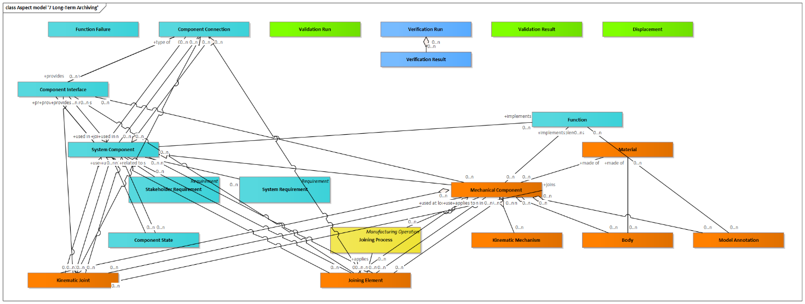

Figure Aspect model '7 Long-Term Archiving'

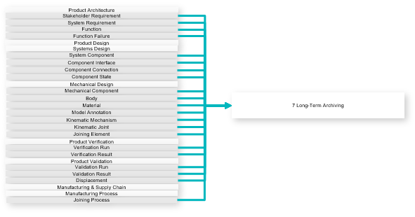

Figure Use-case Diagram

|  |  |
| --- | --- |
| **Outputs** | Stakeholder Requirement  System Requirement  Function  Function Failure  System Component  Component Interface  Component Connection  Component State  Mechanical Component  Body  Material  Model Annotation  Kinematic Mechanism  Kinematic Joint  Joining Element  Verification Run  Verification Result  Validation Run  Validation Result  Displacement  Joining Process |

## CASCaDE

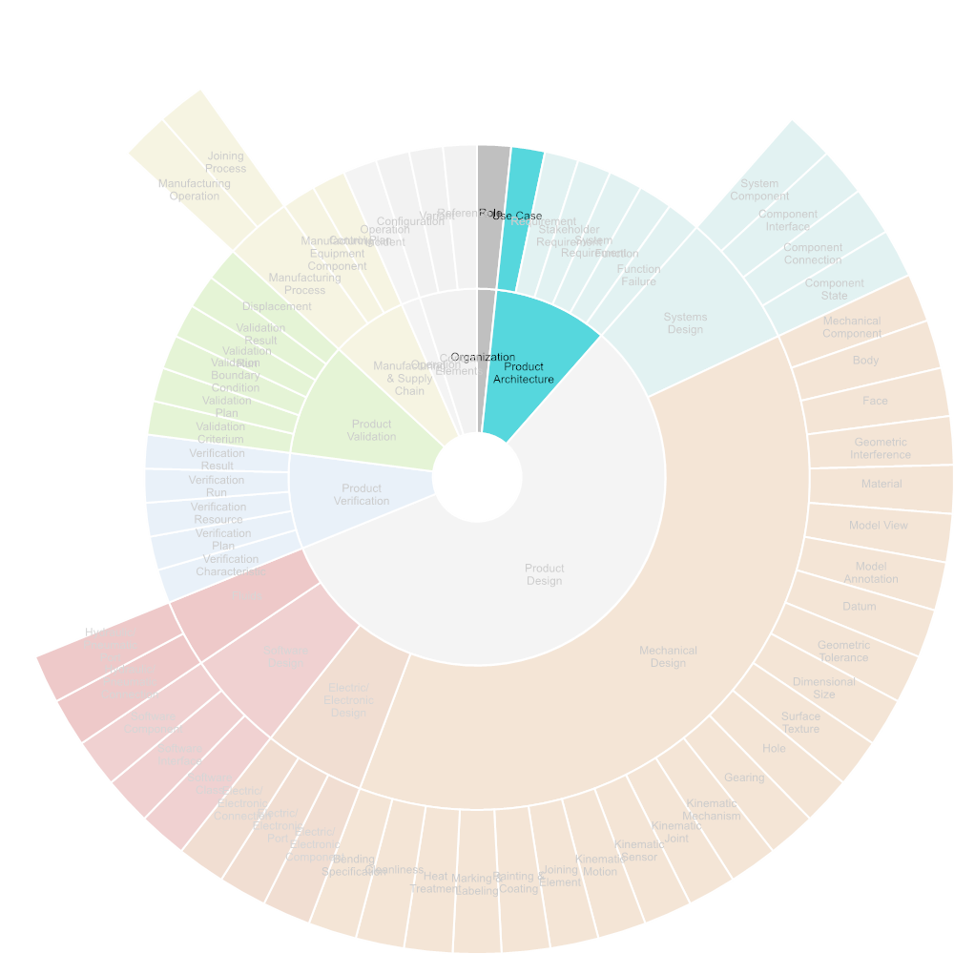

Figure Required Input



Figure Used Tools

### Collaborative Product Requirements Management

Establish and maintain a requirements management process in common with the supplier. Approve requirements specifications ("model based SCD") , get change alerts, manage change requests & releases between OEM and supplier

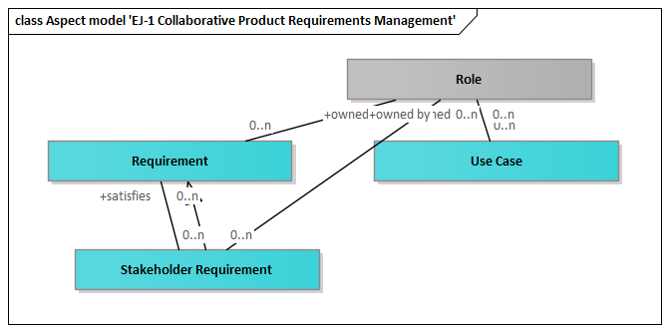

Figure Aspect model 'EJ-1 Collaborative Product Requirements Management'

|  |  |
| --- | --- |
| **Inputs** | Requirement  Stakeholder Requirement |
| **Outputs** | Role  Use Case |

### Collaborative Architecture Design Co-Development

Establish and maintain a method and tool to collaboratively define a system and sub-system architecture & interfaces where supplier provided work products are integrated. Including mission, operational architecture, functional architecture, logical architecture and interface (ICD) definition.

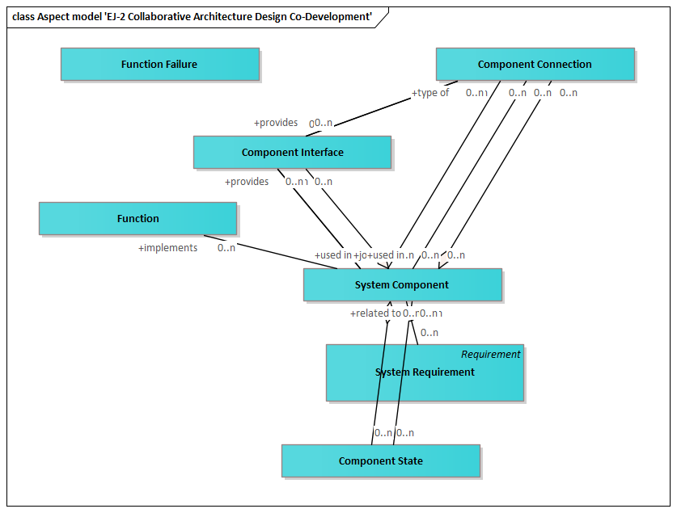

Figure Aspect model 'EJ-2 Collaborative Architecture Design Co-Development'

|  |  |
| --- | --- |
| **Inputs** | System Requirement  Function  Function Failure  System Component  Component Interface  Component Connection  Component State |

### Co-Simulation & early Requirements V&V

Establish method and tool to Co-simulate systems, assembling suppliers' sub-systems into a systems integration model, used to perform early design and requirements Verification & Validation. Incorporate Supplier inputs into Safety analysis.

### Collaborative 3D MBD, Electrical and Software Design Co-Development

Establish method and tool to collaboratively develop and manage 3D MBD and E-BOM connected to the Requirements, Functional and Logical Archtecture (L-BOM)

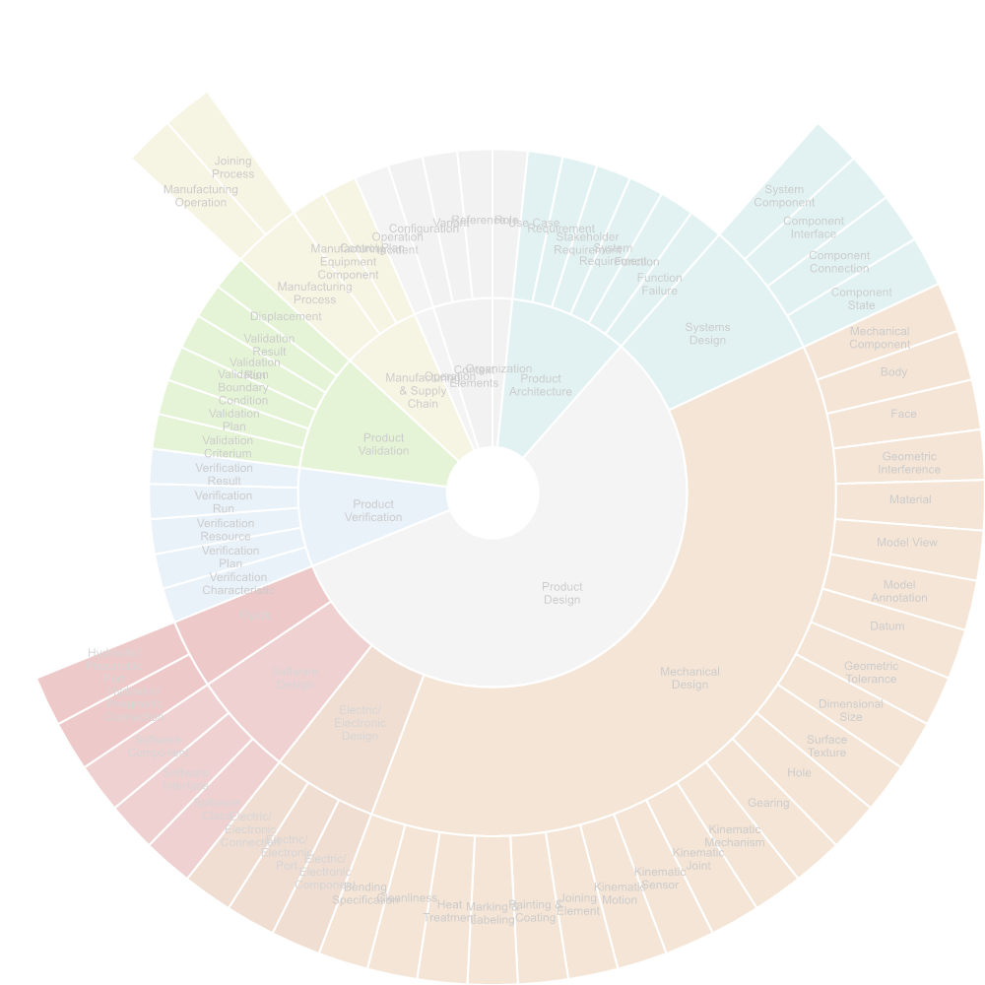

Figure Required Input



Figure Used Tools

#### Mechanical Design

see: Mechanical Design

|  |  |
| --- | --- |
| **Inputs** | Mechanical Component  Body  Geometric Interference  Material  Model View  Model Annotation  Kinematic Mechanism  Kinematic Joint  Kinematic Sensor  Kinematic Motion  Joining Element  Hydraulic/Pneumatic Connection  Hydraulic/Pneumatic Port  Joining Process  Configuration  Variant  Reference |
| **Outputs** | System Requirement  Function  System Component  Component Interface  Component Connection  Component State |

##### Define Joining Elements

see: Define Joining Elements

|  |  |
| --- | --- |
| **Inputs** | Joining Element |
| **Outputs** | System Requirement  Mechanical Component  Face  Material  Joining Process |

##### Define Joining Elements

see: Define Joining Elements

|  |  |
| --- | --- |
| **Inputs** | Joining Element |
| **Outputs** | System Requirement  Mechanical Component  Face  Material  Joining Process |

#### Electrical/Electronical Design

see: Electrical/Electronical Design

|  |  |
| --- | --- |
| **Inputs** | Electric/Electronic Component  Electric/Electronic Port  Electric/Electronic Connection  Configuration  Variant  Reference |
| **Outputs** | System Requirement  Function  System Component  Component Interface  Component Connection  Component State  Mechanical Component  Body |

#### Software Engineering

see: Software Engineering

|  |  |
| --- | --- |
| **Inputs** | Software Class  Software Interface  Software Component  Configuration  Variant  Reference |
| **Outputs** | System Requirement  Function  System Component  Component Interface  Component Connection  Component State  Mechanical Component  Body  Electric/Electronic Component  Electric/Electronic Port  Electric/Electronic Connection |

#### Electrical/Mechanical Design Collaboration

see: Electrical/Mechanical Design Collaboration

|  |  |
| --- | --- |
| **Outputs** | Mechanical Component  Body  Electric/Electronic Component  Electric/Electronic Port  Electric/Electronic Connection |

### Collaborative Manufacturing Engineering

Establish process and tool for Collabrative Manufacturing MBD: M-BOM, manufacturing process planning and model based work instruction MBI, connected to the 3D MBD

### Collaborative Digital Product Quality Management (APQP)

Establish process and tool for the creation, definition, retention of APQP (Advanced Product Quality Planning ) and PPAP (Production part approval process) elements, following indutsry standards such as AS9145.

### LOTAR Long-term Archiving and Retrieval

I want to preserve a baseline of system informationt for later retrieval and reuse. Reference: https://lotar-international.org/

### Model-based Acquisition

Reference: https://www.omg.org/communities/model-based-acquisition-user-community.htm